TilBuci
User manual
TilBuci is a tool for creating interactive digital content. This document describes how it works, focusing on user interaction.
All user interaction on TilBuci is managed by JSON-formatted texts with instructions about how to handle both input and playback flow.
Buci is a very friendly but also very mischievous little dog who brings a lot of joy to our daily lives. This software is dedicated to him!

Lucas Junqueira, 2026/11

Contents
1. Scripting actions on TilBuci 17
1.1. Where do I use these interaction scripts? 18
1.1.1. Instance interactions 18
1.1.2. Movie load 19
1.1.3. Scene start 19
1.1.4. Keyframe end 20
1.1.5. Media playback end 20
1.1.6. Timed actions 21
1.1.7. Inventory items 21
1.2. Variables 22
1.2.1. Initial variables 22
1.3. Globals 23
1.3.1. Boolean globals 24
1.3.2. Number globals 25
1.3.3. Text globals 25
1.3.4. Input values 26
1.3.5. Form values 26
1.4. Strings.json file 27
1.5. Instance text and replace 27
1.5.1. Content replace at runtime 28
1.6. Code snippets 28
1.6.1. Snippets parameters 30
2. Available actions 31
2.1. Boolean conditions 31
if.bool 31
if.boolset 31
2.2. Boolean values 31
bool.clear 31
bool.clearall 31
bool.set 31
bool.setinverse 32
2.3. Data 32
data.event 32
data.eventclear 32
data.liststates 33
data.load 33
data.loadlocal 33
data.loadquickstate 34
data.loadstatelocal 34
data.save 34
data.savelocal 34
data.savequickstate 35
data.savestate 35
data.savestatelocal 35
2.4. Float conditions 35
if.floatsdifferent 35
if.floatsequal 36
if.floatset 36
if.floatgreater 36
if.floatgreaterequal 36
if.floatlower 36
if.floatlowerequal 37
2.5. Float values 37
float.abs 37
float.clear 37
float.clearall 37
float.divide 37
float.max 37
float.min 38
float.multiply 38
float.random 38
float.set 38
float.subtract 38
float.sum 38
float.toint 39
float.tostring 39
2.6. Input 39
input.email 39
input.float 39
input.int 40
input.list 40
input.login 40
input.message 41
input.string 41
input.add 41
input.place 42
input.remove 42
input.removeall 42
input.settext 42
input.setpassword 42
input.addtarea 42
input.placetarea 43
input.removetarea 43
input.removealltareas 43
input.settextarea 43
input.addnumeric 43
input.placenumeric 43
input.removenumeric 43
input.removeallnumerics 44
input.setnumeric 44
input.setnumericbounds 44
input.addtoggle 44
input.placetoggle 44
input.removetoggle 44
input.removealltoggles 44
input.settoggle 44
input.inverttoggle 45
2.7. Instance 45
instance.clearall 45
instance.clearalpha 45
instance.clearcolor 45
instance.clearcoloralpha 45
instance.clearfont 45
instance.clearfontalign 45
instance.clearfontbackground 46
instance.clearfontbold 46
instance.clearfontcolor 46
instance.clearfontitalic 46
instance.clearfontleading 46
instance.clearfontsize 46
instance.clearheight 46
instance.clearorder 47
instance.clearrotation 47
instance.clearvisible 47
instance.clearvolume 47
instance.clearwidth 47
instance.clearx 47
instance.cleary 47
instance.loadasset 47
instance.next 48
instance.pause 48
instance.play 48
instance.playpause 48
instance.previous 48
instance.scrollbottom 48
instance.scrolldown 48
instance.scrolltop 48
instance.scrollup 49
instance.seek 49
instance.setalpha 49
instance.setcolor 49
instance.setcoloralpha 49
instance.setfont 49
instance.setfontalign 49
instance.setfontbackground 50
instance.setfontbold 50
instance.setfontcolor 50
instance.setfontitalic 50
instance.setfontleading 50
instance.setfontsize 50
instance.setheight 51
instance.setorder 51
instance.setparagraph 51
instance.setrotation 51
instance.setvisible 51
instance.setvolume 51
instance.setwidth 52
instance.setx 52
instance.sety 52
instance.stop 52
instance.zoom 52
instance.morezoom 52
instance.lesszoom 53
instance.clearzoom 53
instance.moveup 53
instance.movedown 53
instance.moveleft 53
instance.moveright 53
instance.clearmove 53
instance.startdrag 54
instance.stopdrag 54
instance.isoverlapping 54
2.8. Integer conditions 54
if.intsdifferent 54
if.intsequal 54
if.intset 55
if.intgreater 55
if.intgreaterequal 55
if.intlower 55
if.intlowerequal 55
int.switch 56
int.switchcase 56
int.switchdefault 56
2.9. Integer values 56
int.abs 56
int.clear 56
int.clearall 56
int.divide 56
int.max 57
int.min 57
int.multiply 57
int.random 57
int.set 57
int.subtract 57
int.sum 58
int.tofloat 58
int.tostring 58
2.10. Mouse 58
mouse.hide 58
mouse.show 58
2.11. Movie 58
movie.load 58
2.12. Replace 59
replace.clearfile 59
replace.clearstring 59
replace.clearallfiles 59
replace.clearallstrings 59
replace.origin 59
replace.setfile 59
replace.setstring 59
if.replacefileset 60
if.replacestringset 60
2.13. Runtime 60
runtime.ifbrowser 60
runtime.install 60
runtime.quit 60
runtime.savedata 60
runtime.loaddata 60
runtime.ifdataexist 61
runtime.startkiosk 61
runtime.endkiosk 61
2.14. Scene 61
scene.load 61
scene.navigate 61
scene.pause 61
scene.play 61
scene.playpause 61
scene.nextkeyframe 61
scene.previouskeyframe 62
scene.loadfirstkeyframe 62
scene.loadlastkeyframe 62
scene.loadkeyframe 62
scene.historyback 62
scene.shake 62
scene.zoomset 62
scene.zoomreset 62
scene.zoomincrease 62
scene.zoomdecrease 62
scene.reset 63
scene.movecenter 63
scene.movetop 63
scene.movebottom 63
scene.moveleft 63
scene.moveright 63
scene.movereset 63
scene.move 63
2.15. Snippets 63
run 63
snippets.load 64
snippets.unload 64
2.16. String conditions 64
if.stringcontains 64
if.stringendswith 64
if.stringsdifferent 64
if.stringsequal 65
if.stringset 65
if.stringstartswith 65
if.stringemail 65
string.switch 65
string.switchcase 66
string.switchdefault 66
2.17. String values 66
string.clear 66
string.clearall 66
string.clearglobal 66
string.concat 66
string.replace 66
string.set 67
string.setglobal 67
string.setgroup 67
string.tofloat 67
string.toint 67
2.18. System 67
system.copytext 67
system.fullscreen 68
system.visitoringroup 68
system.logout 68
system.openembed 68
system.closeembed 68
system.embedreset 69
system.embedplace 69
system.openurl 69
system.sendevent 69
system.setkftime 69
system.ifhorizontal 69
system.ifvertical 69
system.ifwebsite 70
system.ifpwa 70
system.ifpwainstalled 70
system.ifdesktop 70
system.ifmobile 70
system.ifpublish 70
system.ifplayer 70
2.19. Target 71
target.show 71
target.hide 71
target.toggle 71
target.setposition 71
target.clear 71
target.set 71
2.20. Text 71
css.clear 71
css.set 71
2.21. Timer 72
timer.clear 72
timer.clearall 72
timer.set 72
3. Plugin actions 73
3.1. Debug plugin 73
trace 73
trace.bools 73
trace.ints 73
trace.floats 73
trace.strings 73
debuginfo.hide 73
debuginfo.show 73
3.2. Share 74
share.facebook 74
share.linkedin 74
share.pinterest 74
share.reddit 74
share.x 74
3.3. Google Analytics 74
analytics.event 75
3.4. Server Call 75
call.process 75
call.sdprocess 76
call.url 76
3.5. Overlay 76
overlay.show 77
4. Contraptions 80
4.1. Menu 80
contraption.menu 80
contraption.menuhide 81
4.2. Cover 81
contraption.cover 82
contraption.coverhide 82
4.3. Loading icon 82
contraption.showloading 82
contraption.hideloading 82
4.4. Music tracks 83
contraption.musicplay 83
contraption.musicpause 83
contraption.musicstop 83
contraption.musicvolume 83
4.5. Sound effects 84
contraption.soundplay 84
contraption.soundpause 84
contraption.soundstop 84
contraption.soundvolume 85
4.6. Forms 85
contraption.form 86
contraption.formvalue 86
contraption.formsetstepper 86
contraption.formhide 87
4.7. Interfaces 87
contraption.interface 88
contraption.interfacehide 88
contraption.interfacehideall 89
contraption.interfacetext 89
contraption.interfaceanimframe 89
contraption.interfaceanimplay 89
contraption.interfaceanimpause 89
contraption.interfacepbinstance 89
contraption.interfacepbscene 89
4.8. Background 89
contraption.background 90
contraption.backgroundhide 90
4.9. Targets 90
4.10. Messages 91
contraption.message 92
contraption.messagehide 92
5. Narrative 93
5.1. Characters 93
5.2. Dialogues 93
dialogue.loadgroup 94
dialogue.start 94
dialogue.next 94
dialogue.previous 95
dialogue.last 95
dialogue.first 95
dialogue.close 95
5.3. Decision flow 95
5.4. Inventory 97
inventory.show 99
inventory.close 99
inventory.addkeyitem 99
inventory.removekeyitem 99
inventory.clearkeyitems 99
inventory.haskeyitem 99
inventory.addconsumable 99
inventory.removeconsumable 99
inventory.consumeitem 100
inventory.clearconsumables 100
inventory.tostring 100
inventory.fromstring 100
inventory.keytostring 100
inventory.keyfromstring 100
inventory.constostring 100
inventory.consfromstring 100
5.5. Card battle 101
battle.show 104
battle.close 104
battle.setattribute 104
battle.setopponent 105
6. String files and Arrays 106
6.1. String files 106
string.loadfile 107
6.2. Arrays 107
array.loadfile 107
array.create 108
array.remove 108
array.push 108
array.set 108
array.get 108
array.getint 108
array.getfloat 109
array.getbool 109
array.clear 109
array.current 109
array.currentint 109
array.currentfloat 109
array.currentbool 110
array.next 110
array.nextint 110
array.nextfloat 110
array.nextbool 110
array.previous 110
array.previousint 111
array.previousfloat 111
array.previousbool 111
array.setindex 111
array.getindex 111
array.tostring 111
array.fromstring 111
7. QR code functionality 113
system.getqr 114
system.closeqr 114
8. Accessibility 115
8.1. Color adjustment 115
accessibility.changeshader 115
accessibility.setshader 115
8.2. Focus mode 116
accessibility.focuson 116
accessibility.focusoff 116
accessibility.focusswitch 116
8.3. Description text 117
accessibility.setdescription 117
9. Code assist 118
10. Block editor 119
11. Content encryption 122
11.1. Custom encryption 123
12. The WordPress* plugin 124
13. TilBuci Showtime 126
13.1. Showtime for computers and Android 126
13.1.1. Setting the movie to display 126
13.1.2. Settings access key 127
13.1.3. Additional options 128
13.1.4. Hardware connection 128
13.1.5. Online functionality 131
13.1.6. Installing Showtime 135
13.2. Showtime for Makers 136
13.2.1. Talking to the hardware 137
13.3. Showtime actions 139
13.3.1. Recording events 139
showtime.event 140
13.3.2. Sending commands to hardware 140
showtime.hardware 140
13.3.3. Handling user names 140
showtime.getname 141
showtime.setname 141
showtime.clearname 141
13.3.4. Saving and retrieving values 141
showtime.setval 141
showtime.getval 141
showtime.delval 141
showtime.delallval 142
showtime.setglobal 142
showtime.getglobal 142
showtime.delglobal 142
showtime.delallglobal 142
14. PDF Support 143

1. Scripting actions on TilBuci
You may create beautiful scenes and animations on TilBuci but they won’t be really useful if you don’t provide user interaction to them. A good interaction design is fundamental for your content to get life!
To enable these interactions, TilBuci uses a JSON-formatted text describing the actions. If you are not familiar with the JSON concept, is it a data format based on JavaScript. You don’t really need to go too deep on JSON to use it on TilBuci, but if you are interested on it, please check out json.org for further information.
The TilBuci actions are always provided as an object with at least two fields: ac, a simple string, and param, an array of strings (all parameters must be provided as strings, even numeric ones like “3.1416”). If an action does not require parameters, the param value must still be given as an empty array.
{
“ac”: “actionhere”,
“param”: [ “param1”, “param2”, “param3” ]
}
Actions may also be provided as an array of objects. You can use these arrays on every place that accepts a single action.
[
{ “ac”: “firstaction”, “param”: [ “param1” ] },
{ “ac”: “secondaction”, “param”: [ ]
]
There are some actions, like conditionals, timers and inputs, that may accept additional fields. Check out the following example:
{
“ac”: “if.stringsequal”,
“param”: [ “$okemail”, “name@email.com” ],
“then”: {
“ac”: “timer.set”,
“param”: [ “displaytimer”, “1000”, “1” ],
“tick”: [ ],
“end”: { “ac”: “scene.load”, “param”: [ “userscene” ] }
},
“else”: [
{ “ac”: “timer.clearall”, “param”: [ ] },
{
“ac”: “input.login”,
“param”: [ ],
“ok”: {
“ac”: “string.set”,
“param”: [ “okemail”, “$_USERNAME” ]
},
“cancel”: {
“ac”: “string.clear”,
“param”: [ “okemail” ]
}
}
]
}
You can input your action script on its window at the editor. By clicking on ok your JSON text will be evaluated for errors (notice that this will only look for text inconsistencies, not your script logic.
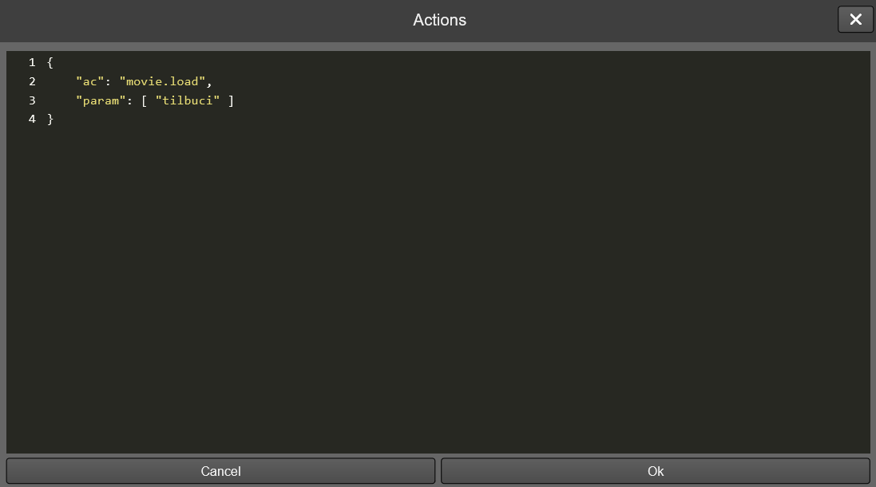

1.1. Where do I use these interaction scripts?
You can provide action scripts on many places. The usual one is on an user click/touch of an instance, but there are many more.

1.1.1. Instance interactions
This is the usual place to set an action script. Just select an instance on the stage and look for the Actions tab on the right menu. You can set actions for three different moments: trigger (when the instance is clicked/tapped), when the mouse cursor hovers it or you can use the instance playback to create timed actions.
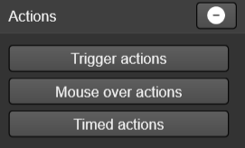

1.1.2. Movie load
You can provide actions to run just after your movie is loaded. Look for the Movie > Properties right menu and access the Start actions tab.
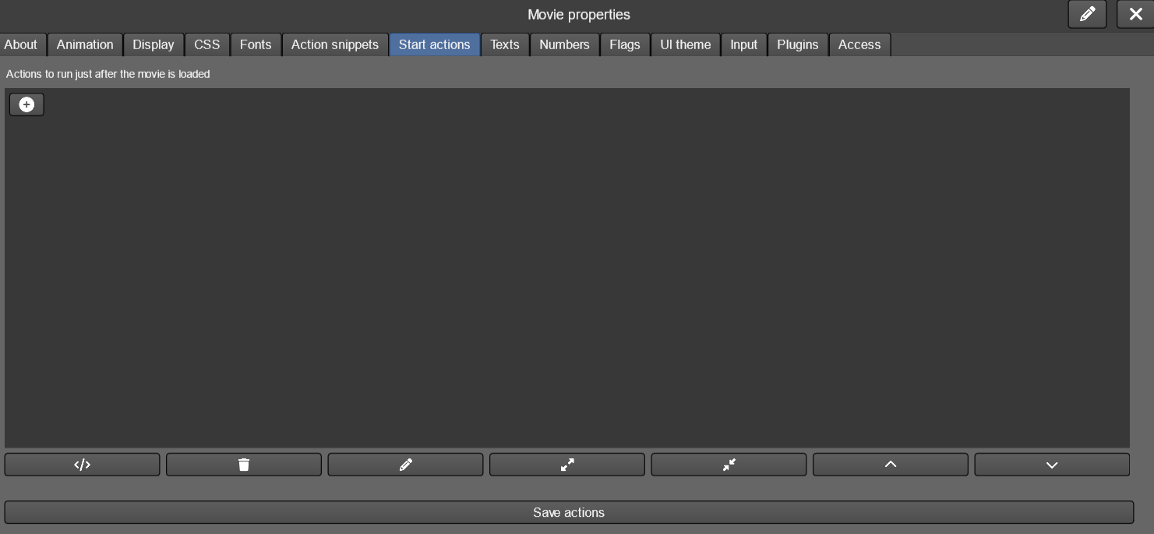

The movie properties window also gives you access to the action snippets. These are groups of actions that can be easily reused on your entire movie by calling the run command.
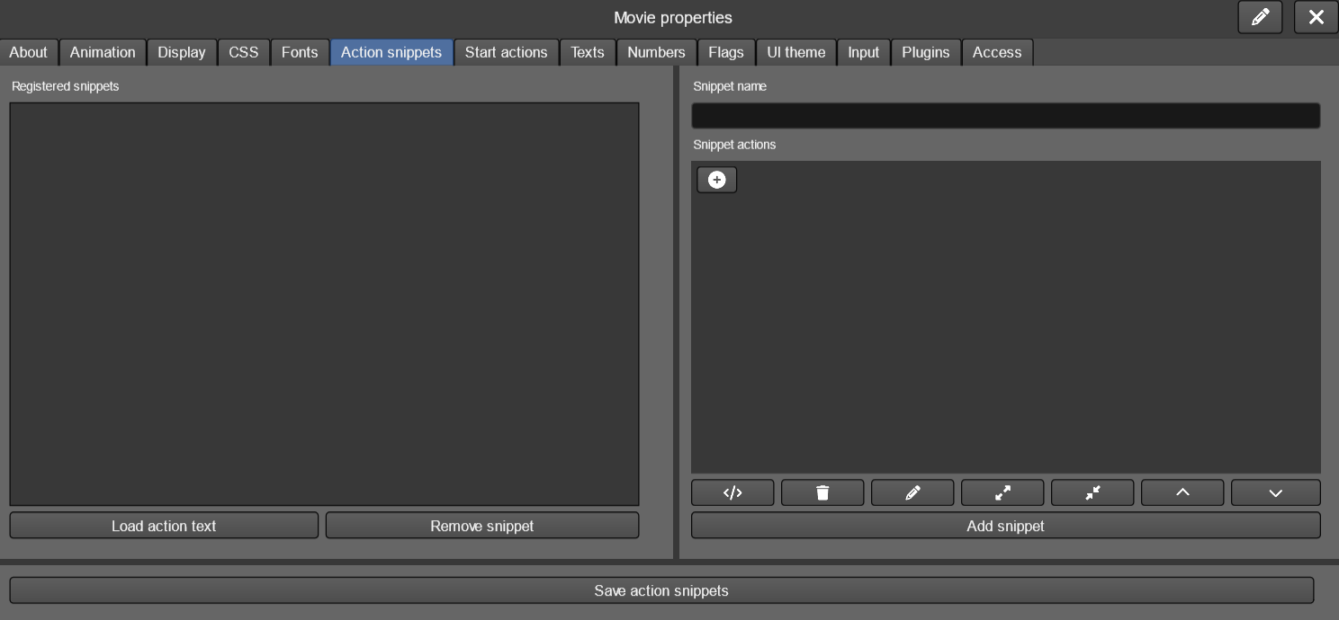

1.1.3. Scene start
You can set actions to run when a scene starts playing. Check out the Start actions tab from the Scene > Properties menu.
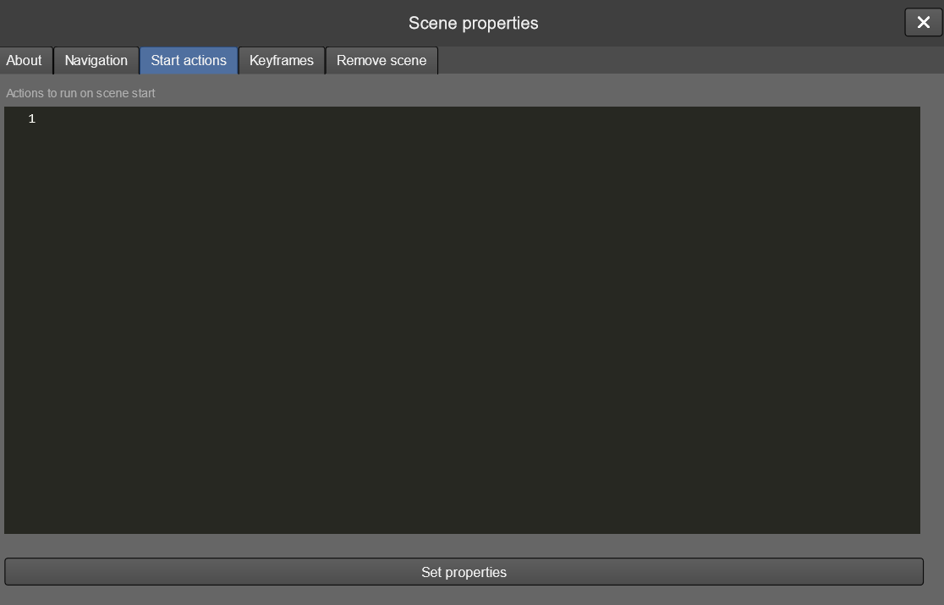

1.1.4. Keyframe end
Scenes can contain multiple keyframes. You may set actions to run at the end of each of them. You can set these actions either from the Keyframes tab of the Scene > Properties menu or the Keyframes > Manage one.
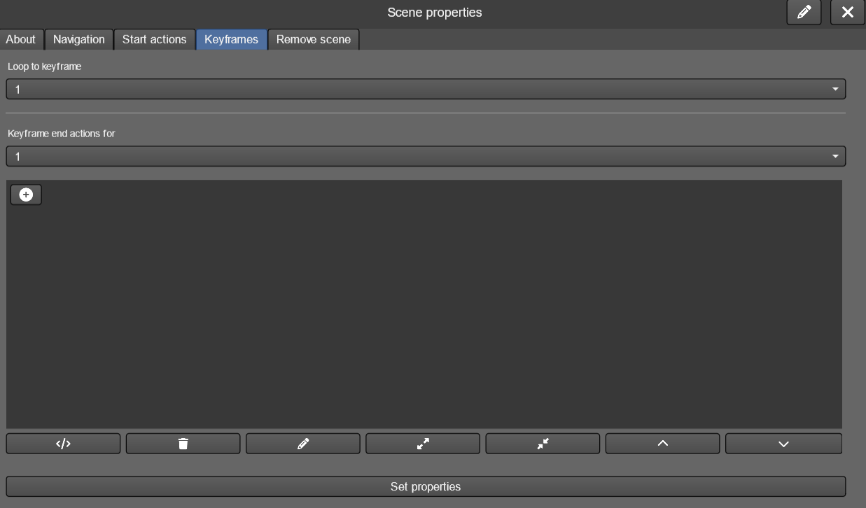

1.1.5. Media playback end
Actions triggered when a media, like a movie, finishes playing.
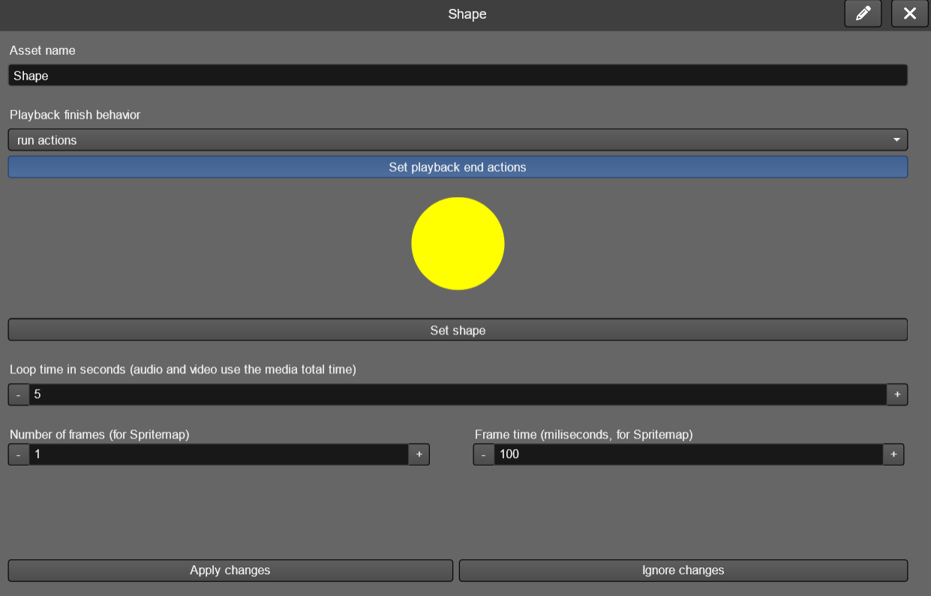

1.1.6. Timed actions
It's possible to time actions based on the playback of an instance, which can be quite useful for reacting to specific moments in a video or audio file.
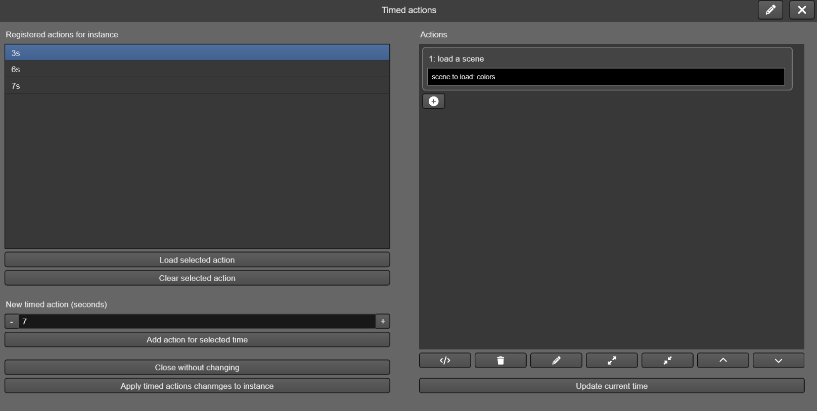

1.1.7. Inventory items
The narrative inventory tool allows the creation of items that have associated actions, triggered when activated.
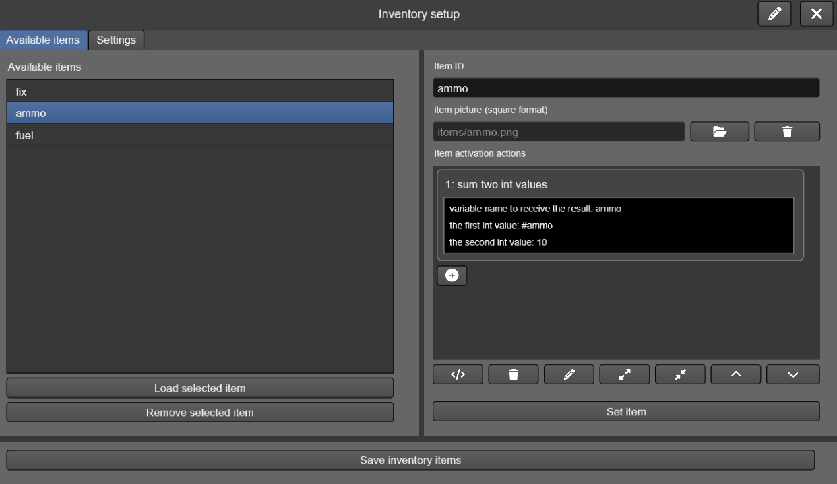

1.2. Variables
You can use variables on TilBuci actions to help design your interactions. Four variable types are available:
- Boolean
- Float
- Integer
- String
There are many actions that set the values for each of these types. The basic ones are bool.set, int.set, float.set and string.set. Every time a variable is set you can use it on any action that requires parameters of that type by using the variable name preceded by the appropriate symbol: ? for Boolean, # for integer or float and $ for string. Here are some examples:
[
{ “ac”: “bool.set”, “param”: [ “boolvar1”, “true” ] },
{
“ac”: “if.bool”,
“param”: [ “?boolvar1” ],
“then”: { “ac”: “scene.load”, “param”: [ “tilbuci” ] },
“else”: [ ]
},
{ “ac”: “int.set”, “param”: [ “intvar1”, “10” ] },
{
“ac”: “int.sum”,
“param”: [ “intvar2”, “#intvar1”, “20” ]
},
{ “ac”: “float.set”, “param”: [ “floatvar1”, “10.7” ] },
{ “ac”: “float.set”, “param”: [ “floatvar2”, “10.5” ] },
{
“ac”: “float.min”,
“param”: [ “floatvar3”, “#floatvar1”, “#floatvar2” ]
},
{ “ac”: “string.set”, “param”: [ “stringvar1”, “Til” ] },
{
“ac”: “string.concat”,
“param”: [ “stringvar2”, “$stringvar1”, “Buci” ]
}
]
When you use the # mark TilBuci will look for a float variable first and, if not found, look for an integer one. Every time a float is used on integer operations it will be rounded.

1.2.1. Initial variables
When the TilBuci runtime is loaded from a web page, it's possible to define string variables to be passed to the first movie loaded. These variables will be loaded immediately before the movie plays, and will be available right at the beginning.
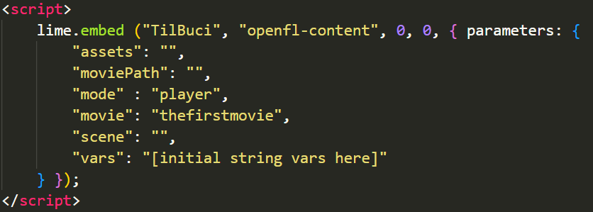
When initializing the TilBuci JavaScript file, add the "vars" parameter with the desired variables. The text describing these variables should be a JSON-formatted text with "name/value" pairs, encoded in Base64.
The "index.php" file of the TilBuci player and the original "index.html" files of all exported formats can receive a GET parameter called "vars" with this variable text - it will be automatically embedded, as in the example "https://mytilbuci.com/index.html?vars= eyJ2YXIxIjoidmFsdWUgMSIsInZhcjIiOiJ2YWx1ZSAyIn0=".
Variables (JSON-formatted text) | Vars parameter
{"var1":"value 1","var2":"value 2"} | vars= eyJ2YXIxIjoidmFsdWUgMSIsInZhcjIiOiJ2YWx1ZSAyIn0=

When using the TilBuci WordPress plugin, the "TilBuci Movie" block allows you to register up to five "custom variables" that will be sent to the player in this way.
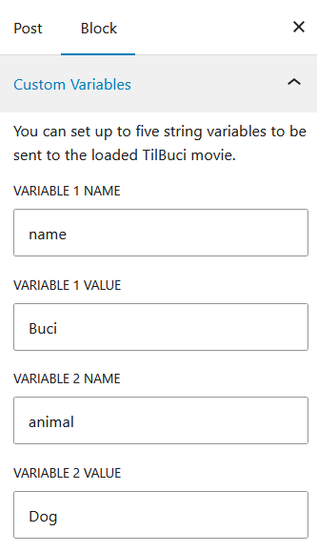

1.3. Globals
Besides the variables you can set on your own, TilBuci comes with several global values you can use on your actions to retrieve all sorts of information from the playback. You can use them just like the variables.
Some of these globals are always available, but you can also set your own per movie. Access the left menu Movie > Properties and look for the Texts, Numbers and Flags tabs.
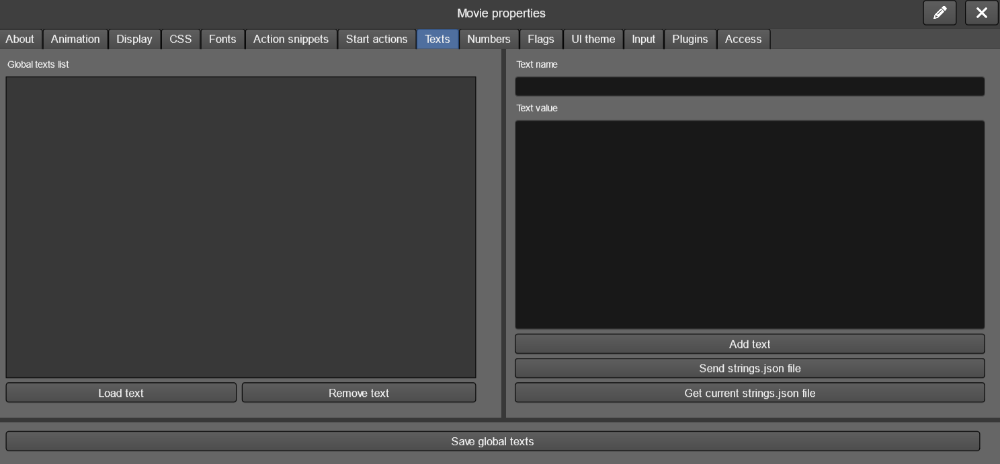

To access these globals you must use $_TEXTS:, #_NUMBERS: or ?_FLAGS:, according to the type. #_NUMBERS: can be used as both integer and float values – it will be rounded for integers. Place the global name you set after the : on your scripts, like this example:
{
“ac”: “string.set”,
“param”: [ “stringvar1”, “$_TEXTS:my global” ]
}
Another group of globals that use : to retrieve information are the ones about instance properties. Place the instance id after the : to retrieve the correct value like:
{
“ac”: “int.set”,
“param”: [ “intvar1”, “#_INSTANCEWIDTH:my instance id” ]
}
Besides these values, plugins may also define their own globals that add to the standard ones.

1.3.1. Boolean globals
General globals
?_PLAYING | Is the movie playing right now?
?_SERVER | Online server connection active?
?_USERLOGGED | Is there an user logged?
?_HADINTERACTION | Has the visitor ever interacted?

Instance globals
?_INSTANCEPLAYING | playing content?
?_INSTANCEVISIBLE | instance visible?
?_INSTANCEFONTBOLD | text set to bold?
?_INSTANCEFONTITALIC | text set to italic?

1.3.2. Number globals
General globals
#_KEYFRAME | Current keyframe number (starts on 0).
#_AREABIG | Movie “big” dimension.
#_AREASMALL | Movie “small” dimension.
#_CONTENTX | Movie display actual X position
#_CONTENTY | Movie display actual Y position
#_CONTENTWIDTH | Movie display actual width
#_CONTENTHEIGHT | Movie display actual height

Instance globals
#_INSTANCEX | x position
#_INSTANCEY | y position
#_INSTANCEWIDTH | width
#_INSTANCEHEIGHT | height
#_INSTANCEALPHA | alpha value (0 to 1.0)
#_INSTANCEVOLUME | sound volume
#_INSTANCEORDER | order index (starts on 0)
#_INSTANCECOLORALPHA | color overlay alpha (0 to 1.0)
#_INSTANCEROTATION | rotation (0 to 359, experimental)
#_INSTANCEFONTSIZE | text font size
#_INSTANCEFONTLEADING | text leading

1.3.3. Text globals
General globals
$_MOVIETITLE | Current movie title
$_MOVIEID | Current movie id
$_SCENETITLE | Current scene title
$_SCENEID | Current scene id
$_ORIENTATION | Player orientation (horizontal or vertical)
$_RENDER | Current display render mode (webgl or dom)
$_RUNTIME | The current runtime (see below for datails)
$_URLMOVIE | Url to access current movie directly
$_URLSCENE | Url to access current movie+scene directly
$_USERNAME | Logged user name (e-mail)
$_VERSION | Current TilBuci player version
$_WSSERVER | URL for the current webservice requests
$_SESSION | Current player session ID
$_YEAR | Current year as YYYY
$_MONTH | Current month as MM
$_DAY | Current day as DD
$_HOUR | Current hour as HH (24h)
$_MINUTE | Current minute as MM
$_SECOND | Current seconds as SS
$_DATE | Current date as YYYY-MM-DD
$_TIME | Current time as HH:MM:SS (24h)

The Tilbuci content can be played on different runtimes. If necessary, the $_RUNTIME global can be used to find out the current one. The possible returns are:
website | Running from an exported website
pwa | Running as a pwa application
desktop | Running from a desktop application (Windows, Linux or macOS)
mobile | Running from a mobile app (Android or iOS/iPadOS)
publish | Running from a publish service like itch.io
embed | Running form a TilBuci player embed on an OpenFL project
tilbuci | Running from the TilBuci installation (default)

Instance globals
$_INSTANCECOLOR | Overlay color (0x###### hex format)
$_INSTANCETEXT | Current text set to instance
$_INSTANCEFONT | Text font name
$_INSTANCEFONTCOLOR | Text font color (0x###### hex format)

When running a code snippet, 7 global strings are available that can be accessed in the action blocks using the global texts "$_PARAM:1" to "$_PARAM:7". If these values ​​are not set in the snippet execution call, their value will be an empty string.

1.3.4. Input values
You can create input elements using actions. Every input has an unique name that can be used to retrieve its current value, just inform the given name after the : like “$_INPUT:name”. The possible values are:

$_INPUT | text input content
$_TAREA | text area content
#_NUMERIC | numeric stepper value
?_TOGGLE | toggle input value

1.3.5. Form values
While using the form contraption, you can use these values to retrieve the data provided by the visitor using the element name, like $_FORM: name
All information is retrieved as string, even from numeric or toggle inputs. You can use TilBuci’s convert actions if needed.

1.4. Strings.json file
Another way to work with strings is the usage of a strings.json file. You may upload this file containing pairs of string variable names and values to simplify your creation. At this file, the string variables must be grouped so you can easily change their value from an user interaction (like changing language settings) – you can use any name you want for the groups. A simple strings.json file content will look like this:
{
“group1”: {
“string1”: “site name: ”,
“string2”: “site: ”
},
“group2”: {
“string1”: “nome da página: ”,
“string2”: “página: ”
},

}
Before using the strings.json content you must set the values group with the string.setgroup action, like this:
[
{ “ac”: “string.setgroup”, “param”: [ “group1” ] },
{
“ac”: “string.concat”,
“param”: [ “stringvar1”, “$string1”, “TilBuci” ]
}
]
The script above will set the value of $stringvar1 to “site name: TilBuci”. However, if you set another group, the results are different:
[
{ “ac”: “string.setgroup”, “param”: [ “group2” ] },
{
“ac”: “string.concat”,
“param”: [ “stringvar1”, “$string1”, “TilBuci” ]
}
]
In that case, the $stringvar1 value will be “nome da página: TilBuci”.

1.5. Instance text and replace
When you set a string variable (by using an action or with the strings.json file) you can also retrieve its value on instance text. When you create a paragraph image, just use the variable name (and nothing more) instead of directly input the text. It will be automatically replaced by the current value of the variable when it shows up.

1.5.1. Content replace at runtime
Besides setting a single variable to an instance, you may also set values to be automatically replaced at runtime in both instance display and action operations. There are two actions to set these replacements.
First, replace.setstring: using this action you will set string parts that will always replaced by something else, on paragraph and html instances and also on usual string operations.
[
{ “ac”: “replace.setstring”, “param”: [ “[MAIL]”, “$_USERNAME” ] },
{ “ac”: “string.set”, “param”: [ “stringvar1”, “my email is [MAIL]” ] }
]
If there is an user logged with the e-mail “doggo@tilbuci.com.br”, the $stringvar1 variable will receive the value “my email is doggo@tlbuci.com.br”. Also, if you set an html instance content to a file with “<p>the e-mail address is [MAIL]<p>”, it will be shown as “the e-mail address is doggo@tlbuci.com.br” as well.
The second automatic replace you can set affects file names used by audio, html, picture and video instances. If you call repace.setfile, every time TilBuci attempts to load a file, it will look for the needle text on the name and replace it. This can be very useful to load different assets based on user language choices. Check out this example: if you are using a picture named “en/title.png” on your movie, after you call the following action, TilBuci will load “pt/title.png” instead.
{ “ac”: “replace.setfile”, “param”: [ “en/”, “pt/” ] }

1.6. Code snippets
You can group various action blocks into groups called "snippets". This allows you to create reusable code, very similar to functions found in programming languages. For simpler creations, you can set these snippets from the movie's properties window.
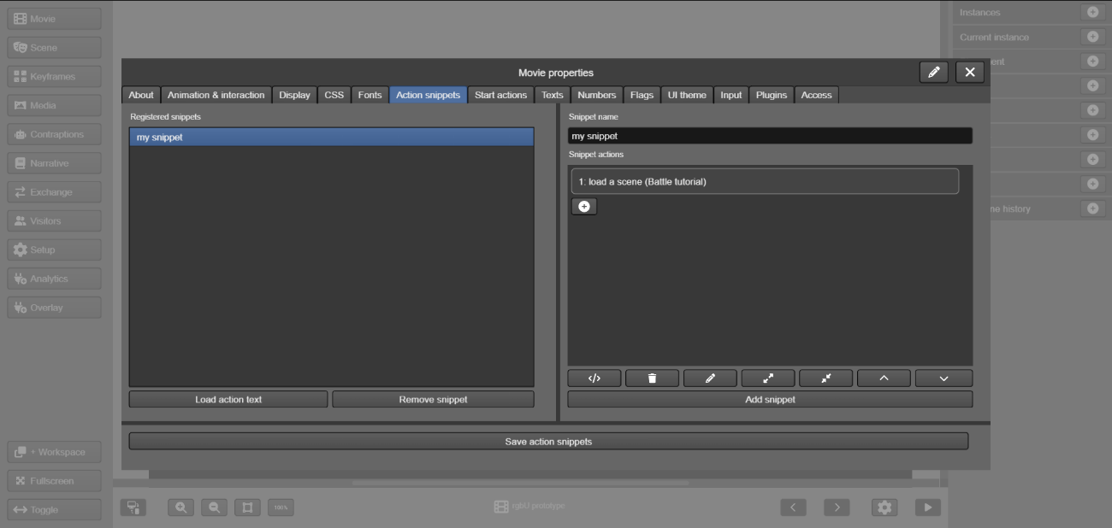
For more complex creations, you can use "dynamic code snippets", configurable from the window of the same name in the left Movie menu. In this window, you can create groups of snippets that will be dynamically loaded into your content using the "snippets.load" action. Once loaded, the snippets in the group remain available until you unload the group using the "snippets.unload" command. If a snippet has the same name in more than one group, the most recently loaded version will be used.
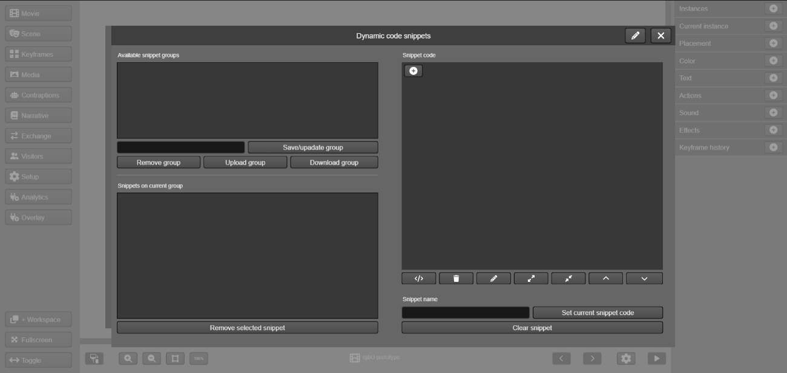
Groups of snippets can even be exported as JSON files and imported into other movies to reuse your work.

1.6.1. Snippets parameters
When you run a snippet, you can set up to 7 optional string parameters that can be accessed in your action blocks using the global texts "$_PARAM:1" to "$_PARAM:7".
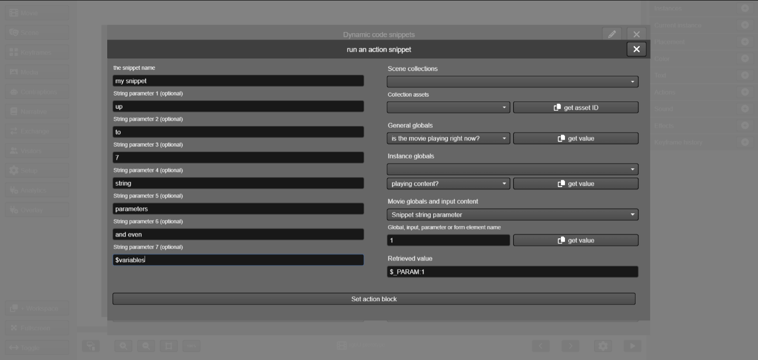

2. Available actions
Here we present a list of currently available actions on TilBuci (ac field at the action object). Please note that plugins may add additional commands to this list. Some of these actions require parameters, but even if none is needed you still must add the param field to the object. Additional optional fields can be used on some actions, like then, else, ok, cancel, tick, end, success and error.

2.1. Boolean conditions
Conditional statements based on boolean values.

if.bool
Checks if the boolean value is true.
params
- the boolean variable to check
additional optional object fields
- then: actions to run if the result is true
- else: actions to run if the result is false

if.boolset
Checks if a boolean variable exists.
params
- the variable name to check
additional optional object fields
- then: actions to run if true
- else: actions to run if false

2.2. Boolean values
Management of boolean variables.

bool.clear
Removes a boolean variable.
params
- the variable name

bool.clearall
Removes all boolean variables.

bool.set
Sets a boolean variable.
params
- the variable name
- the variable value

bool.setinverse
Inverts the value of a boolean variable.
params
- the variable name

2.3. Data
These actions handle user persistent data management. This can be done both locally on the browser storage of remotely using your server. The user must be logged in to access remote data. Logged user can still access local data. TilBuci uses a dark default theme for the load state UI, but you can adjust the colors according to your content at the UI colors tab of the Movie properties window.

data.event
Registers an event on TilBuci database at the “events” table. You may use events to record visitor interactions and keep track of your movies’ access. While the Google Analytics plugin offers a more sophisticated approach, the data.event action is easier to use and keeps the data in your own server.
All events must receive a name, and you can add as many information you want providing additional string parameters to the action call. All events are recorded with the current movie, scene and visitor information. Access the Visitor button on the left menu and go to the Event tab to download the recorded information for analysis.
If TilBuci finds an error while sending the event to the server, such as an Internet connection failure, the data is recorded locally and sent together with the next event sending action. TilBuci holds up to 100 unsent events for future sending. When exporting the events spreadsheet from the “Visitors” left menu on TilBuci editor, both the received date/time and the original one are included.
params
- the event name

data.eventclear
Clears the unsent events pool for the current movie.

data.liststates
Shows the load state window so the user can choose the one to load from the last 3 saved states on server. When loaded, the current variable values are replaced by the saved ones and the scene playing while the state was saved is loaded. All interface text must be set as text globals at the Text tab of the Movie properties window – if not set, default English strings are used. The text names you must set to avoid using default values are shown on table below. Global texts can be changed at runtime by using the string.setglobal action.
Global | Description | Default value
titlestates | Window title | Select a state to load
waistates | States load wait message | Please wait while a list of available saves states is loaded.
selectstate | Selects state message | Select a state to load.
nostates | No save states found message | Sorry, no saved states found to load.
dateformat | Date/time format string | Y-m-d h:i a  (use the PHP format described here: https://www.php.net/manual/en/datetime.format.php )

additional optional object fields
- success: actions to run after successful data load
- error: actions to run after error on data load

data.load
Loads custom data saved at the server. The loaded values replaces the variables used on data.save action.
params
- data save name
additional optional object fields
- success: actions to run after successful data load
- error: actions to run after error on data load

data.loadlocal
Loads custom data saved at the browser storage. The loaded values replaces the variables used on data.savelocal action.
params
- data save name
additional optional object fields
- success: actions to run after successful data load
- error: actions to run after error on data load

data.loadquickstate
Loads the quick state saved on the server. When loaded, the current variable values are replaced by the saved ones and the scene playing while the state was saved is loaded.
additional optional object fields
- success: actions to run after successful data load
- error: actions to run after error on data load

data.loadstatelocal
Loads the state saved on browser storage. When loaded, the current variable values are replaced by the saved ones and the scene playing while the state was saved is loaded.
additional optional object fields
- success: actions to run after successful data load
- error: actions to run after error on data load

data.save
Saves custom data at the server. At least two parameters are required, but you can add as many as you want to be saved under the same name. Each saved value must be the name of an already set variable, preceded by its type, like in the following table.
Variable type | Prefix | Example
boolean | B: | B:boolvar1
float | F: | F:floatvar1
integer | I: | I:intvar1
string | S: | S:stringvar1

params
- data save name
- first variable to save
additional optional object fields
- success: actions to run after successful data save
- error: actions to run after error on data save

data.savelocal
Saves custom data at the browser storage. At least two parameters are required, but you can add as many as you want to be saved under the same name. Each saved value must be the name of an already set variable, preceded by its type, like in the following table.
Variable type | Prefix | Example
boolean | B: | B:boolvar1
float | F: | F:floatvar1
integer | I: | I:intvar1
string | S: | S:stringvar1

params
- data save name
- first variable to save
additional optional object fields
- success: actions to run after successful data save
- error: actions to run after error on data save

data.savequickstate
Quickly saves all current variable values as well the current scene playing on the server. Saving a quick save overrides the previously saved one for current user/movie.
additional optional object fields
- success: actions to run after successful data save
- error: actions to run after error on data save

data.savestate
Saves all current variable values as well the current scene playing on the server. The server holds up to 3 save states for each user on each movie, besides the quick save.
params
- state title (for reference while loading)
additional optional object fields
- success: actions to run after successful data save
- error: actions to run after error on data save

data.savestatelocal
Saves all current variable values as well the current scene playing on the browser storage. The browser can hold only one state per movie.
additional optional object fields
- success: actions to run after successful data save
- error: actions to run after error on data save

2.4. Float conditions
Conditional statements based on float values.

if.floatsdifferent
Checks if the two float values are different.
params
- first value
- second value
additional optional object fields
- then: actions to run if the result is true
- else: actions to run if the result is false

if.floatsequal
Checks if the two float values are equal.
params
- first value
- second value
additional optional object fields
- then: actions to run if the result is true
- else: actions to run if the result is false

if.floatset
Checks if a float variable exists.
params
- the variable name to check
additional optional object fields
- then: actions to run if true
- else: actions to run if false

if.floatgreater
Checks if the first value is greater than the second one.
params
- first value
- second value
additional optional object fields
- then: actions to run if the result is true
- else: actions to run if the result is false

if.floatgreaterequal
Checks if the first value is greater or equal than the second one.
params
- first value
- second value
additional optional object fields
- then: actions to run if the result is true
- else: actions to run if the result is false

if.floatlower
Checks if the first value is lower than the second one.
params
- first value
- second value
additional optional object fields
- then: actions to run if the result is true
- else: actions to run if the result is false

if.floatlowerequal
Checks if the first value is lower or equal than the second one.
params
- first value
- second value
additional optional object fields
- then: actions to run if the result is true
- else: actions to run if the result is false

2.5. Float values
Management of float variables.

float.abs
Returns the absolue value of a float.
params
- the variable name to receive the result
- the value

float.clear
Removes a float variable.
params
- the variable name

float.clearall
Removes all float variables.

float.divide
Divides two or more float values. At least 3 parameters are required but you can provide as many as you want and their values are sequentially divided.
params
- the variable name to receive the result
- the first value
- the second value

float.max
Returns the maximum between two float values.
params
- the variable name to receive the result
- the first value
- the second value

float.min
Returns the minimum between two float values.
params
- the variable name to receive the result
- the first value
- the second value

float.multiply
Multiplies two or more float values. At least 3 parameters are required but you can provide as many as you want and their values are values are sequentially multiplied.
params
- the variable name to receive the result
- the first value
- the second value

float.random
Generates a random float value.
params
- the variable name to receive the rando value
- minimum value
- maximum value

float.set
Sets a float variable.
params
- the variable name
- the variable value

float.subtract
Subtracts two or more float values. At least 3 parameters are required but you can provide as many as you want and their values are subtracted from the result.
params
- the variable name to receive the result
- the first value
- the second value

float.sum
Sums two or more float values. At least 3 parameters are required but you can provide as many as you want and their values are add to the result.
params
- the variable name to receive the result
- the first value
- the second value

float.toint
Converts a float value to an int one (rounds).
params
- the int variable name to receive the result
- the float value

float.tostring
Converts a float value to a string.
params
- the string variable name to receive the result
- the float value

2.6. Input
These actions asks for user input to use on the movie. TilBuci uses a dark default theme for input UI, but you can adjust the colors according to your content at the UI theme tab of the Movie properties window.
Besides the preferred input boxes you may add input elements right into your design using actions. These inputs appear over any graphics on your scene and must also be removed using actions (they do not automatically disappear when a new scene is loaded). The size/place given is relative to your content. These elements also respect the UI theme settings of your movie.

input.email
Shows a text input window the ckecks for a valid e-mail address on confirmation. You may also add buttons to include common e-mail service domains like “@gmail.com” – just add additional string parameters.
params
- string variable name to get the resulting e-mail address
- text to display on input window
- common email service domain, like “@hotmail.com” (optional)
additional optional object fields
- ok: actions to run after user clicks on ok
- cancel: actions to run after user click on cancel

input.float
Shows a dialog window asking for a float input.
params
- float variable name to get the resulting input
- text to display on input window
- numeric stepper step value
- minimum input value
- maximum input value
additional optional object fields
- ok: actions to run after user clicks on ok
- cancel: actions to run after user click on cancel

input.int
Shows a dialog window asking for an int input.
params
- int variable name to get the resulting input
- text to display on input window
- numeric stepper step value
- minimum input value
- maximum input value
additional optional object fields
- ok: actions to run after user clicks on ok
- cancel: actions to run after user click on cancel

input.list
Presents a list to the user asking for a selection. You must provide at least 4 parameters, but you may add as many as you want – they will be add as additional item options. The returned value is the text of the option selected.
params
- string variable name to get the resulting input
- text to display on input window
- first list option
- second list option
additional optional object fields
- ok: actions to run after user clicks on ok
- cancel: actions to run after user click on cancel

input.login
Starts the user login procedure. Login is done by sending a confirmation code to the provided e-mail address. All interface text must be set as text globals at the Text tab of the Movie properties window – if not set default English strings are used. The text names you must set to avoid using default values are shown on table below. Global texts can be changed at runtime by using the string.setglobal action.
Global | Description | Default value
logintitle | Window title | Login
logintext | Window message | Please type your e-mail address. You'll receive a 6 digit code to confirm your identity.
termsagree | Terms agree message | I agree with the above terms.
invalidemail | Invalid email address input | Please provide a valid e-mail address.
emailwait | Processing message | Please wait while a confirmation code is sent to your e-mail.
noemailsent | Send email error message | Error while sending the code by e-mail. Please try again.
checkforcode | Code check instructions | Please check out your e-mail inbox. Type below the 6 digit code you received. If you do not find the message, take a look at you spam folder.
codewait | Code check processing | Please wait while the provided code is checked.
invalidcode | Invalid code message | The provided code is invalid. Please try again.
emailsubject | E-mail message subject | TilBuci login
emailbody | E-mail message body | Hi, you are receiving this message to confirm your login at TilBuci. Please provide the code below to proceed:\r\n\r\n[CODE]\r\n\r\nIf you did'nt request this code, don't worry: just ignore this message.
emailsender | E-mail sender name | TilBuci

additional optional object fields
- ok: actions to run after user clicks on ok
- cancel: actions to run after user click on cancel

input.message
Shows a message to the user asking for confirmation. If no cancel action is set, the window will only show the ok button.
params
- window title
- window text
additional optional object fields
- ok: actions to run after user clicks on ok
- cancel: actions to run after user click on cancel

input.string
Shows a dialog window asking for a string input.
params
- string variable name to get the resulting input
- text to display on input window
additional optional object fields
- ok: actions to run after user clicks on ok
- cancel: actions to run after user click on cancel

input.add
Adds a text input element into your screen.
params
- the input name
- the x position
- the y position
- the width (height is automatically set from the font size of UI theme)
- (optional) placeholder to show when no text is set

input.place
Sets a text input placement.
params
- the input name
- the x position
- the y position
- the width (height is automatically set from the font size of UI theme)

input.remove
Removes a text input from screen.
params
- the input name

input.removeall
Removes all text inputs from screen.

input.settext
Sets the text of a text input element.
params
- the input name
- the new text

input.setpassword
Sets a text input password mask display
params
- the input name
- show as password? (true/false)

input.addtarea
Adds a text area element into your screen.
params
- the text area name
- the x position
- the y position
- the width
- the height

input.placetarea
Sets a text area placement.
params
- the text area name
- the x position
- the y position
- the width
- the height

input.removetarea
Removes a text area from screen.
params
- the text area name

input.removealltareas
Removes all text areas from screen.

input.settextarea
Sets the content of a text area element.
params
- the text area name
- the new text

input.addnumeric
Adds a numeric stepper input element into your screen.
params
- the input name
- the initial value
- the minimum value
- the maximum value
- the increase/decrease step

input.placenumeric
Sets a numeric stepper input placement.
params
- the input name
- the x position
- the y position
- the width (height is automatically set from the font size of UI theme)

input.removenumeric
Removes a numeric stepper input from screen.
params
- the input name

input.removeallnumerics
Removes all numeric stepper inputs from screen.

input.setnumeric
Sets the value of a numeric stepper input element.
params
- the input name
- the new value

input.setnumericbounds
Sets a numeric stepper bounds.
params
- the input name
- minimum value
- maximum value
- increase/decrease step

input.addtoggle
Adds a toggle stepper input element into your screen.
params
- the input name
- toggle selected?
- X position
- Y position

input.placetoggle
Sets a toggle input placement.
params
- the input name
- the x position
- the y position

input.removetoggle
Removes a toggle input from screen.
params
- the input name

input.removealltoggles
Removes all toggle inputs from screen.

input.settoggle
Sets the value of a toggle input element.
params
- the input name
- the new value

input.inverttoggle
Inverts a toggle input value.
params
- the input name

2.7. Instance

instance.clearall
Clears any previously set value (instance returns to design setting).
param
- instance id

instance.clearalpha
Clears previously set alpha value (instance returns to design setting).
param
- instance id

instance.clearcolor
Clears previously set color overlay value (instance returns to design setting).
param
- instance id

instance.clearcoloralpha
Clears previously set overlay alpha value (instance returns to design setting).
param
- instance id

instance.clearfont
Clears previously set font face name value (instance returns to design setting).
param
- instance id

instance.clearfontalign
Clears previously set text align value (instance returns to design setting).
param
- instance id

instance.clearfontbackground
Clears previously set font background value (instance returns to design setting).
param
- instance id

instance.clearfontbold
Clears previously set font bold state value (instance returns to design setting).
param
- instance id

instance.clearfontcolor
Clears previously set font color value (instance returns to design setting).
param
- instance id

instance.clearfontitalic
Clears previously set font italic state value (instance returns to design setting).
param
- instance id

instance.clearfontleading
Clears previously set font leading value (instance returns to design setting).
param
- instance id

instance.clearfontsize
Clears previously set font size value (instance returns to design setting).
param
- instance id

instance.clearheight
Clears previously set height value (instance returns to design setting).
param
- instance id

instance.clearorder
Clears previously set order value (instance returns to design setting).
param
- instance id

instance.clearrotation
Clears previously set rotation value (instance returns to design setting - experimental).
param
- instance id

instance.clearvisible
Clears previously set visible state (instance returns to design setting).
param
- instance id

instance.clearvolume
Clears previously set sound volume value (instance returns to design setting).
param
- instance id

instance.clearwidth
Clears previously set width value (instance returns to design setting).
param
- instance id

instance.clearx
Clears previously set x value (instance returns to design setting).
param
- instance id

instance.cleary
Clears previously set y value (instance returns to design setting).
param
- instance id

instance.loadasset
Loads a collection asset into the instance.
param
- instance id
- new asset id to load

instance.next
Load the next collection item on instance.
param
- instance id

instance.pause
Pauses an instance content.
param
- instance id

instance.play
Plays an instance content.
param
- instance id

instance.playpause
Plays an instance content if it is paused, pauses it otherwise.
param
- instance id

instance.previous
Load the previous collection item on instance.
param
- instance id

instance.scrollbottom
Scrolls text to bottom.
param
- instance id

instance.scrolldown
Scrolls text down.
param
- instance id

instance.scrolltop
Scrolls text to top.
param
- instance id

instance.scrollup
Scrolls text up.
param
- instance id

instance.seek
Jumps an instance to a time position (integer, seconds).
param
- instance id
- time position

instance.setalpha
Changes the instance alpha level (0 to 1.0).
param
- instance id
- new value for horizontal display
- new value for vertical display (optional)

instance.setcolor
Changes the instance overlay color (0x###### hex format).
param
- instance id
- new value for horizontal display
- new value for vertical display (optional)

instance.setcoloralpha
Changes the instance color overlay alpha level (0 to 1.0).
param
- instance id
- new value for horizontal display
- new value for vertical display (optional)

instance.setfont
Changes the instance font face name.
param
- instance id
- new value for horizontal display
- new value for vertical display (optional)

instance.setfontalign
Changes the instance alignment (left, right, center or justify).
param
- instance id
- new value for horizontal display
- new value for vertical display (optional)

instance.setfontbackground
Changes the instance font background color (0x###### hex format, empty string for none).
param
- instance id
- new value for horizontal display
- new value for vertical display (optional)

instance.setfontbold
Changes the instance font to bold (boolean).
param
- instance id
- new value for horizontal display
- new value for vertical display (optional)

instance.setfontcolor
Changes the instance text font color (0x###### hex format).
param
- instance id
- new value for horizontal display
- new value for vertical display (optional)

instance.setfontitalic
Changes the instance font to italic (boolean).
param
- instance id
- new value for horizontal display
- new value for vertical display (optional)

instance.setfontleading
Changes the instance font leading space (integer).
param
- instance id
- new value for horizontal display
- new value for vertical display (optional)

instance.setfontsize
Changes the instance text font size (int value).
param
- instance id
- new value for horizontal display
- new value for vertical display (optional)

instance.setheight
Changes the instance height size (numeric).
param
- instance id
- new value for horizontal display
- new value for vertical display (optional)

instance.setorder
Changes the instance order on display list (int value).
param
- instance id
- new value for horizontal display
- new value for vertical display (optional)

instance.setparagraph
Sets a paragraph instance content.
param
- instance id
- new text

instance.setrotation
Changes the instance rotation (experimental).
param
- instance id
- new value for horizontal display
- new value for vertical display (optional)

instance.setvisible
Changes the instance visible state (boolean).
param
- instance id
- new value for horizontal display
- new value for vertical display (optional)

instance.setvolume
Changes the instance sound volume (0 to 1.0).
param
- instance id
- new value for horizontal display
- new value for vertical display (optional)

instance.setwidth
Changes the instance width size (numeric).
param
- instance id
- new value for horizontal display
- new value for vertical display (optional)

instance.setx
Changes the instance x position (numeric).
param
- instance id
- new value for horizontal display
- new value for vertical display (optional)

instance.sety
Changes the instance y position (numeric).
param
- instance id
- new value for horizontal display
- new value for vertical display (optional)

instance.stop
Stops an instance playback.
param
- instance id

instance.zoom
[consider using instance.morezoom and instance.lesszoom that provide better results] Enlarges the instance content to cover the stage. Works on picture and video content. The enlarged content will be hidden on user click.
param
- instance id

instance.morezoom
Increases the zoom display of an instance from its center – the instance remains on place.
param
- instance id
- the zoom amount (in %)

instance.lesszoom
Decreases the zoom display of an instance from its center – the instance remains on place.
param
- instance id
- the zoom amount (in %)

instance.clearzoom
Removes all zoom applied to an instance and places it on the original position.
param
- instance id

instance.moveup
Moves an instance up on display.
param
- instance id
- the amount to move

instance.movedown
Moves an instance down on display.
param
- instance id
- the amount to move

instance.moveleft
Moves an instance left on display.
param
- instance id
- the amount to move

instance.moveright
Moves an instance right on display.
param
- instance id
- the amount to move

instance.clearmove
Places an instance on display on its design position.
param
- instance id

instance.startdrag
Grabs the instance and moves it following the mouse cursor or the target. The instance remains in drag mode until the mouse click/touch ends, the target trigger button is pressed again or the instance.stopdrag action is called. Warning: only use this action on the instance trigger event.
param
- instance id
additional optional object fields
- complete: actions to run when the instance is released from drag

instance.stopdrag
Stops any instance dragging.

instance.isoverlapping
Checks if one instance is overlapping another. Useful for verifying the status of an instance after the drag has finished.
param
- first instance id
- second instance id
additional optional object fields
- then: actions to run if the instances are overlapping
- else: actions to run if the instances are not overlapping

2.8. Integer conditions
Conditional statements based on integer values.

if.intsdifferent
Checks if the two int values are different.
params
- first value
- second value
additional optional object fields
- then: actions to run if the result is true
- else: actions to run if the result is false

if.intsequal
Checks if the two int values are equal.
params
- first value
- second value
additional optional object fields
- then: actions to run if the result is true
- else: actions to run if the result is false

if.intset
Checks if an int variable exists.
params
- the variable name to check
additional optional object fields
- then: actions to run if true
- else: actions to run if false

if.intgreater
Checks if the first value is greater than the second one.
params
- first value
- second value
additional optional object fields
- then: actions to run if the result is true
- else: actions to run if the result is false

if.intgreaterequal
Checks if the first value is greater or equal than the second one.
params
- first value
- second value
additional optional object fields
- then: actions to run if the result is true
- else: actions to run if the result is false

if.intlower
Checks if the first value is lower than the second one.
params
- first value
- second value
additional optional object fields
- then: actions to run if the result is true
- else: actions to run if the result is false

if.intlowerequal
Checks if the first value is lower or equal than the second one.
params
- first value
- second value
additional optional object fields
- then: actions to run if the result is true
- else: actions to run if the result is false

int.switch
Compare the value of an integer with a list of possibilities.
params
- the integer value to compare
additional object fields
- case: list of comparisons (int.switchcase or int.switchdefault)

int.switchcase
Compares a value to the one in switch block.
params
- the integer values to check
additional object fields
- then: actions to run if the values match

int.switchdefault
Set actions to run of no match are found on a switch block.
additional object fields
- then: actions to run if the values match

2.9. Integer values
Management of integer variables.

int.abs
Returns the absolue value of an int.
params
- the variable name to receive the result
- the value

int.clear
Removes an int variable.
params
- the variable name

int.clearall
Removes all int variables.

int.divide
Divides two or more int values. At least 3 parameters are required but you can provide as many as you want and their values are sequentially divided.
params
- the variable name to receive the result
- the first value
- the second value

int.max
Returns the maximum between two int values.
params
- the variable name to receive the result
- the first value
- the second value

int.min
Returns the minimum between two int values.
params
- the variable name to receive the result
- the first value
- the second value

int.multiply
Multiplies two or more int values. At least 3 parameters are required but you can provide as many as you want and their values are values are sequentially multiplied.
params
- the variable name to receive the result
- the first value
- the second value

int.random
Generates a random int value.
params
- the variable name to receive the rando value
- minimum value
- maximum value

int.set
Sets an int variable.
params
- the variable name
- the variable value

int.subtract
Subtracts two or more int values. At least 3 parameters are required but you can provide as many as you want and their values are subtracted from the result.
params
- the variable name to receive the result
- the first value
- the second value

int.sum
Sums two or more int values. At least 3 parameters are required but you can provide as many as you want and their values are add to the result.
params
- the variable name to receive the result
- the first value
- the second value

int.tofloat
Converts an int value to a float one.
params
- the float variable name to receive the result
- the int value

int.tostring
Converts an intvalue to a string.
params
- the string variable name to receive the result
- the int value

2.10. Mouse

mouse.hide
Hides the mouse cursor above the content area.

mouse.show
Displays the mouse cursor above the content area again.

2.11. Movie

movie.load
Loads a new movie into player.
params
- new movie id

2.12. Replace
Use these actions to set automatic replaced both in string processing an file naming.

replace.clearfile
Removes a file replacement.
params
- the needle (text to search) to remove

replace.clearstring
Removes a string replacement.
params
- the needle (text to search) to remove

replace.clearallfiles
Clears all file replacement needles.

replace.clearallstrings
Clears all string replacement needles.

replace.origin
Replaces the current movie images origin set while loading scenes/keyframes. Possible values are “alpha”, “center”, “top”, “topkeep”, “bottom”, “bottomkeep”, “left”, “leftkeep”, “right” and “rightkeep”.
params
- the new origin

replace.setfile
Sets a needle that will replace of its occurrences on loaded file names.
params
- the needle (text to search)
- the string to replace the needle on file names

replace.setstring
Sets a needle that will replace of its occurrences by the value given in both string processing and text display.
params
- the needle (text to search)
- the string to replace the needle

if.replacefileset
Checks if a file replacement exists.
params
- the replacement name to check
additional optional object fields
- then: actions to run if true
- else: actions to run if false

if.replacestringset
Checks if a string replacement exists.
params
- the replacement name to check
additional optional object fields
- then: actions to run if true
- else: actions to run if false

2.13. Runtime

runtime.ifbrowser
Check if the content is running from a browser (TilBuci player, web or PWA runtimes).
additional optional object fields
- then: actions to run if true
- else: actions to run if false

runtime.install
Installs the content as a native application.
Available on PWA runtime only.

runtime.quit
Ends the content execution.
Available on desktop app runtime only.

runtime.savedata
Saves the values of all current variables into an encrypted file. If running from a browser or as a mobile app, the file is downloaded to the device. If running from a desktop app, the file is automatically saved into the user’s data folder.
params
- the file name (.movieid will be add at the name end)

runtime.loaddata
Loads an encrypted variables file into memory. If running from a browser or as a mobile app, a file selection dialogue will appear. If running from a desktop app, the file is automatically loaded from the user’s data folder.
params
- the file name (.movieid will be add at the name end)
additional optional object fields
- success: the file was loaded and the variable values recovered
- error: the file couldn’t be loaded

runtime.ifdataexist
Checks if a variables data file exists on the user’s data folder.
Available on desktop app runtime only.
params
- the file name (.movieid will be add at the name end)

runtime.startkiosk
Starts kiosk display mode (available for desktop and mobile apps).

runtime.endkiosk
Closes kiosk display mode (available for desktop and mobile apps).

2.14. Scene

scene.load
Loads a new scene.
params
- new scene id

scene.navigate
Loads the scene set at the navigation settings of the current one.
params
- the navigation direction: up, down, left, right, nin or nout

scene.pause
Pauses the current scene playback.

scene.play
Plays the current scene.

scene.playpause
Plays a stopped scene or pauses a playing one.

scene.nextkeyframe
Loads the next keyframe of a paused scene.

scene.previouskeyframe
Loads the previous keyframe of a paused scene.

scene.loadfirstkeyframe
Loads the first keyframe of a paused scene.

scene.loadlastkeyframe
Loads the last keyframe of a paused scene.

scene.loadkeyframe
Loads a keyframe from a paused scene.
params
- the keyframe number to load (keyframe numbers start at 1)

scene.historyback
Loads the previously displayed scene (the history of loaded scenes is erased when adding a new movie).

scene.shake
Shakes the entire scene display.
params
- shake effect duration in seconds (you may use float values like 1.5)
- effect intensity
additional optional object fields
- end: actions to run when the effect ends

scene.zoomset
Sets the zoom size of the current scene display.
params
- the zoom amount (in % of original size)

scene.zoomreset
Sets the scene zoom size to the original (100%).

scene.zoomincrease
Increases the current scene zoom size.
params
- the zoom amount to increase (in % of original size)

scene.zoomdecrease
Decreases the current scene zoom size.
params
- the zoom amount to decrease (in % of original size)

scene.reset
Resets the scene display zoom and position to the original values.

scene.movecenter
Moves the scene display to the center of the screen.

scene.movetop
Moves the scene display to the top of the screen.

scene.movebottom
Moves the scene display to the bottom of the screen.

scene.moveleft
Moves the scene display to the left of the screen.

scene.moveright
Moves the scene display to the right of the screen.

scene.movereset
resets the scene display position.

scene.move
Moves the scene display around the screen.
params
- the horizontal amount to move (in % of the scene width, can be negative)
- the vertical amount to mode (in % of the scene height, can be negative)

2.15. Snippets
Action snippets can be set at the Action snippets tab of the Movie properties window and also at the Dynamic snippets window form the left Movie menu. Check out the section 1.6 of this document to learn more about action snippets.

run
Runs a named action (code snippet).
params
- action snippet name
- optional string parameter 1
- optional string parameter 2
- optional string parameter 3
- optional string parameter 4
- optional string parameter 5
- optional string parameter 6
- optional string parameter 7

snippets.load
Loads a dynamic snippets group.
params
- action snippet group name
additional optional object fields
- success: actions to run when the snippets group is loaded
- error: actions to run on loading error

snippets.unload
Unloads a dynamic snippets group.
params
- action snippet group name

2.16. String conditions
Conditional statements based on string values.

if.stringcontains
Checks if the first string contains the second one.
params
- first string to compare
- second string to compare
additional optional object fields
- then: actions to run if the string contains the other one
- else: actions to run if the string does not contain the other one

if.stringendswith
Checks if the first string ends with the second one.
params
- first string to compare
- second string to compare
additional optional object fields
- then: actions to run if the string ends with the other one
- else: actions to run if the string does not end with the other one

if.stringsdifferent
Checks if two strings are different.
params
- first string to compare
- second string to compare
additional optional object fields
- then: actions to run if the strings are different
- else: actions to run if the strings are equal

if.stringsequal
Checks if two strings are equal.
params
- first string to compare
- second string to compare
additional optional object fields
- then: actions to run if the strings are equal
- else: actions to run if the strings are different

if.stringset
Checks if a string variable exists.
params
- the variable name to check
additional optional object fields
- then: actions to run if true
- else: actions to run if false

if.stringstartswith
Checks if the first string starts with the second one.
params
- first string to compare
- second string to compare
additional optional object fields
- then: actions to run if the string starts with the other one
- else: actions to run if the string does not start with the other one

if.stringemail
Checks if the strig is a valid e-mail address.
params
- the address to check
additional optional object fields
- then: actions to run if the string is a valid email
- else: actions to run if the string isn’t a valid email

string.switch
Compare the value of a string with a list of possibilities.
params
- the string value to compare
additional object fields
- case: list of comparisons (string.switchcase or string.switchdefault)

string.switchcase
Compares a value to the one in switch block.
params
- the string value to check
additional object fields
- then: actions to run if the values match

string.switchdefault
Set actions to run of no match are found on a switch block.
additional object fields
- then: actions to run if the values match

2.17. String values
Management of string variables.

string.clear
Removes a string variable.
params
- the variable name

string.clearall
Removes all string variables.

string.clearglobal
Clears a text global.
params
- the global name

string.concat
Concatenates two or more strings. Three parameters are required. Each additional one will be concatenated at the string end. You can use any type of variable (string, int, float or bool) – the value will be automatically converted to string.
params
- the variable name to receive the concatenated one
- the first string to concatenate
- the second string to concatenate

string.replace
Replaces all occurrences of the needle string by the given one at the provided text.
params
- the variable name to receive the replace result
- the original string
- the needle (string to look for)
- the replacement text

string.set
Sets a string variable.
params
- the variable name
- the variable value

string.setglobal
Sets a text global.
params
- the global name
- the global value

string.setgroup
Sets a group of the strings.json file to look for string variable values.
params
- the group name

string.tofloat
Converts a string value to a float one.
params
- the float variable name to receive the result
- the string to convert

string.toint
Converts a string value to an integer one.
params
- the integer variable name to receive the result
- the string to convert

2.18. System

system.copytext
Copies a string into the user clipboard.
params
- the string to copy

system.fullscreen
Shows the content at fullscreen or brings back the display to normal state. Please note that you must trigger this action only on an user interaction. It won’t work on movie/scene/keyframe actions due to browser policies. No parameters are required.

system.visitoringroup
Checks if the current logged visitor is part of a give group. If no visitor is currently logged, always return false.
params
- the group name to check (case sensitive)
additional optional object fields
- then: actions to run if the visitor belongs to the provided group
- else: actions to run if the visitor is not in the group or if no visitor is logged at all

system.logout
Logs out the current user.

system.openembed
Opens an overlay with a previously embedded HTML5 content (access Media > Embed on the left menu to send the HTM5 content to embed).
params
- the embed name used when sending the content
Embed content can exchange information with the host movie using javascript methods. Since the embed content is displayed using an iframe, all melhods must be called from “parent”.
parent.tilbuci_getstring($name) | gets the current value of the $name variable (empty string if it is not set)
parent.tilbuci_setstring($name, $value) | sets the value of the string variable $name
parent.tilbuci_getfloat($name) | gets the current value of the $name variable (0 if it is not set)
parent.tilbuci_setfloat($name, #value) | sets the value of the float variable $name
parent.tilbuci_getint($name) | gets the current value of the $name variable (0 if it is not set)
parent.tilbuci_setint($name, #value) | sets the value of the integer variable $name
parent.tilbuci_getbool($name) | gets the current value of the $name variable (false if it is not set)
parent.tilbuci_setbool($name, ?value) | sets the value of the boolean variable $name
parent.tilbuci_runaction($action) | runs any json-formatted action on movie

system.closeembed
Closes the HTML5 embed content display.

system.embedreset
Resets the HTML5 embed display site and position so it appears covering all display area.

system.embedplace
Sets the position and size of the HTML5 embed content area. The placement values are absolute, considering the entire stage, not only your movie display area. Because of that, the #_CONTENTX, #_CONTENTY, #_CONTENTWIDTH and #_CONTENTHEIGHT values can be useful to help figuring out the desired values.
params
- x position
- y position
- width
- height

system.openurl
Opens an URL on user browser.
params
- the UL to open

system.sendevent
Sends a custom event (TilBuciEvent.EVENT) to everyone listening to the player object. The event info field will be filled with any string parameters you add to this action.

system.setkftime
Sets the time between keyframes in milliseconds. Values lower than 250 will be ignored.
params
- the new time between keyframes in milliseconds

system.ifhorizontal
Checks if the current display orientation is horizontal.
additional optional object fields
- then: actions to run if true
- else: actions to run if false

system.ifvertical
Checks if the current display orientation is vertical.
additional optional object fields
- then: actions to run if true
- else: actions to run if false

system.ifwebsite
Checks if running from the website export runtime.
additional optional object fields
- then: actions to run if true
- else: actions to run if false

system.ifpwa
Checks if running from the PWA export runtime.
additional optional object fields
- then: actions to run if true
- else: actions to run if false

system.ifpwainstalled
Checks if running from an installed PWA.
additional optional object fields
- then: actions to run if true
- else: actions to run if false

system.ifdesktop
Checks if running from the desktop app export runtime.
additional optional object fields
- then: actions to run if true
- else: actions to run if false

system.ifmobile
Checks if running from the mobile app export runtime.
additional optional object fields
- then: actions to run if true
- else: actions to run if false

system.ifpublish
Checks if running from the publish services export runtime.
additional optional object fields
- then: actions to run if true
- else: actions to run if false

system.ifplayer
Checks if running from the standard TilBuci player.
additional optional object fields
- then: actions to run if true
- else: actions to run if false

2.19. Target
The target can be used for navigation using the keyboard or a game controller. It replaces the mouse cursor.

target.show
Starts the target navigation, showing the target graphic at the center of the screen.

target.hide
Stops the target navigation, hiding the target graphic.

target.toggle
Alternates the target current display state.

target.setposition
Sets the target graphic position (showing it if necessary).
params
- x position
- y position

target.clear
Clear current custom target graphic, returning to the default one.

target.set
Sets a custom target (configured at the contraptions menu).
params
- the custom target name

2.20. Text
Text actions adjust the css styles used on html instances. You can provide a default css stylesheet at the CSS tab of the Movie properties window.

css.clear
Clears current css styles.

css.set
Sets css styles.
params
- css styles text

2.21. Timer
Timers allow you to run actions in intervals and after some time.

timer.clear
Stops and clears a timer.
params
- the timer name to clear

timer.clearall
Stops an clears all set timers.

timer.set
Sets a timer with a given interval in milliseconds and a number of iteractions.
params
- timer name
- interval among timer ticks in milliseconds (minimum of 250)
- number of iteractions
additional optional object fields
- tick: actions to run after evey tick
- end: actions to tun on timer end

3. Plugin actions
Plugins may add actions and conditions to TilBuci. The software comes with some of them already available. Here are the actions they provide.

3.1. Debug plugin
This plugin is intended to be used during your content development. It is recommended to turn it off in movies already available to the public.

trace
This command will display a text on the browser’s console. You can use it to show anything. It requires one parameter, but you may add as many as you want – all of them will displayed at the console.
params
- content to display on browser’s console
params

trace.bools
Displays all current boolean variables as their values at the browser console.

trace.ints
Displays all current integer variables as their values at the browser console.

trace.floats
Displays all current float variables as their values at the browser console.

trace.strings
Displays all current string variables as their values at the browser console.

debuginfo.hide
Hides the debug info window if it is being displayed (F8 on keyboard).

debuginfo.show
Shows the debug info window over your content with many . You may also press F8 on the keyboard to show this window.

3.2. Share
This plugin provides actions to open a browser tab ready for the user to share a content from your movies. They don’t require any parameters – the movie url and title are automatically add to the share call – but you may add a boolean one set to true to force the share url to point to the movie index instead of the current scene, even if the share mode on movie properties is set to scene.

share.facebook

share.linkedin

share.pinterest

share.reddit

share.x

3.3. Google Analytics
This plugin enables measurement of user activities while checking out your content. It must be configured with the Measurement ID before use. Movie and scene load operations are automatically registered as events on the Analytics platform, but you may also create your custom events.
When a movie is loaded, a new campaign is automatically set on Analytics with these parameters:
- id: the movie ID
- name: the movie name
- source: your TilBuci base installation domain
Automatic movie load events set these parameters:
- movie_id: the loaded movie ID
- movie_name: the loaded movie title
Automatic scene load events hold these parameters:
- movie_id: the current movie ID
- movie_name: the current movie title
- scene_id: the loaded scene ID
- scene_name: the loaded scene title

analytics.event
Registers a custom event at the Google platform. You must provide the event name and its description.
The recorded event will set these parameters:
- movie_id: the current movie ID
- movie_name: the current movie title
- scene_id: the current scene ID
- scene_name: the current scene title
- about: the provided description
params
- event name
- event description

3.4. Server Call
This plugin is aimed at operations that must run at your TilBuci installation server.

call.process
Calls a server script to process and return data to TilBuci. The script can even be loaded from another domain, but it must always return a JSON text considering the format below.
This is a versatile function. It can be used to collect data from other internet sources, process data collected while viewing your content, and even create communication systems like your own user management and data storage.
The function requires at least two string parameters but you may add as many as you want. When called, it will make a POST request to the URL of the first parameter with the following values:
value | content
movieid | Current movie ID
sceneid | Current scene ID
movietitle | Current movie title
scenetitle | Current scene title
visitor | Current visitor e-mail or “system” if none is logged in
data | A JSON-encoded array with all string parameters set, in order, except the script url

Your script must process the information and return a JSON encoded object with values that will be loaded into TilBuci variables when received. The JSON object can contain as many variables as you want to return, described as:
“name”: { “t”:“the variable type”, “v”:“the value” }
Possible types are “B” (boolean), “I” (integer”), “F” (float) and “S” (string). A return example that sets four variables:
{
"mystring":{"t":"S","v":"the string value"},
"myfloat":{"t":"F","v":100.101},
"myint":{"t":"I","v":10},
"mybool":{"t":"B","v":true}
}
You may provide the “success” and “error” optional object fields to run after a successful or failure call.
params
- the url to call
- string parameter to send for processing
additional optional object fields
- success: actions to run on successful call
- error: actions to run on call failure

call.sdprocess
This action is like the previous one, but the URL to call must always be hosted at the same domain as your TilBuci movie is loaded from. Everything else works just like call.process. Because of the same domain URL limitation, you can still use this action to access server data on exported websites or PWA applications, unlike the other Server Call plugin actions.

call.url
Calls any URL from the server. By transferring the request to the server, TilBuci avoids browser “CORS” limitations. You may provide a string variable name to receive the return on a successful request. You may provide the “success” and “error” optional object fields to run after a successful or failure call.
params
- the url to call
- optional string variable name to receive the result
additional optional object fields
- success: actions to run on successful call
- error: actions to run on call failure

3.5. Overlay
This plugin can load an external content and display it above your TilBuci movie. You can even exchange data between them.

overlay.show
Loads an external content on an overlay frame above your movie.
params
- the url to load
- title to display above the overlay content (may be an empty string)
- optional bool value to send additional information as get parameters
additional optional object fields
- success: actions to run after the overlay is successfully displayed and closed
- error: actions to run on overlay error
The overlay is a powerful feature to enhance your TilBuci creation. It can be anything loaded as a web page, from a simple page to a detailed form or a complex game.
The first parameter is the url of the overlay content. You can set it to an address on your domain (recommended) or event to other sites. TilBuci will automatically assign a unique key to every overlay call. This key will be sent as a get “key” parameter add to your url, like:
https:tilbuci.com.br/myoverlaycontent/?key=uniquekey
This key is very important: you can use it to exchange data between your movie and the overlay.
The second parameter is a title that will appear above the overlay content. If you do not want a title, just use a blank string.
The third parameter is optional. You can add as many additional parameters as you want to send to your overlay. If the third parameter is set to “true”, this extra information will be included as get values on your url. Check out this example:
{
"ac":"overlay.show",
"param":[
"https://tilbuci.com.br/myoverlaycontent/",
"My overlay title",
"true",
"param4",
"param5"
]
}
Will open an overlay calling this address:
https:tilbuci.com.br/myoverlaycontent/?key=uniquekey&v1=param4&v2=param5
Since there are limitations regarding the size of get requests, use this with caution. The “key” value is always sent.
Even if you do not add the additional information as get values, your overlay can still retrieve it by calling the TilBuci webservice interface. To do so, you must call the “ws” route of your TilBuci installation with a POST request, like https://tilbuci.com.br/ws/, with the following values:
POST parameter | Value
a | Overlay/GetKeyData
k | The overlay key you received
s | A signature made of MD5(secret key + overlay key)

You must set a secret key at your TilBuci overlay plugin configuration. This secret key, add to the unique key of your overlay and encoded as a MD5 string must always be sent as the “s” signature parameter to validate your request.
The response you receive will always be a JSON-formatted string. To evaluate it, you must first look for the “e” (error) value. If the error is “0”, your request was successful, and you may proceed parsing the “data” value. You’ll receive it as a JSON-encoded object with name/value pairs with the same names you’d receive as get values.
You can also use this webservice request to send data back to the TilBuci movie. This data will be loaded into variables when the overlay is closed. Here are the required POST parameters:
POST parameter | Value
a | Overlay/SetKeyData
k | The overlay key you received
s | A signature made of MD5(secret key + overlay key)
d | The data to send as a JSON-encoded string

The “d” parameter is a JSON-encoded string describing the variables to set on your TilBuci movie. It can contain as many variables as you want to return, described as:
“name”: { “t”:“the variable type”, “v”:“the value” }
Possible types are “B” (boolean), “I” (integer”), “F” (float) and “S” (string). A return example that sets four variables:
{
"mystring":{"t":"S","v":"the string value"},
"myfloat":{"t":"F","v":100.101},
"myint":{"t":"I","v":10},
"mybool":{"t":"B","v":true}
}
If you call this webservice more than once, new values will replace the previous ones. The TilBuci movie will only receive this information when the overlay is closed. This happens when the visitor clicks at the close button that will always appear above your overlay. You may also call this javascript function from your content to force it to close but notice that if the url of the overlay request is not at the same domain of your TilBuci installation, the browser may block this call.
parent.overlay_close();

The overlay.show action supports the success and error additional optional object fields. Error actions are run on any problem regarding the overlay display, while the success ones will run after the overlay is closed and the return variables are set.

4. Contraptions
Contraptions are ways to simplify creation by grouping together tools that help you develop your content more quickly. They can include both settings found in the left menu and specific actions.

4.1. Menu
The menu contraption is a quick way to create menus and display them in your scenes. The process starts with creating layouts from the left menu. To do this, you need to provide some information such as the name of the font to be used and the images for both the background and the menu buttons. Once the layouts are created, they can be used in the contraption.menu action to start displaying them at any time.
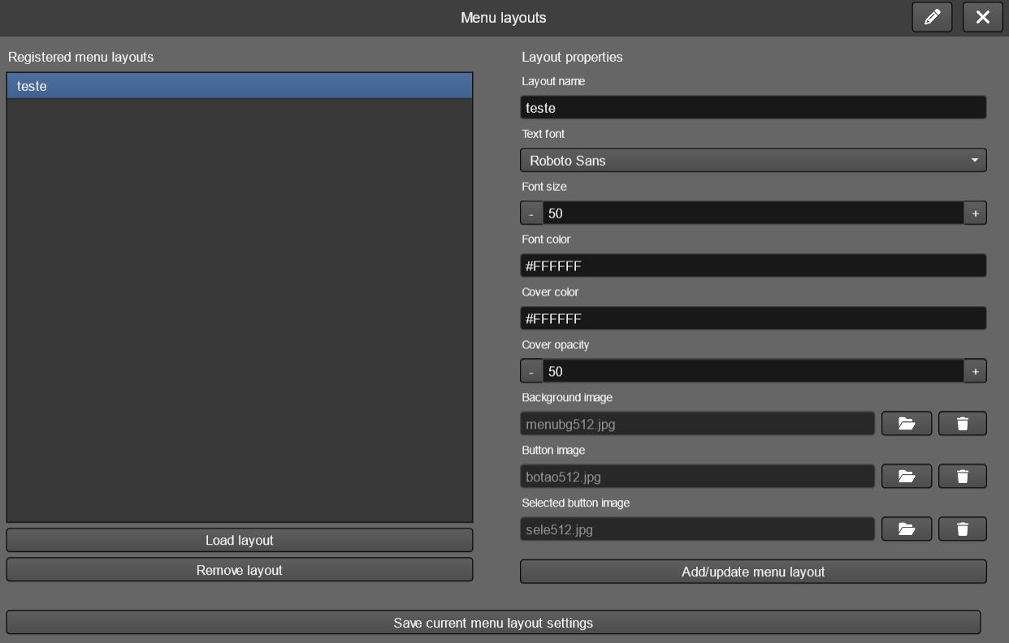

contraption.menu
This command allows you to display a menu from a previously defined layout. It receives 6 parameters. When a button is clicked, its number is stored at the provided int variable (first button value is 1, second is 2 and so on). After setting the value, the actions set at “select” are run. The menu won’t automatically disappear after a button is clicked – you’ll need to add the contraption.menuhide when you want to remove it.

params
- the layout name
- the menu option texts (all of them, split by ; )
- integer variable name to receive the click result
- placement (top, topleft, topright, center, centerleft, centerright, bottom, bottomleft, bottomright, absolute)
- x distance from border (or position for absolute placement)
- y distance from border (or position for absolute placement)
additional optional object fields
- select: actions to run on a menu button selection

contraption.menuhide
Hides any menu currently displayed. No parameters needed.

4.2. Cover
The cover contraption is a simple way to create an image layer on top of your content, easy to display at any time. To do this, covers must be configured in the left menu contraptions > content cover.

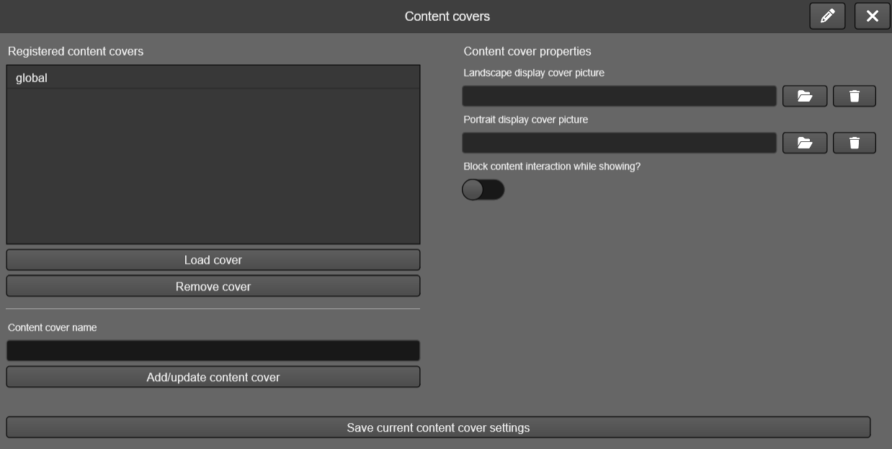

When configuring, in addition to giving a name, you must indicate at least one picture that will be used to cover the entire movie area. You can also define one image for horizontal display and one for vertical display. Finally, you can also indicate whether the cover will block click/touch interactions with the content below.

contraption.cover
This action will cause a defined cover to be displayed. If there is already a cover displayed, it will be replaced with the indicated one.

params
- the cover name

contraption.coverhide
Removes any currently displayed cover.

4.3. Loading icon
The loading icon is a way to give visual feedback to the visitor while some processing is taking place, such as loading content. It is defined in the movie properties, as a spritemap type media.

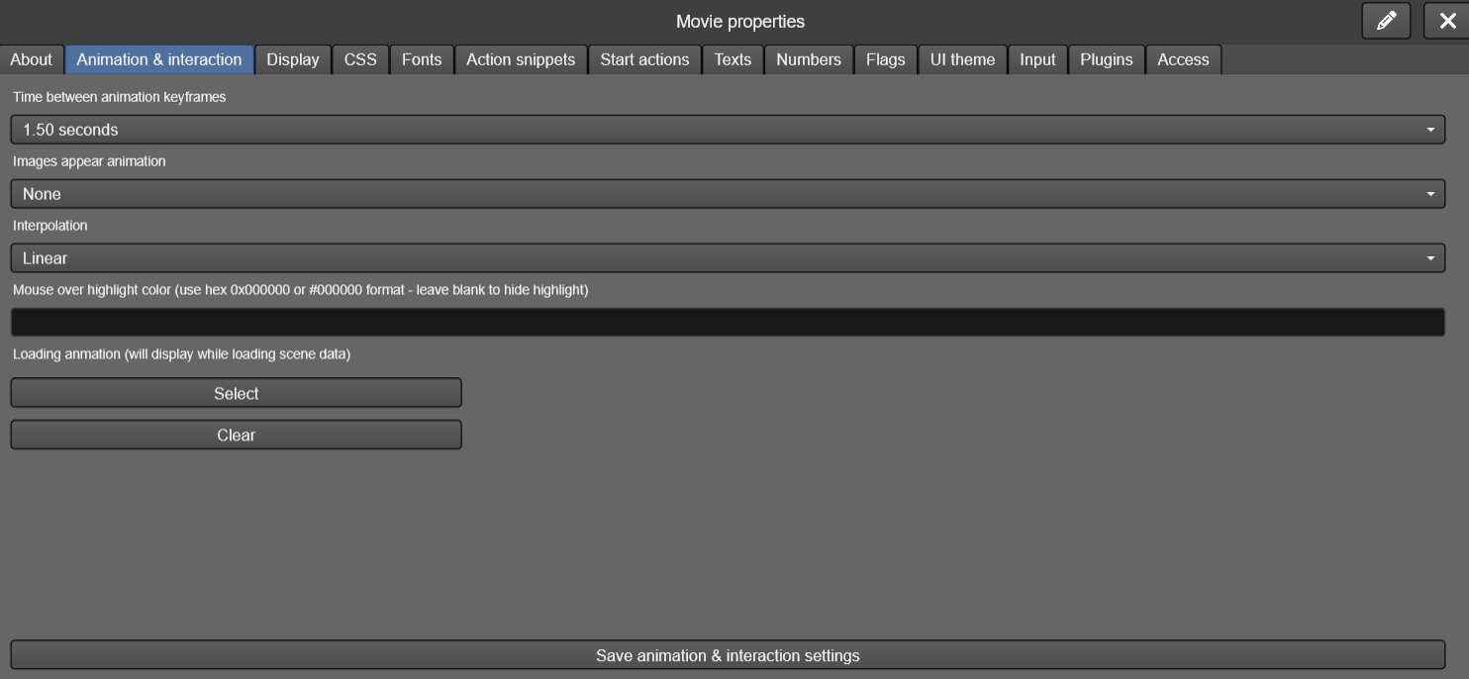

contraption.showloading
Displays the loading icon set for the movie at the display center (notice that scene loading automatically triggers this action).

contraption.hideloading
Hides the loading icon from display (notice that when a scene loading finishes, this action is automatically triggered).

4.4. Music tracks
While it's possible to use an audio instance to include music in your creations, this contraption makes the process easier. Simply create music tracks from your media and, with a simple command, play them when needed.

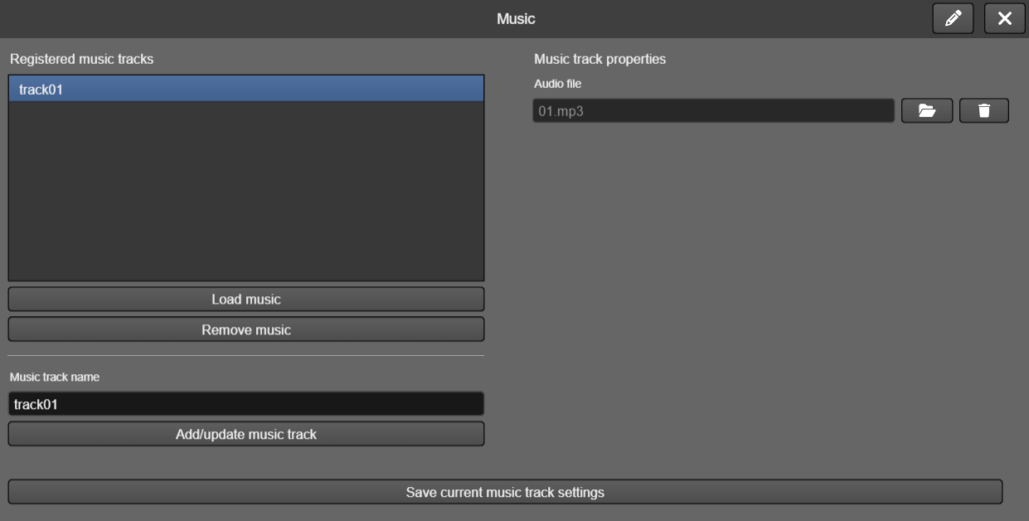

contraption.musicplay
Plays a music track, interrupting any other currently playing music. This action does not interfere with audio instances present in your movie.
params
- the music track name

contraption.musicpause
Pauses the current track. If you start playing it again, it will resume from the same point.

contraption.musicstop
Stops the current track. If you start playing it again, it will start from the beginning.

contraption.musicvolume
Sets the music track sound volume from 0 to 100%.
params
- the sound volume as an integer from 0 to 100

4.5. Sound effects
Just like with music, isolated audio tracks may be needed for your production, and you can include them using audio instances. Even so, TilBuci offers a feature that simplifies this process. You can register sound effects to be played via an action. Unlike music, playing a sound effect doesn't interrupt the previous one. Sound effects are played only once, without looping.

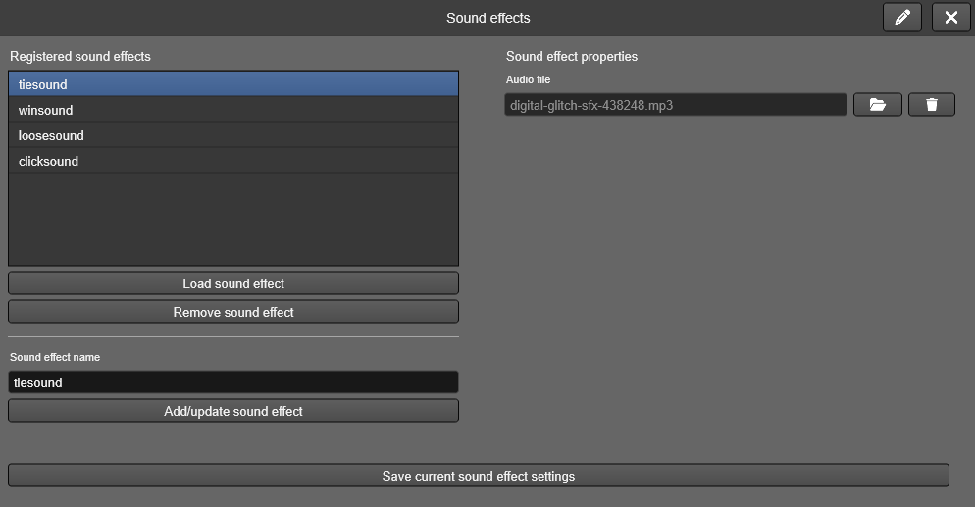

contraption.soundplay
Plays a sound effect. This action does not interfere with audio instances present in your movie.
params
- the sound effect name

contraption.soundpause
Pauses a sound effect. If you start playing it again, it will resume from the same point.
params
- the sound effect name (leave blank to pause all sound effects)

contraption.soundstop
Stops a sound effect. If you start playing it again, it will start from the beginning.
params
- the sound effect name (leave blank to stop all sound effects)

contraption.soundvolume
Sets a sound effect sound volume from 0 to 100%.
params
- the sound volume as an integer from 0 to 100
- the sound effect name (leave blank change all sound effects)

4.6. Forms
TilBuci offers several ways to retrieve information from the visitor. You can use the input actions to either display text areas at the scene display or to show the TiBuci’s interface for getting data like numeric steppers, lists and so on. The form contraption is another option for that: you can create complex forms with several input types and show them using an action command.
First, you must create a fomr using the contraption window. You can create as many forms you want: just give them different names.
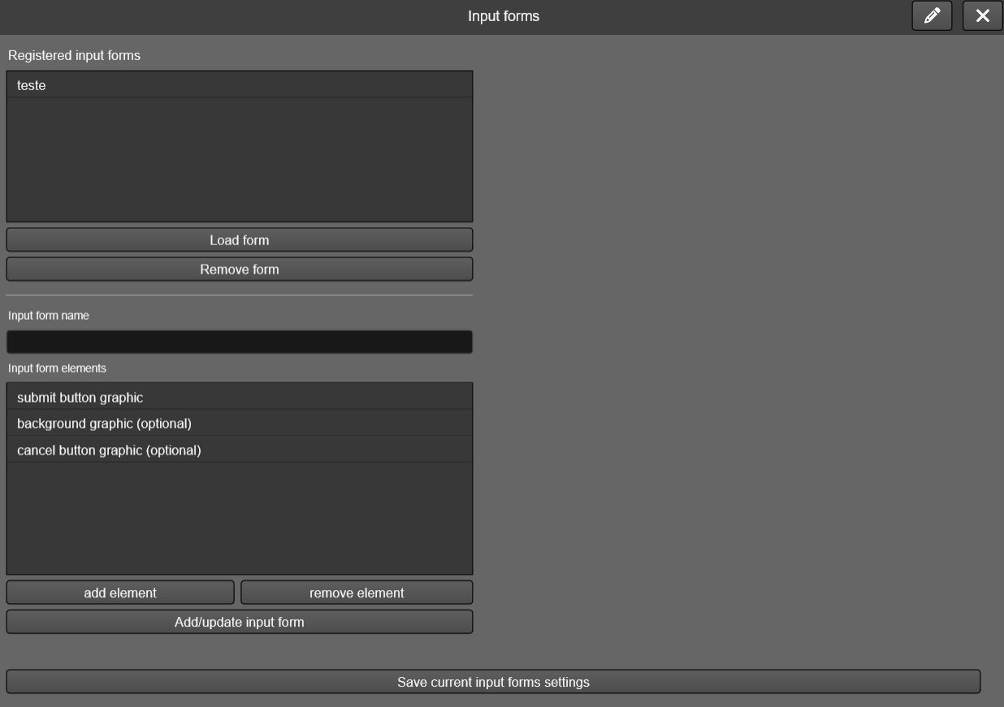
The form must have an “ok button” so the visitor can submit data. There is also optional background and cancel buttons.
Use the “add element” button to create your inputs form any of the several available types. Give each one an unique name (for the same form) its position (from the form display origin) and width. For select inputs you must also provide the options list, split by ;. You can add as many elements you want.
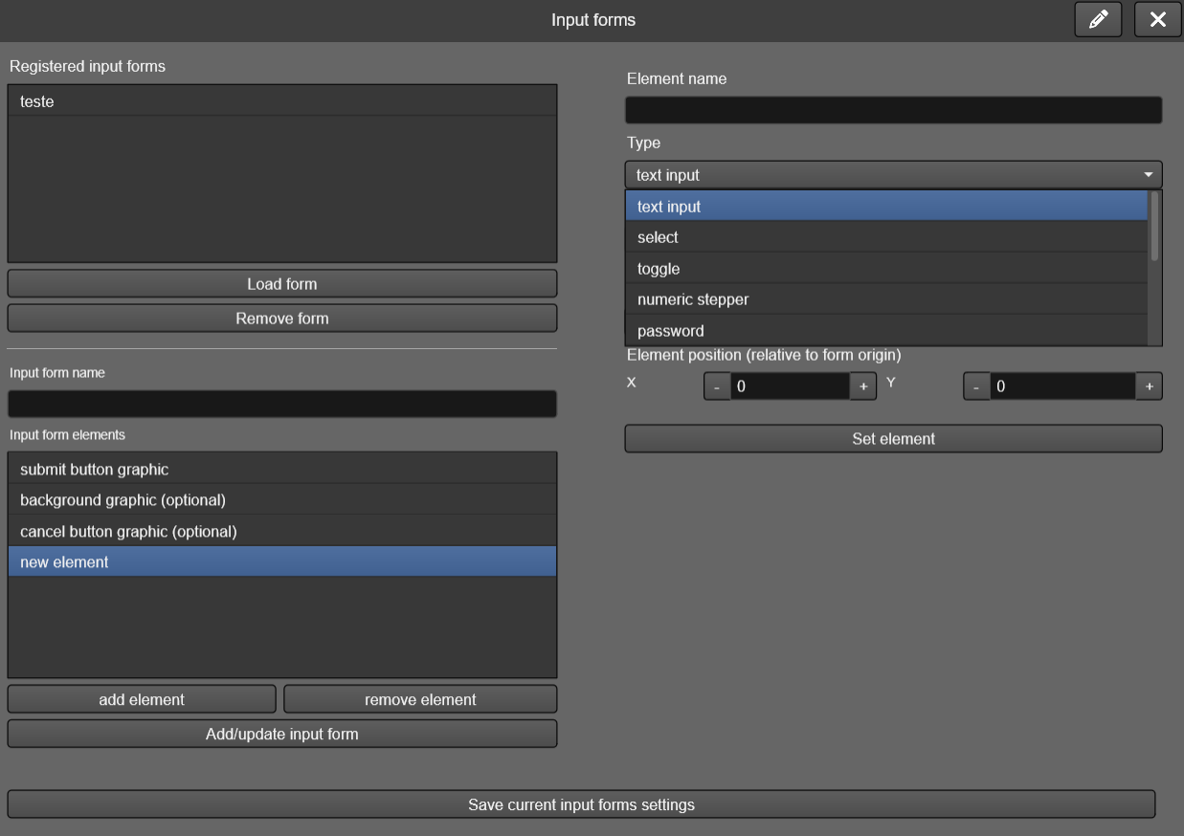
With your forms created, you can use actions to display and handle them. The data provided by the visitor using the forms will be available as a global form value.

contraption.form
Displays a form over the scene content. The selected form will replace any other form being displayed at the moment.
params
- the form name
- the form x position
- the form y position

This action lets you set two additional fields:
- Ok: actions to run when the visitor clicks on the submit button
- Cancel: actions to run when the visitor clicks on the cancel button

contraption.formvalue
Sets the value of a current form element. You must call this action after showing up the form. Use strings for all parameters, including numbers and “true”/”false”.
params
- the form element name
- the value to set

contraption.formsetstepper
Numeric steppers are always created with a minimum of 0, a maximum of 10000 and a step of 1, but you can change these limits using this command.
params
- the numeric stepper element name
- the minimum value
- the maximum value
- the increase/decrease step

contraption.formhide
Hides the current form.

4.7. Interfaces
Visitor interfaces are very useful for your content engagement. TilBuci offers a contraption to simplify the creation of reusable interfaces that may contain graphics, buttons, texts, playback controls and even animations. To create an interface, access “interfaces” at the “contraptions” right menu.
Unlike the forms, you may display as many interfaces as you want at the same time.
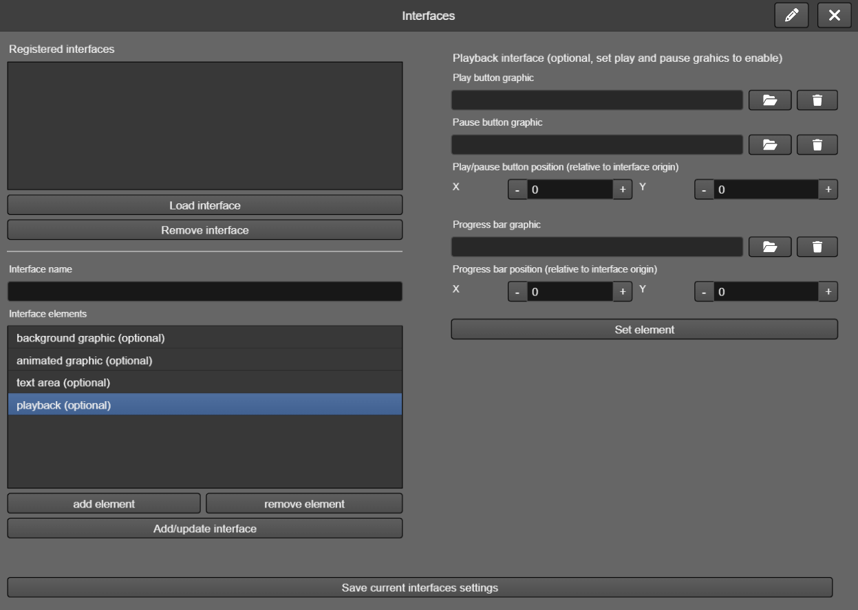
There are four pre-defined elements, but they are all optional: the interface background graphic, an animation (provided by a spritemap), a text line and playback controls. By selecting each of them at the list you can set the properties like the graphic and the text visuals.
The spritemap can be used as a button or just as a graphic. It always starts paused, but you can use actions to play it or even set a static frame to show, enabling you to use the interface as visual feedback for the visitor.
The playback interface allows you to set play and pause buttons and an optional progress bar graphic. When the interface is displayed, you can associate the playback to an instance, like a video one, or to the current scene itself and TilBuci will handle automatically the play/pause buttons behavior and also the progress bar display.
You may add additional graphics to the interface that can be used only for visual purposes or as buttons: just provide an action snippet name to run when clicked/tapped.
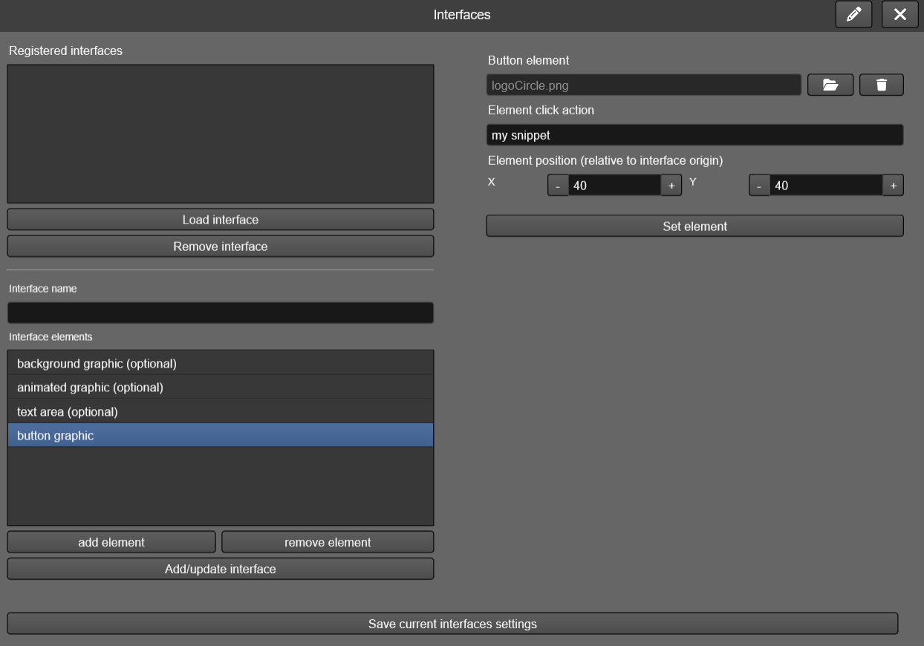

contraption.interface
Shows an interface. You may display as many interfaces you want at the same time.
params
- the interface name
- the interface x position
- the interface y position

contraption.interfacehide
Hides a single interface.
params
- the interface name

contraption.interfacehideall
Hides all interfaces.

contraption.interfacetext
Sets the content of an interface text line.
params
- the interface name
- the text to display

contraption.interfaceanimframe
Sets the current frame of an interface animation (forcing it to pause).
params
- the interface name
- the frame (integer, 1-based)

contraption.interfaceanimplay
Starts playing an interface animation.
params
- the interface name

contraption.interfaceanimpause
Pauses an interface animation.
params
- the interface name

contraption.interfacepbinstance
Associates the playback interface with a scene instance.
params
- the interface name
- the instance name

contraption.interfacepbscene
Associates the playback interface with a the current scene.
params
- the interface name

4.8. Background
You can set the background color of your TilBuci movies. You can also use picture instances to simulate backgrounds on your scenes, but with the background contraptions this process is much easier! When you show a background, it will be displayed even after a new scene loading.

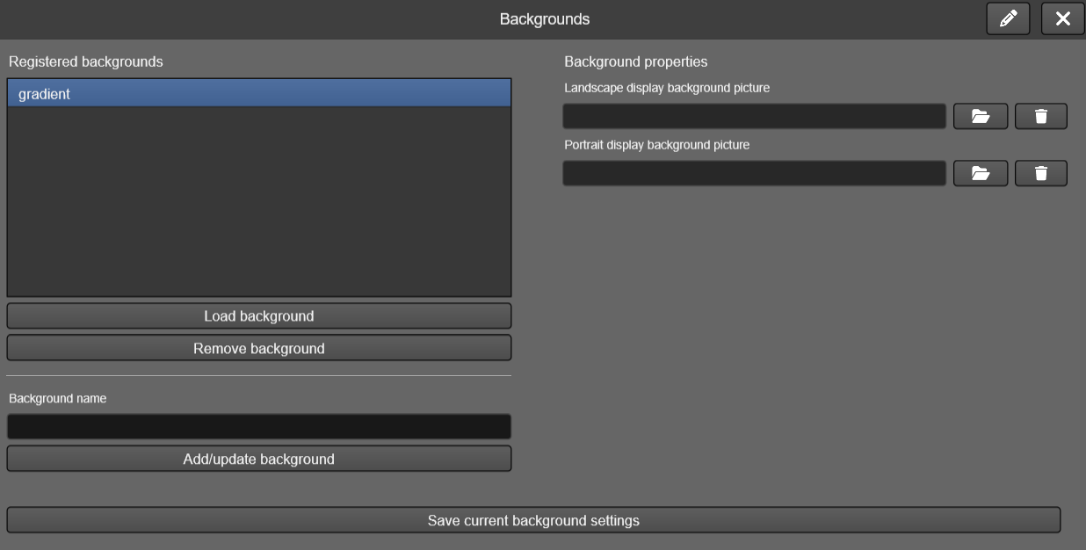

When configuring, in addition to giving a name, you must indicate at least one picture that will be used to cover the entire movie background area. You can also set one image for horizontal display and one for vertical display.

contraption.background
This action will show the requested background picture below the scene content, replacing another background, if shown.
params
- the background name

contraption.backgroundhide
Removes the current background picture.

4.9. Targets
Targets allow navigation through content using both keyboards and game controllers. To do this, you can set groups of images that act as cursors controlled by these input methods. In addition to the default image, you can provide graphics that react to the target by moving over menu buttons, interfaces, or even instances with actions, ensuring visual feedback. If no image is specified, TilBuci will use a default one: a white circle with a black outline.

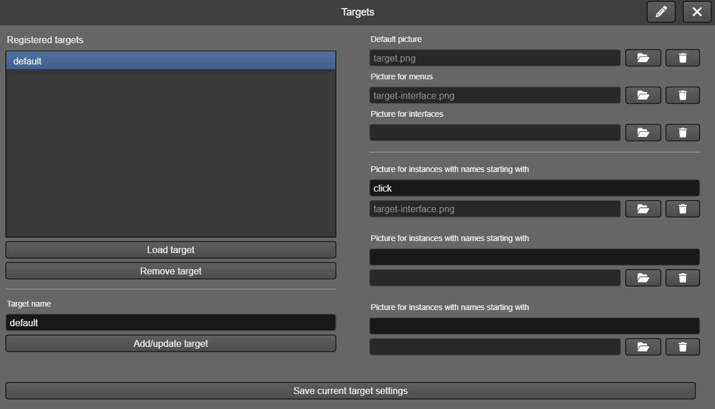

Actions involving targets were grouped under "input management" instead of "contraptions" due to the functions they manage.

4.10. Messages
TIlBuci offers various ways to present content to the user, including dialog boxes with buttons. This contraption is another one of these methods and is fully compatible with target navigation. Here, it's possible to display a "popup" with a message that can contain up to three buttons. In the configuration window of this tool, it's possible to adjust all the visual aspects, including the font, its size and color, as well as images for the message background and the button graphics.

contraption.message
This action will display a dialog box with the indicated text and buttons, which will await user interaction. After user interaction (the "when selected" event), the indicated integer variable will receive a number from 0 to 2 that registers which button was clicked and can be used to take the necessary actions.
params
- the message layout name (configured at the messages contraption settiings)
- the message text
- the buttons labels, split by ; (maximum of 3)
- the name of an integer variable that will receive the clicked button number

contraption.messagehide
Remove the message currently being displayed.

5. Narrative
Narrative tools offer simple ways to manage story-focused content, including character and dialogue management. These tools can be found at the left menu "narrative".

5.1. Characters
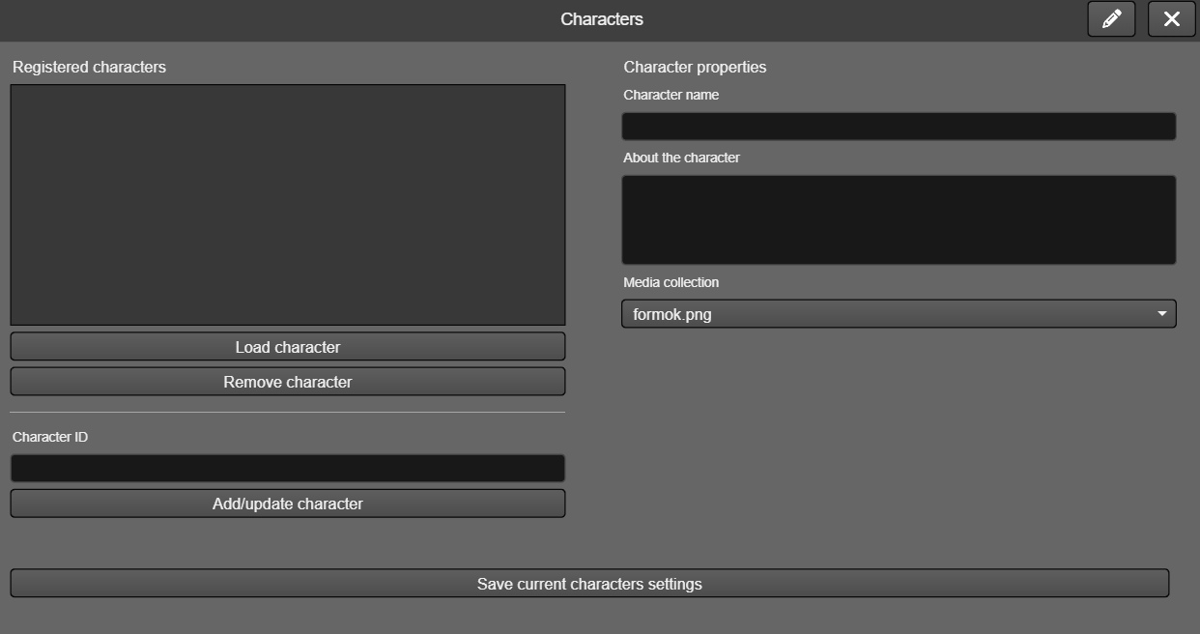
In this window you can register the characters in your story, including their names and a collection of media that will be used later as images of them in dialogues.

5.2. Dialogues
In the dialogue window, you can create conversations between characters in your story that will be displayed based on actions in the content display. These dialogues are stored in groups that can be loaded at any time.
In the dialog editing window, groups are registered in area 1 of the previous image. When a group is selected, its dialogs appear in area 2, from where they can be managed. Once one of these dialogs is selected, area 3 allows you to specify the names of the instances that will be used for navigation and content display, while area 4 shows the conversation lines that can be edited in area 5.
Dialogues are always handled by actions while playing your content.

dialogue.loadgroup
Loads a group of dialogs into memory, replacing any that were previously loaded.
params
- the dialogue group name
additional optional object fields
- success: actions to run if the dialogue group is successfully loaded
- error: actions to run if the dialogue group fails to load

dialogue.start
Begins the display of a dialog from the currently loaded group. If no group is loaded or the specified dialog does not exist, the action has no effect.
params
- the dialogue name

dialogue.next
Shows the next line of the current dialogue.

dialogue.previous
Shows the previous line of the current dialogue.

dialogue.last
Shows the last line of the current dialogue.

dialogue.first
Shows the first line of the current dialogue.

dialogue.close
Finishes the current dialogue display.

5.3. Decision flow
Decision flow is a tool that allows for a simple connection between scenes, displaying options as buttons when the last keyframe of each scene is accessed. In the left "narrative" menu, under the "decision flow" button, you can adjust the graphic properties of these buttons, such as image, font and position.
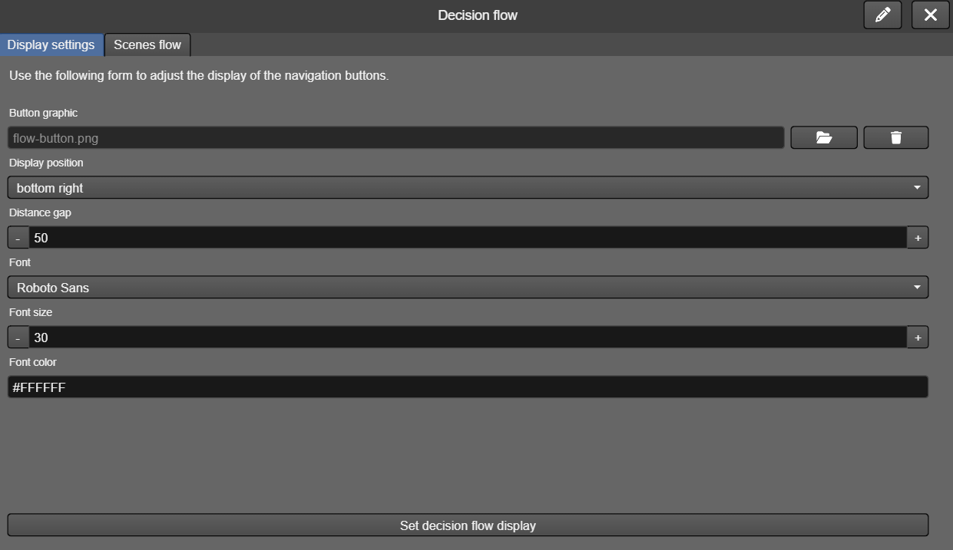
The second tab in this window allows you to view all scenes that have options set for this decision flow.
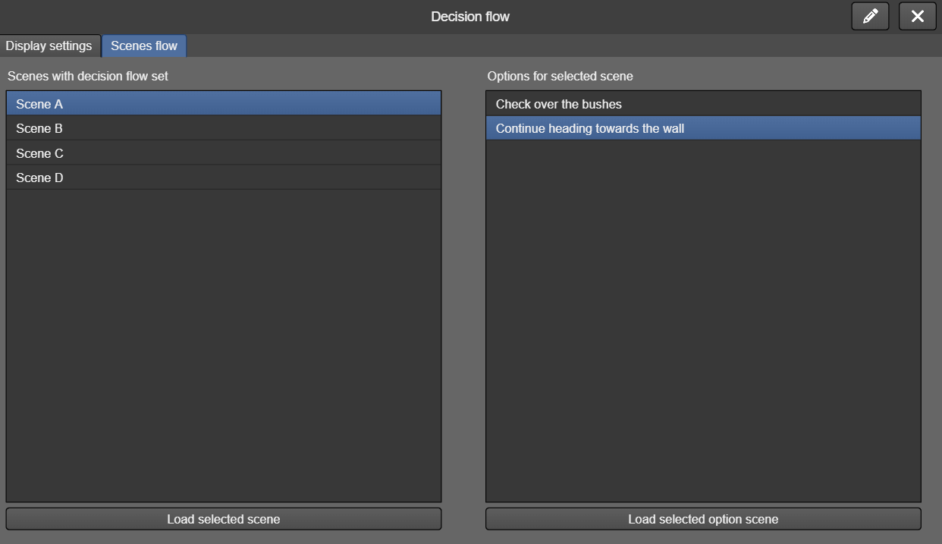
This narrative feature does not have its own actions. Instead, the options are set scene by scene from the left-hand menu "scene", button "decision flow".
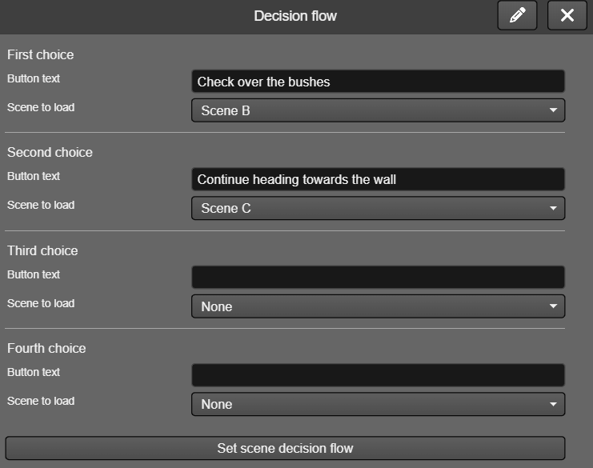

5.4. Inventory
TilBuci offers an inventory management system as a way to increase the arsenal of tools available for creating interactive narratives. The items used in this inventory are configured with a name, an image, and optionally, actions to be performed when they are activated, and can be divided into two groups: key items and consumables.
In addition to registering and managing these items, TilBuci also takes care of displaying the inventory, which can be freely configured.
To begin configuration, access the inventory window from the left-hand narrative menu. The settings tab allows you to choose how the inventory will be managed, background images (for horizontal and vertical screens), an image for the close inventory button, and a sound effect to play when an item is activated, in addition to text adjustments for displaying the quantities of consumable items.
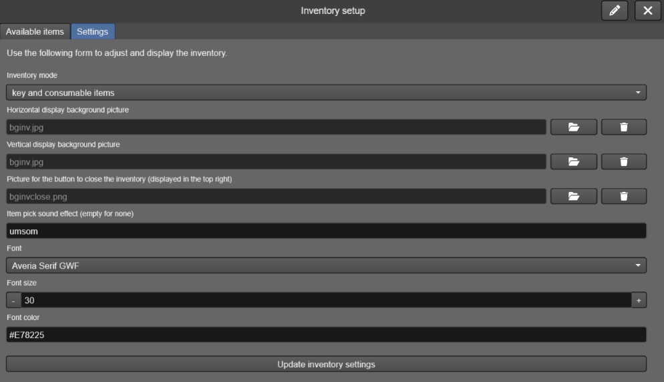
The following picture shows the inventory display layout. The gray area is covered by the background image. The black area shows the rows where the items are arranged, up to 4 in each row. The red area is occupied by the close button image. The height and width of the close button image define the dimensions around the item rows. For vertical screens, the principle is the same, with the close button always remaining in the top right corner.

Tilbuci manages inventories of up to 4 key items, which are always shown in the top row (or on the right in vertical screens), and 8 consumable items, each with its individual quantity, which are displayed 4 in each remaining row.
To register an item, you need to specify a name and an image. The actions, which are optional, are executed whenever the item is activated in the inventory. There is no distinction between key items and consumables for registration purposes. You can register as many items as you want.
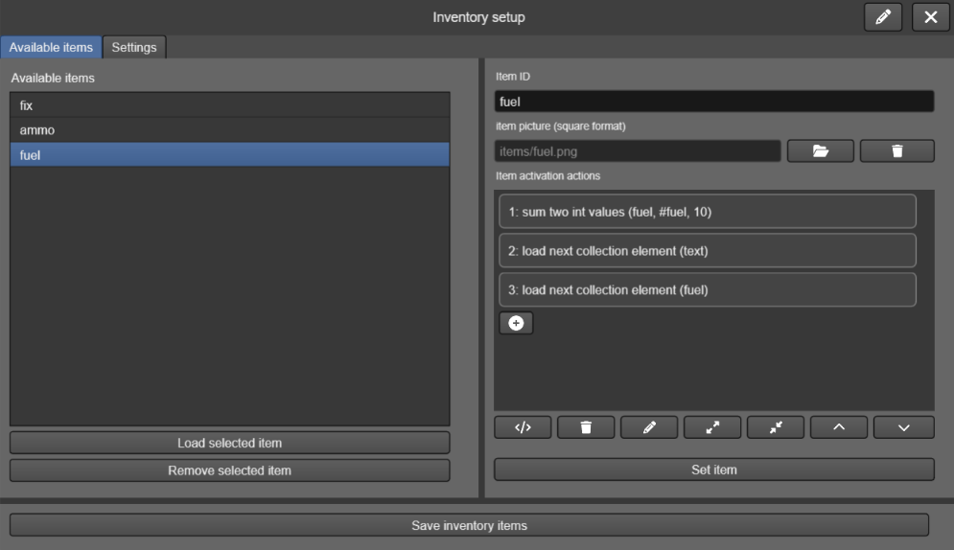
The actions available for manipulating items are in the "narrative" group.

inventory.show
Displays the inventory screen above the current scene image.
additional optional object fields
- complete: actions to run when the inventory display is closed

inventory.close
Closes the inventory window (clicking the close button has the same effect).

inventory.addkeyitem
Adds a key item to the inventory. If 4 key items have already been added, the action is ignored.
params
- the item ID

inventory.removekeyitem
Removes a key item from your inventory if it has been added.
params
- the item ID

inventory.clearkeyitems
Removes all current key items.

inventory.haskeyitem
Check if there is a key item in the inventory.
params
- the item ID to check
additional optional object fields
- then: actions to run if the item is found
- else: actions to run if the item is not found

inventory.addconsumable
Adds a consumable item to the inventory. If it's already in the inventory, the indicated quantity is added to the current quantity.
params
- the item ID
- the amount to add

inventory.removeconsumable
Remove a consumable item completely from the inventory.
params
- the item ID

inventory.consumeitem
Consumes one unit of an item, removing it from inventory if the quantity reaches zero. This action is performed automatically when a consumable item is clicked in the inventory interface.
params
- the item ID

inventory.clearconsumables
Removes all current consumable items.

inventory.tostring
Stores all items in the current inventory in a string variable. This action, along with fromstring, allows you to record the inventory status along with other player data.
params
- the string variable to receive the inventory data

inventory.fromstring
Restores the state of an inventory based on the value of a string variable.
params
- the string variable to load the data from

inventory.keytostring
Stores all key items in the current inventory in a string variable.
params
- the string variable to receive the inventory data

inventory.keyfromstring
Restores the key items of an inventory based on the value of a string variable.
params
- the string variable to load the data from

inventory.constostring
Stores all consumable items in the current inventory in a string variable.
params
- the string variable to receive the inventory data

inventory.consfromstring
Restores the consumable items of an inventory based on the value of a string variable.
params
- the string variable to load the data from

5.5. Card battle
To help add elements of randomness to the narratives, TilBuci features a simplified battle system in the form of card comparisons. This allows for creating situations in the stories where the player faces opponents with varying outcomes. This system is quite simplified in TilBuci to make it easy to configure and use.
Each card used contains up to 5 values, which are called attributes. In the battle system configuration window, accessed via the left-hand narrative menu, you can name the attributes according to the theme of your production - attributes with blank names are ignored. You can either type the name directly or specify a string variable containing that name, such as $attr1, which can be useful for translations.
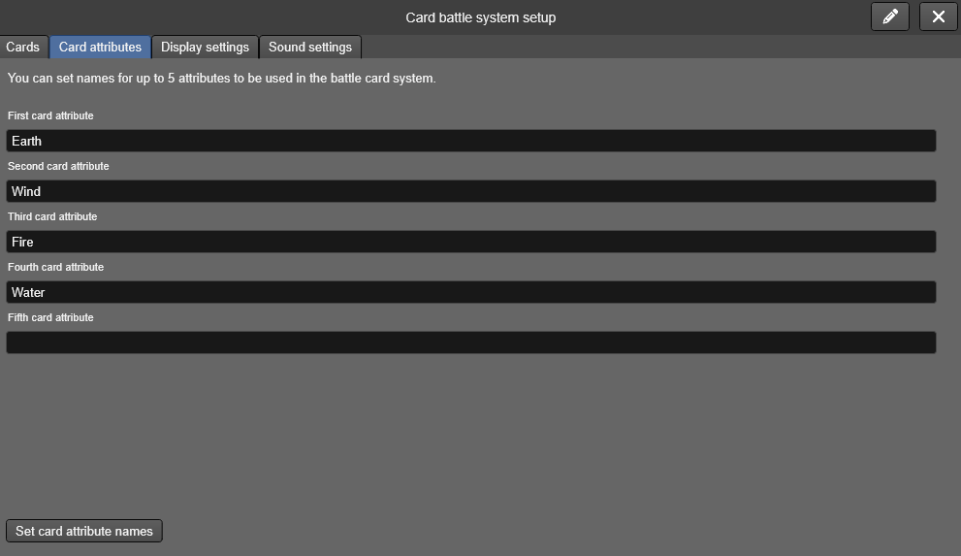
For TilBuci to manage the display of battles, it is necessary to configure the screen's graphic elements, including background images (horizontal and/or vertical), a button to end the battle, background images for cards and texts, attribute values, and adjustments to the font used.
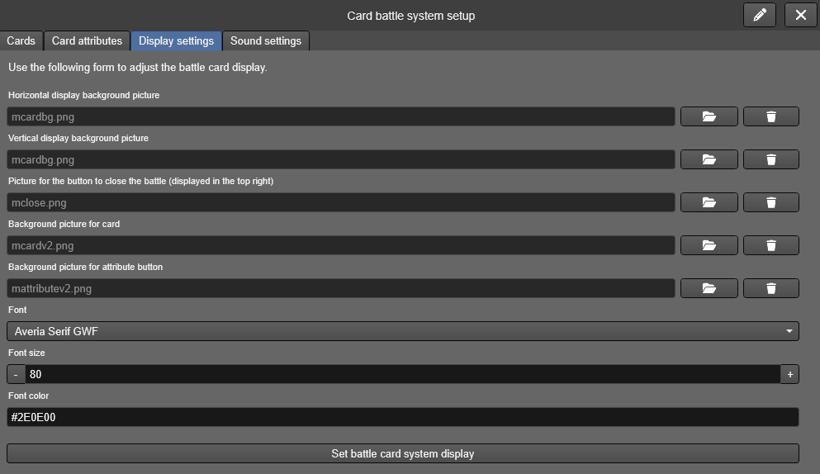
The following picture shows how these elements are displayed on the screen.
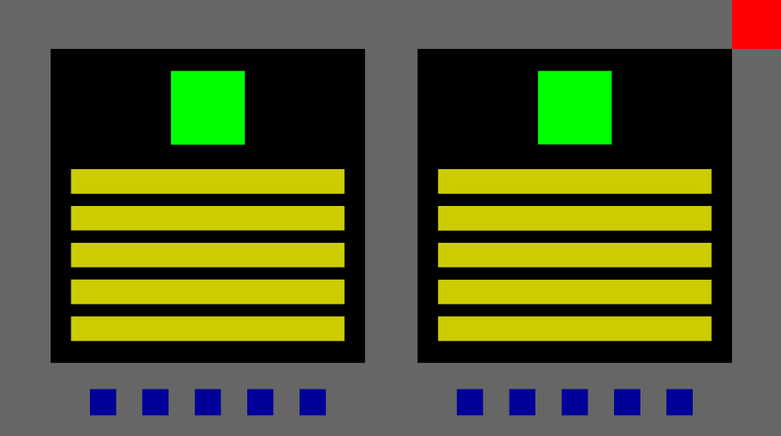
The gray area in the previous image is occupied by the picture set as the background. The red field shows the image of the end battle button. The black square shows the card's background – prefer square images for this. In horizontal view, the cards are shown side-by-side, while in vertical view, one above the other. The yellow rectangles contain the attribute buttons (they are displayed according to the number of attributes used) – produce their image considering the size of the card's background. The green area shows the illustration of the current card, while the blue areas show the images of all cards involved in the battle. The distribution of graphics on the screen considers the width and height of both the "End Battle" button and the attribute background. The following picture shows the application of graphics in this layout.
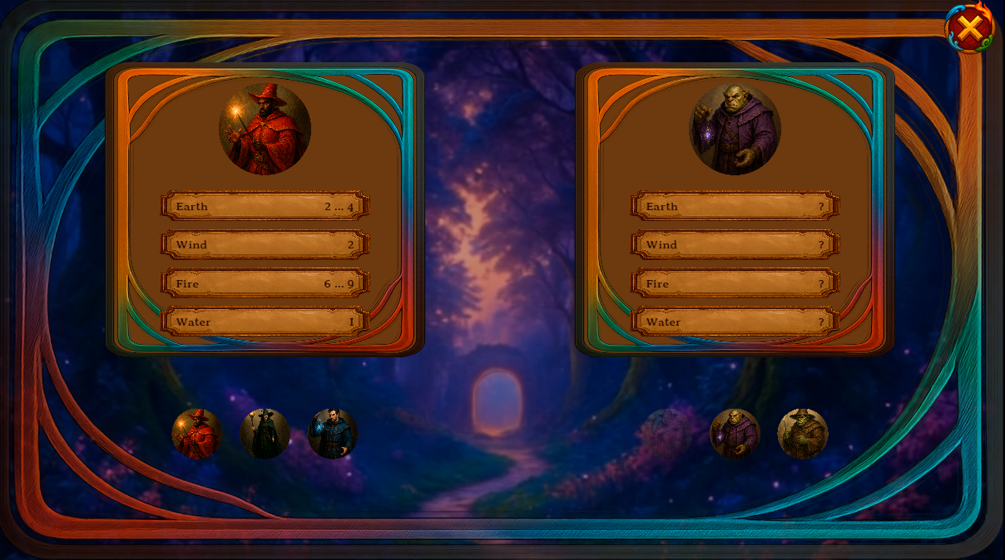

It is also possible to set audio feedback for some battle actions: selecting an attribute for comparison, winning a comparison, losing, or drawing it. Simply use the name of the sound effect to play (configured in the sound effects contraptions) - it is also possible to use a string variable that contains the name of the audio to be used, such as $mysound.
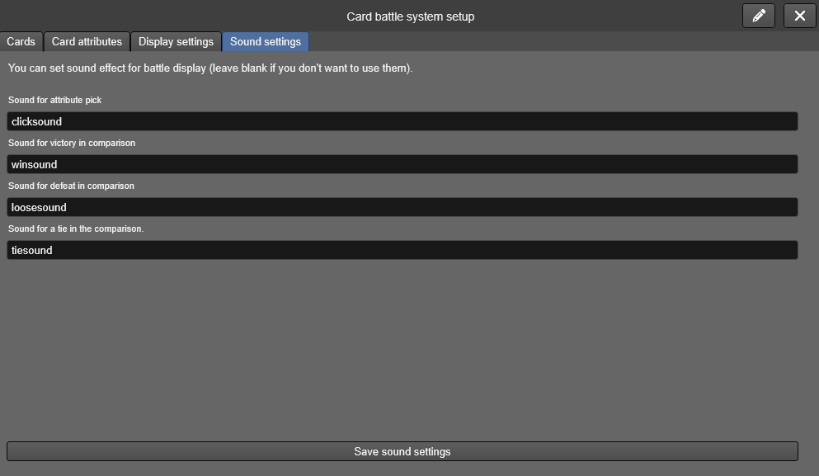
Finally, you need to configure the cards. This step does not distinguish between cards used by the player or the opponent. For each card, you need to provide a name, a picture (always square), and the basic values ​​for all attributes used. You can register as many cards as you want.
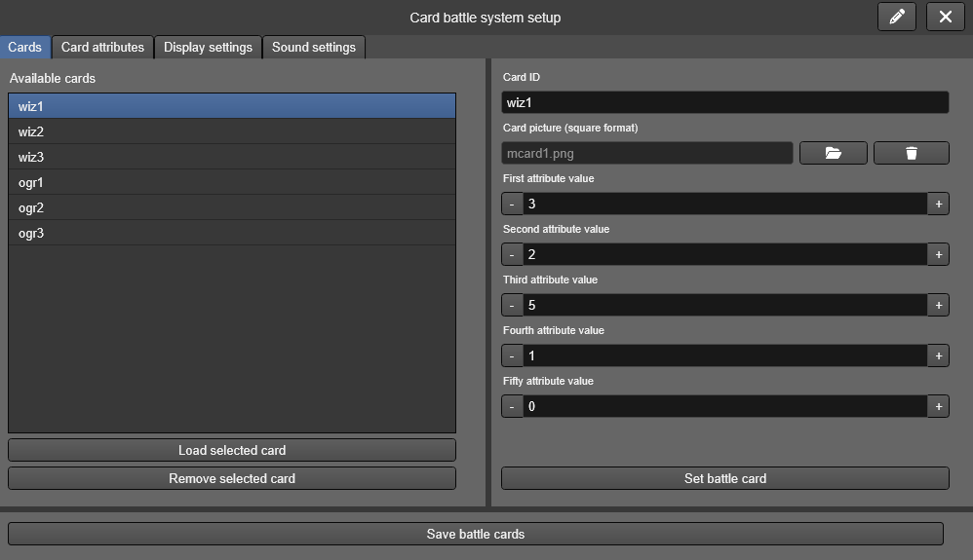

The battle works according to a simple rule. Two cards are displayed, one for the player and one for the opponent. These cards show the current values ​​of each attribute for the player, while the opponent's card shows these values ​​hidden. The value of each attribute is calculated from the card's base value, adding or removing a fixed gain, plus a random amount that can be set via actions. When the comparison value is fixed, only a number is displayed. When it has a random influence, it is displayed as a range, such as 1...5. The losing card is discarded. At the end of the battle, if the player still has cards available, they are the winner. If they have run out of cards, they lose.
The actions related to the card battle are found at the narrative group.

battle.show
Start a card battle. You need to specify one to five cards for yourself and your opponent. The card names should be separated by commas, and you can specify them as a string variable sequence, such as $card1,$card2,$card3.
params
- the player cards list
- the opponent cards list
additional optional object fields
- win: actions to run if the player wins the match
- loose: actions to run if the player looses the match or clicks the end battle button

battle.close
Ends a card battle. This action is automatically executed at the end of the battle or when the player clicks the button to end the battle.

battle.setattribute
Sets adjustments to be applied to one of the player's card attributes. The fixed gain (which can be negative) is always added (subtracted) from the base value registered on the card. The random gain value indicates a number to be randomly added each time the card is used (for example, the value 3 indicates that, at the time of comparison, a total from 0 to 3 will be added to the current value). The random reduction works in reverse, indicating a total that can be subtracted from the current value. This action is quite useful when associated with the use of inventory items.
params
- the attribute to affect (1 to 5)
- fixed gain value
- random gain value
- random reduction value

battle.setopponent
It works similarly to the battle.setattribute action, but applies the values ​​to the opponent's cards.
params
- the attribute to affect (1 to 5)
- fixed gain value
- random gain value
- random reduction value

6. String files and Arrays
In addition to traditional media files such as pictures, videos, and audio, TilBuci supports sending text files in JSON format that can contain information used in your productions. These files can be used both as text sources and as values ​​in a list, which we call an "array". You can upload as many JSON files of strings and arrays as you want for your movie. Avoid using spaces or special characters in the filename for best results.

6.1. String files
These text files are JSON-formatted ones that can be loaded and unloaded at any time into variables, allowing your creations to contain large volumes of text with reduced impact on both load time and memory usage.
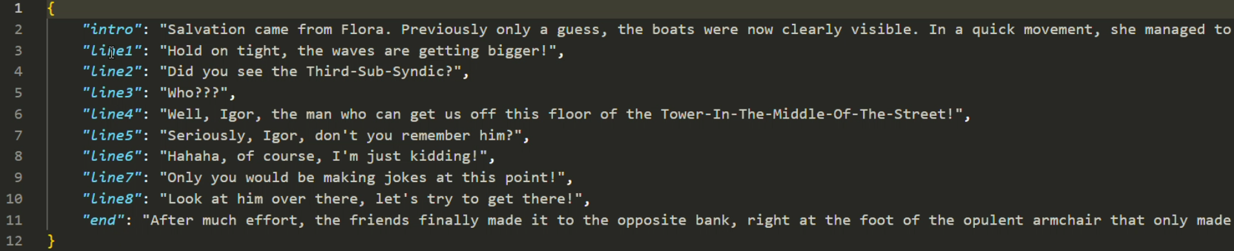
The string files used in TilBuci are quite simple: they contain name-value pairs. Once the file is loaded, string variables with the names found in the file become available with the indicated content. When loading a new text file, the variables defined by the previous file are deleted.

string.loadfile
Loads a string JSON file registered using the media manager (replaces the content of any previously loaded strings file).
params
- the string file name (without “.json”)
additional optional object fields
- success: actions to run on successful file load
- error: actions to run if the file fails to load

6.2. Arrays
Array files also follow the JSON format and consist of only a list of strings.
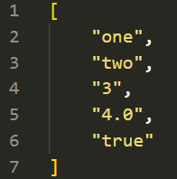
These strings can contain actual text, but also numeric or boolean values. When a file is loaded, the values ​​become available as an array with the same name, and can be manipulated using common array actions. Unlike string files, loading a new array does not delete the previous one from memory - you must use the corresponding action for that.
The information in an array is stored and retrieved from its index, a number that indicates the current position for reading/writing information.
When current information is saved, such as when the data.savestate action is called, loaded arrays are not saved. To save them, use the array.tostring action beforehand to save them into a string variable (and array.formstring to load them back into memory afterward).

array.loadfile
Loads a file into an array with the same name.
params
- the array file name (without “.json”)
additional optional object fields
- success: actions to run on successful file load
- error: actions to run if the file fails to load

array.create
Create an empty array if it doesn't already exist.
params
- the array name

array.remove
Deletes an existing array.
params
- the array name

array.push
Adds a value to the end of the array.
params
- the array name
- the value to add

array.set
Sets the value of a position in the array. If the array length is smaller than the specified position, empty values ​​will be added until the specified value is reached. This action does not change the current index of the array.
params
- the array name
- the position to add
- the value to add

array.get
Retrieves the value of a position in the array as a string. If the array is smaller than the indicated position and does not exist, an empty string will be returned. This action does not change the current index of the array.
params
- the array name
- the position to load
- the string variable to receive the value

array.getint
Retrieves the value of a position in the array as an int. If the array is smaller than the indicated position and does not exist, 0 will be returned. This action does not change the current index of the array.
params
- the array name
- the position to load
- the int variable to receive the value

array.getfloat
Retrieves the value of a position in the array as a float. If the array is smaller than the indicated position and does not exist, 0 will be returned. This action does not change the current index of the array.
params
- the array name
- the position to load
- the float variable to receive the value

array.getbool
Retrieves the value of a position in the array as a boolean. If the array is smaller than the indicated position and does not exist, false will be returned. This action does not change the current index of the array.
params
- the array name
- the position to load
- the bool variable to receive the value

array.clear
Remove all values ​​from an array.
params
- the array name

array.current
Retrieves the value of the current index position in the array as a string. If the array is empty, an empty string will be returned.
params
- the array name
- the string variable to receive the value

array.currentint
Retrieves the value of the current index position in the array as an int. If the array is empty, 0 will be returned.
params
- the array name
- the int variable to receive the value

array.currentfloat
Retrieves the value of the current index position in the array as a float. If the array is empty, 0 will be returned.
params
- the array name
- the float variable to receive the value

array.currentbool
Retrieves the value of the current index position in the array as a boolean. If the array is empty, false will be returned.
params
- the array name
- the bool variable to receive the value

array.next
Moves the array index by one position and returns its value as a string. If the end of the array is reached, the index is moved to the first position.
params
- the array name
- the string variable to receive the value

array.nextint
Moves the array index by one position and returns its value as an int. If the end of the array is reached, the index is moved to the first position.
params
- the array name
- the int variable to receive the value

array.nextfloat
Moves the array index by one position and returns its value as a float. If the end of the array is reached, the index is moved to the first position.
params
- the array name
- the float variable to receive the value

array.nextbool
Moves the array index by one position and returns its value as a boolean. If the end of the array is reached, the index is moved to the first position.
params
- the array name
- the bool variable to receive the value

array.previous
Moves the array index to the previous position and returns its value as a string. If the beginning of the array is reached, the index is moved to the last position.
params
- the array name
- the string variable to receive the value

array.previousint
Moves the array index to the previous position and returns its value as an int. If the beginning of the array is reached, the index is moved to the last position.
params
- the array name
- the int variable to receive the value

array.previousfloat
Moves the array index to the previous position and returns its value as a float. If the beginning of the array is reached, the index is moved to the last position.
params
- the array name
- the float variable to receive the value

array.previousbool
Moves the array index to the previous position and returns its value as a boolean. If the beginning of the array is reached, the index is moved to the last position.
params
- the array name
- the bool variable to receive the value

array.setindex
Sets the current index of the array. If the specified position is greater than the size of the array, the index is moved to the last available position.
params
- the array name
- the index position to set

array.getindex
Retrieves the current index position of an array.
params
- the array name
- the int variable name to receive the value

array.tostring
Stores the current array's entire contents in a string variable.
params
- the array name
- the string variable name to receive the data

array.fromstring
Recreates an array from the contents of a string variable.
params
- the array name
- the string variable name to get the data from

7. QR code functionality
The use of QR codes to access parts of developed content is a very useful feature. They can be used, for example, in exhibitions, where visitor guides can be accessed from codes printed next to the artworks, or in reading physical cards that activate some functionality in a game.
In TilBuci, we can use QR codes either from the program's built-in reader, which is activated by an action, or we can use the reading functionalities of the mobile device's own camera to direct access to the desired part of the content.
The codes read by TilBuci consist of a link to a movie/scene and optional indications of a snippet and string variable to be set, in this structure:
https://tilbuci.com.br/app/?mv=tilbuci&sc=c69155523be07734143a6d7005e29a23&sn=mysnippet&vars=anNvbiBjb250ZW50IGhlcmU=
If you are using the TilBuci web player (and not exported content) the QR code generated by this string can be valid for reading both via the built-in reader and the one normally used by the device. If the content has been exported, for example in the form of a mobile app, only the TilBuci built-in reader will be able to read this code. The variables described using “vars=” are immediately set and the snippet indicated after "sn=" will be executed as soon as the indicated scene is loaded.
To simplify the process of creating codes, the "Movie" menu has a "QR Code" option. This will open a window where codes can be easily generated; simply indicate the scene and snippet to be played.
Use only global snippets (configured in the movie properties) since dynamic snippets may not have been loaded at the time the indicated code is executed.
The "vars" parameter of the QR code should contain the registered variables in a JSON-formatted text with "name/value" pairs, encoded in Base64, as in the following example.
Variables (JSON-formatted text) | Vars parameter
{"var1":"value 1","var2":"value 2"} | vars= eyJ2YXIxIjoidmFsdWUgMSIsInZhcjIiOiJ2YWx1ZSAyIn0=

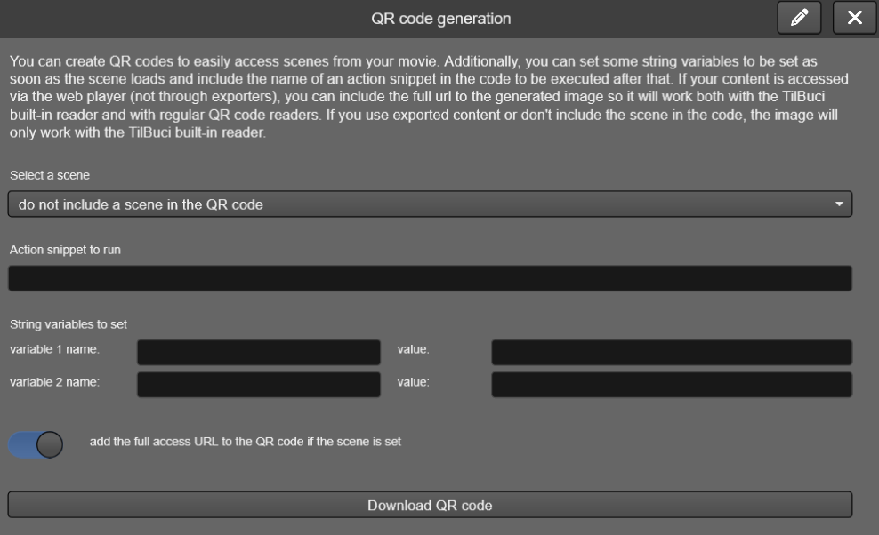

system.getqr
Opens the internal QR code reader. The “complete” event is called when a valid QR code is read.
params
- the camera display feedback size (square proportion)
- the x position of the camera feedback
- the y position of the camera feedback
additional optional object fields
- complete: actions to run when a valid QR code is read

system.closeqr
Closes the internal QR code reader. The reader is automatically closed when a valid QR code is found.

8. Accessibility
To improve the visualization of your creations, TilBuci has several accessibility tools for the created content that can be activated through specific actions.

8.1. Color adjustment
Actions related to color adjustment attempt to make the colors in your production more recognizable to people with some of the more common types of color vision deficiency. Filters are applied to the content that don't "correct" the colors but rather try to make them more perceptible. The actions can be found under the “Accessibility” group of the block editor.

accessibility.changeshader
Loads the next color adjustment shader, in this order:
- no shader
- adjustment for deuteranotopia
- adjustment for protonatopia
- adjustment for tritanotopia
- high contrast mode
- grayscale mode

accessibility.setshader
Loads a color adjustment shader.
params
- the shader to load. Available values are: “none”, “deuteranotopia”, “protonatopia”, “tritanotopia”, “contrast” and “grayscale”.

8.2. Focus mode
Your interactive movies can become quite complex, displaying multiple elements and animations simultaneously on screen, which can be distracting for some users. To avoid this problem, TilBuci features a "focus mode." During content editing, you can mark the most important instances to retain their visual properties when this mode is activated and demarcate the focus for less important ones.

When focus mode is activated, the movie display is altered as follows:
- the transition time between keyframes and scenes remains constant, always lasting 3 seconds;
- the interpolation of transition animations will always be linear, avoiding abrupt changes and inertia effects;
- the colors of less important instances will be reduced, decreasing the overall saturation of the display;
- text instances not marked as important will be hidden.

accessibility.focuson
Starts the focus mode.

accessibility.focusoff
Stops the focus mode.

accessibility.focusswitch
Switch the focus mode.

8.3. Description text
For some occasions, having descriptive text for your movie's content can be quite useful. For this, the "accessibility.setdescription" action can be used. When executed, it checks if there is a Javascript function called "tb_description" on the page where the TilBuci content is embedded, and if it finds it, executes this function, sending the indicated text as a parameter. This function can be used to forward the descriptive text in the best way for your situation. If you are using the WordPress plugin, simply add the additional class "tb_description" to a paragraph block so that the descriptive text is displayed there whenever it is changed.
The use of descriptive texts can be quite useful in conjunction with tools such as screen readers, sign language, etc.

accessibility.setdescription
Sets the current descriptive text.
params
- the text to use

9. Code assist
To simplify the action coding process, TilBuci provides some assistants to help the script creation. On every scripting window there are some buttons to display these tools.
These buttons actions are, in order:
- return to the block editor
- copy current action script
- show movie and scene actions
- show media/instance actions
- show variable management actions and conditions
- show data and input handling actions
- show additional actions, like system and timer
- show runtime actions
- show contraption-related actions
- show narrative actions
- show available plugin actions
All windows shown from these buttons have tools to help code creation. Just set what you want and click the buttons with the copy icon – the code will be copied to clipboard so you can paste it on your creations. Please note that this copy functions will only work if TilBuci is running from secure “https” urls due to browser policies. You will also find the “show action” buttons that will display the action at the “Action/value” area, from which you can manually copy the result – this will work from both https and http.

10. Block editor
Even though you can write the code for your actions in TilBuci, using or not the assistants, the simplest way to create interactions is through the block editor. The action blocks are a visual way to enter commands and the software's default method.
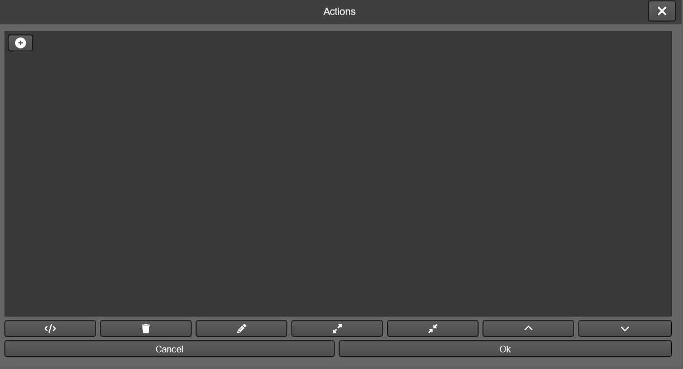
The block area always displays a + button used to create a block. Click it to show the action groups available. By clicking on one of them, you’ll see the available actions. Select the one you want and, them click on “create action block”.
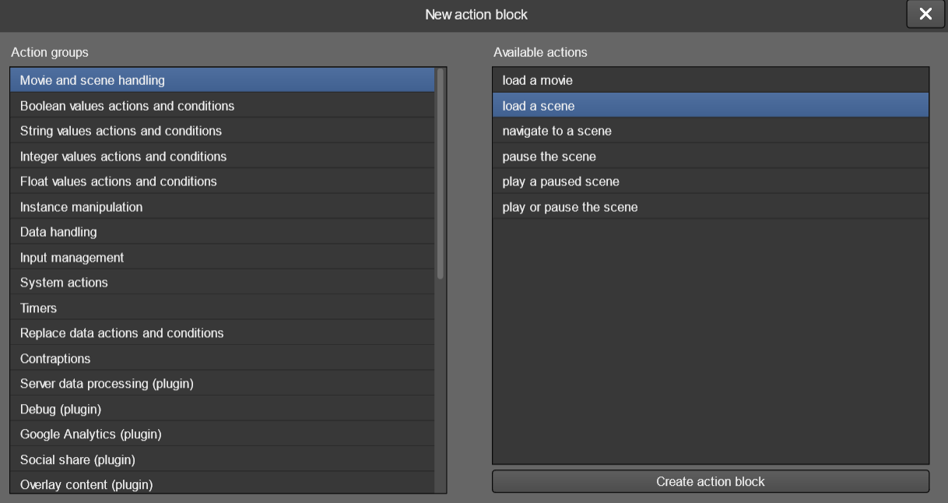

The next window will show all necessary parameters to finish setting your action.
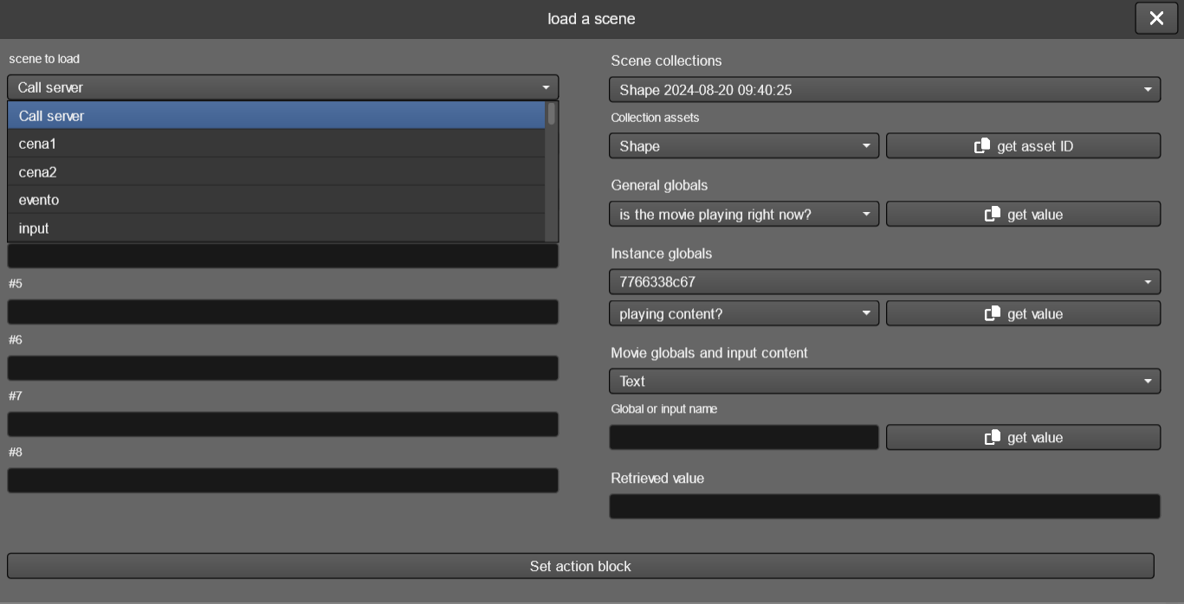
You can add as many blocks as you want to an action: just press the + button to add another one. The actions will be run at the numbered order.
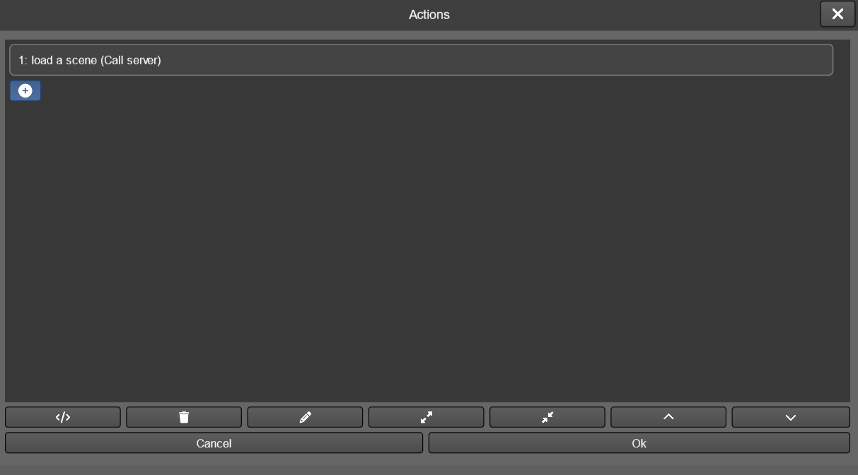

Some blocks, like conditions, can hold themselves further actions. In these cases, additional + buttons are displayed where necessary.
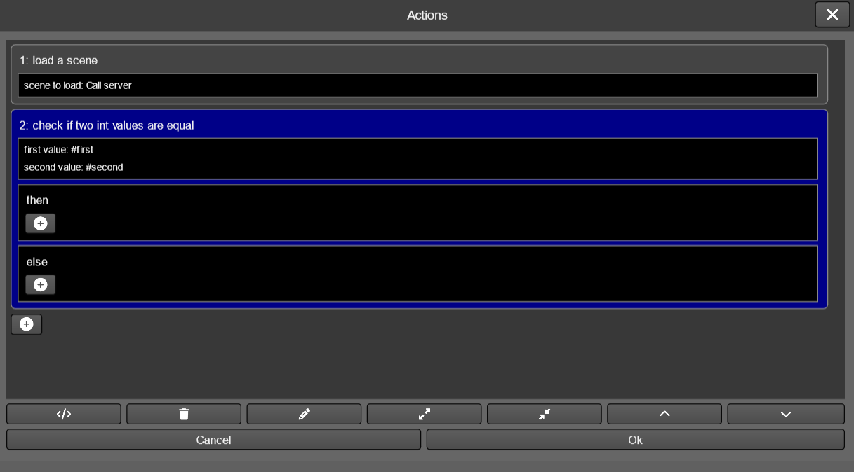
Just below the blocks area you’ll find some buttons to help your coding.
They represent, in order:
- switch to the code view (you can switch between block and code display at any time, both methods are 100% compatible)
- delete the selected block
- edit the selected block
- expand the selected block (or mouse center button click)
- reduces the selected block view
- move selected block up in execution order
- mode selected block down in execution order

11. Content encryption
TilBuci movies are saved as folders containing the media files and also several plain text, json-encoded ones that describe all your movie settings and interactions. These json files are, by default, saved unencrypted. While this is good for many cases, you may need to protect your creation from access by other people.
TilBuci offers an encryption option for your movies. Just open the access tab of the movie properties, change the “encrypt movie files?” setting to true and click the set access options button.
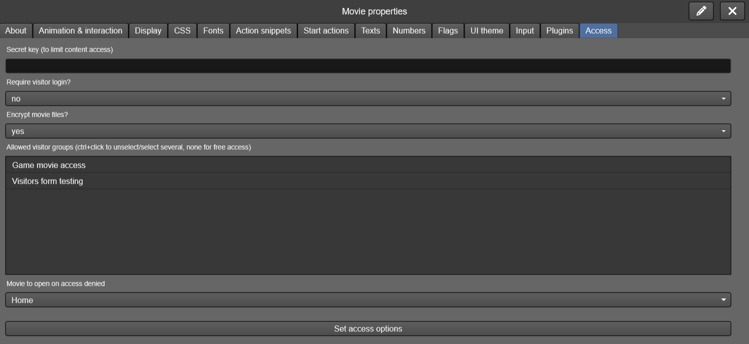
Every time you change this setting, go to the movie left menu and click the republish button. This will force all movie json files to be rewritten, forcing the encryption.
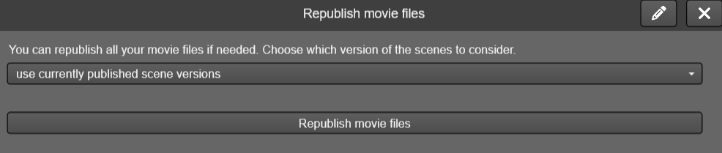
Encrypted movies are compatible with all exporters, but remember that movies exported for importing on other TilBuci installations are always saved unencrypted.

11.1. Custom encryption
TilBuci uses a standard AES-256 encryption method which should be sufficient for most cases. If you need to bring your own encryption method/key, however, you can do it following some simple steps.
First, you must save your movie unencrypted – do not use the TilBuci default encryption. Then, after exporting your content, load and encrypt all movie json files using your custom encryption.
Now, access the index.html file used to load your content. You must add your own decryption method to it – this method must receive a single parameter, the encrypted text, and return a string containing the decrypted one.
The last thing to do is look for the TilBuci initialization script at the index.html file. It looks like this:
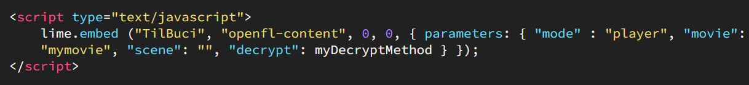
You must add the “decrypt” property to the initialization parameters, referring to your custom decryption method.
For a simple example of custom decryption, please download this exported website:
http://tilbuci.com.br/files/customencryption.zip

12. The WordPress* plugin
TilBuci can be installed standalone on your web server, run as a desktop application for various systems, or used fully functionally as a WordPress* plugin. To install, simply download the latest version (a compressed ZIP file) and follow the standard installation procedure, as described at the pictures below.
You can find the TilBuci WordPress* plugin at the software repository or at https://plugin.tilbuci.com.br/
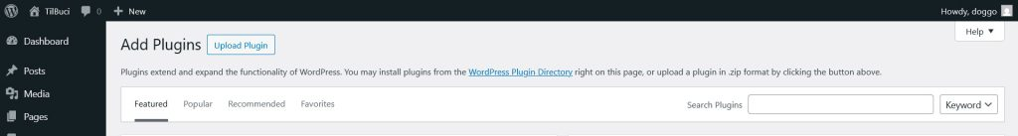

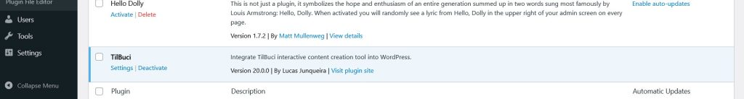
After creating your content, in your posts or pages, include a "TilBuci Movie" block, choosing the movie to be displayed. You can only add one of these blocks per page or post.
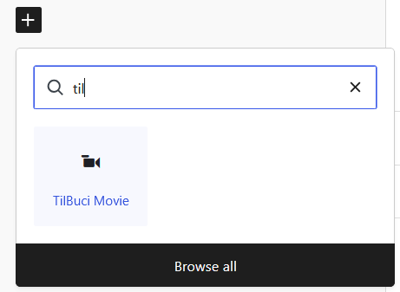

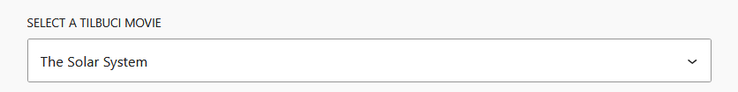
After choosing the movie to be displayed, you have a few viewing options. The first is displaying it only in a block within your post or in full screen. If it's displayed as a block, you can define the aspect ratio (height/width).
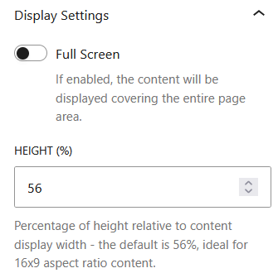

Another option is the way the content is drawn. By default, TilBuci uses a canvas/WebGL area to draw the content, but you can choose to draw using traditional DOM elements such as "div" or "img". This solution can be quite useful when you want to focus on the usability of your production, since these elements are more exposed to tools such as screen readers. You can even specify the "alt text" attribute of images in the TilBuci editor.

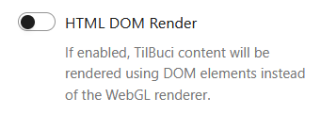

* The WordPress® trademarks are the intellectual property of the WordPress Foundation. Uses of the WordPress® name in this document are for identification purposes only and do not imply an endorsement by WordPress Foundation. TilBuci is not endorsed or owned by, or affiliated with, the WordPress Foundation.

13. TilBuci Showtime
Creating public displays, such as in museums, events, and the like, is an interesting topic but raises several technical questions. To help with this process, your content created in TilBuci has a tool that facilitates its use in these cases.
TilBuci Showtime is available in two forms. First, as an executable for Windows, Linux, and macOS systems on Intel and ARM (Silicon) platforms, and also for Android devices such as tablets. In all these cases, you copy or install the application on your device, import the content you created, set some parameters such as initialization, and that's it: your projection, totem, kiosk, or any other form of display is ready for the public!
A second option is "Showtime for Makers". Generated via the content export interface of the TilBuci editor, this format creates code to be embedded in controllers that broadcast their own Wi-Fi access point; devices such as smartphones, tablets, or computers can connect to this network to access the content created in TilBuci. To implement this, the hardware platform requires a controller capable of generating a Wi-Fi signal—such as the Espressif ESP32—and an SD card to store the movie data.

13.1. Showtime for computers and Android
In this format, you copy an executable to your system (Windows, Linux, macOS, or Android) and configure it by importing the movies you want to use and making any necessary adjustments—such as setting an access password for configuration, setting online connectivity, or preparing hardware interaction. For a video presentation of this tool, check out https://youtu.be/-vYDmaokqbY

13.1.1. Setting the movie to display
The first time you start the software, you are taken to the configuration screen.
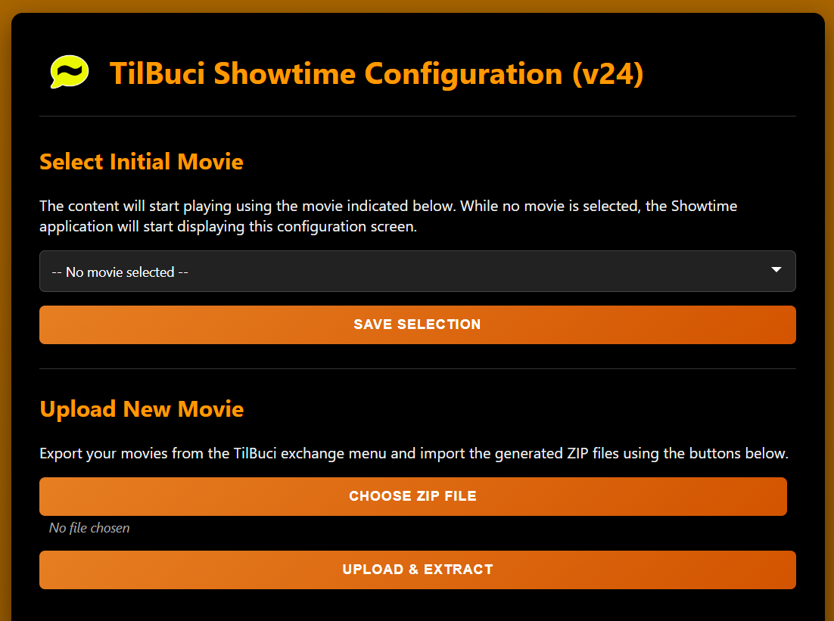
Start by uploading the movies you want to use in your presentation. To do this, simply export them from the "exchange" menu in TilBuci and use the ZIP files generated there. Then, select the initial movie and save your configuration. When Showtime has an initial movie selected, the program will start playing it immediately upon opening.
From the settings screen you can also remove movies that you will no longer use in your display.
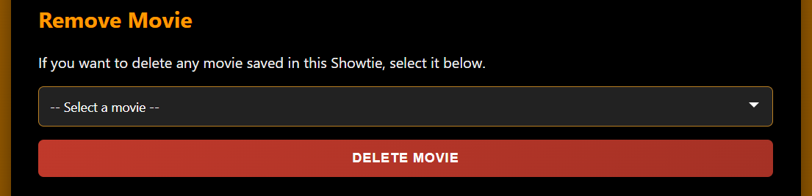

13.1.2. Settings access key
While content is being displayed, Showtime assumes a "kiosk mode" that attempts to prevent users from leaving the display, but we know that it can often be necessary to revert to the settings. To resolve this issue, you can set a five-character "access key" from A to D. Each letter refers to a corner of the screen:
A | Top left
B | Top right
C | Bottom left
D | Bottom right

Therefore, simply click or tap the corners according to the set password to exit kiosk mode and display the configuration again. By default, the access key is "AAAAA", which means five taps in the upper left corner of the screen.
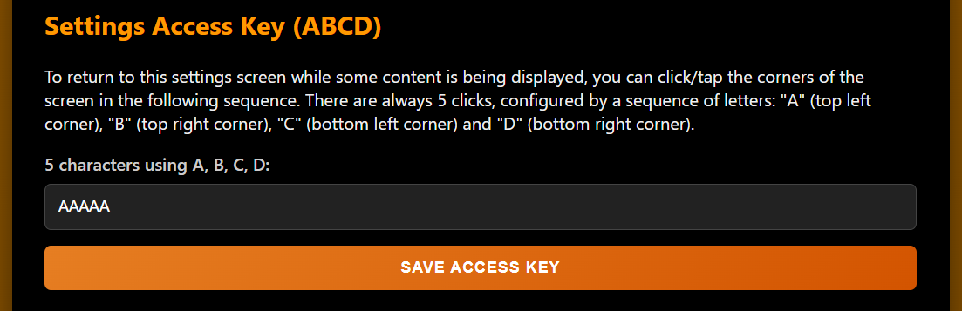

13.1.3. Additional options
Two other interesting adjustments are the automatic startup of the application when the device is turned on and the removal of the mouse cursor in the desktop version (useful for touch screens).
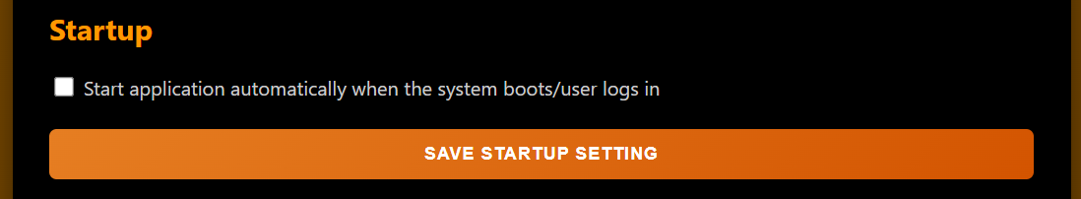
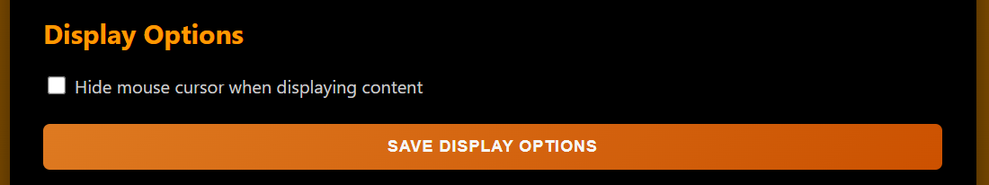

13.1.4. Hardware connection
The Showtime app can also connect to Arduino*-compatible hardware connected to the device via cable or Bluetooth serial SPP (experimental), in both the computer and Android versions. In this case, you need to configure the port used for communication with the hardware and its baud rate. Once this is done, you will be able to both send commands via the serial connection and receive responses from the hardware.
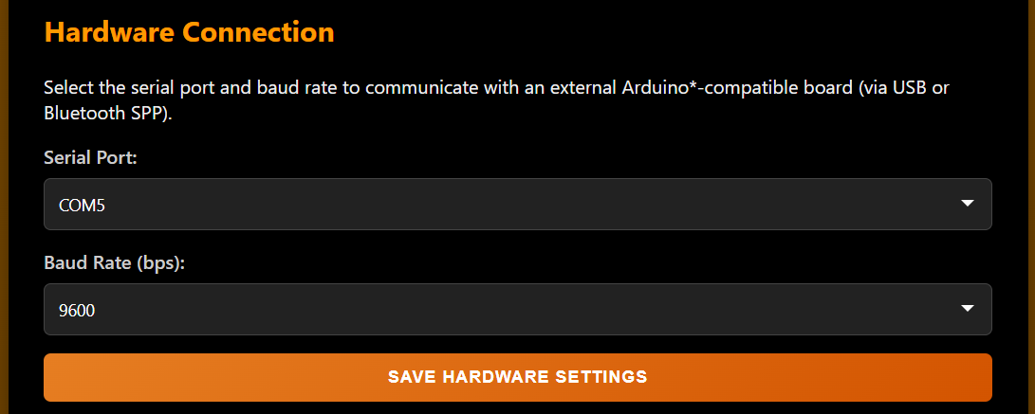
* Arduino is a registered trademark of Arduino AG. The name "Arduino" is used here solely for reference purposes to describe compatibility with the Arduino platform. This project is not affiliated with or endorsed by Arduino AG.
Here's an example of an Arduino sketch that receives a command via the serial port to turn the built-in LED connected to pin 13 on or off. Note that the command is received via serial containing two parts separated by |. The code breaks down this command and evaluates what to do.
const int LED_PIN = 13;
String inputBuffer = "";

void setup() {
pinMode(LED_PIN, OUTPUT);
digitalWrite(LED_PIN, HIGH);
Serial.begin(9600);
}

void loop() {
while (Serial.available() > 0) {
char c = Serial.read();
if (c == '\n' || c == '\r') {
if (inputBuffer.length() > 0) {
processCommand(inputBuffer);
inputBuffer = "";
}
} else {
inputBuffer += c;
}
}
}

void processCommand(String cmd) {
int sepIndex = cmd.indexOf('|');
if (sepIndex == -1) {
return;
}
String part1 = cmd.substring(0, sepIndex);
String part2 = cmd.substring(sepIndex + 1);
part1.trim();
part2.trim();
if (part1 == "light") {
if (part2 == "on") {
digitalWrite(LED_PIN, HIGH);
} else if (part2 == "off") {
digitalWrite(LED_PIN, LOW);
}
}
}

When creating your content in TilBuci, you will find the option "send a command to connected hardware" in the action block editor, within the "Showtime application" group.
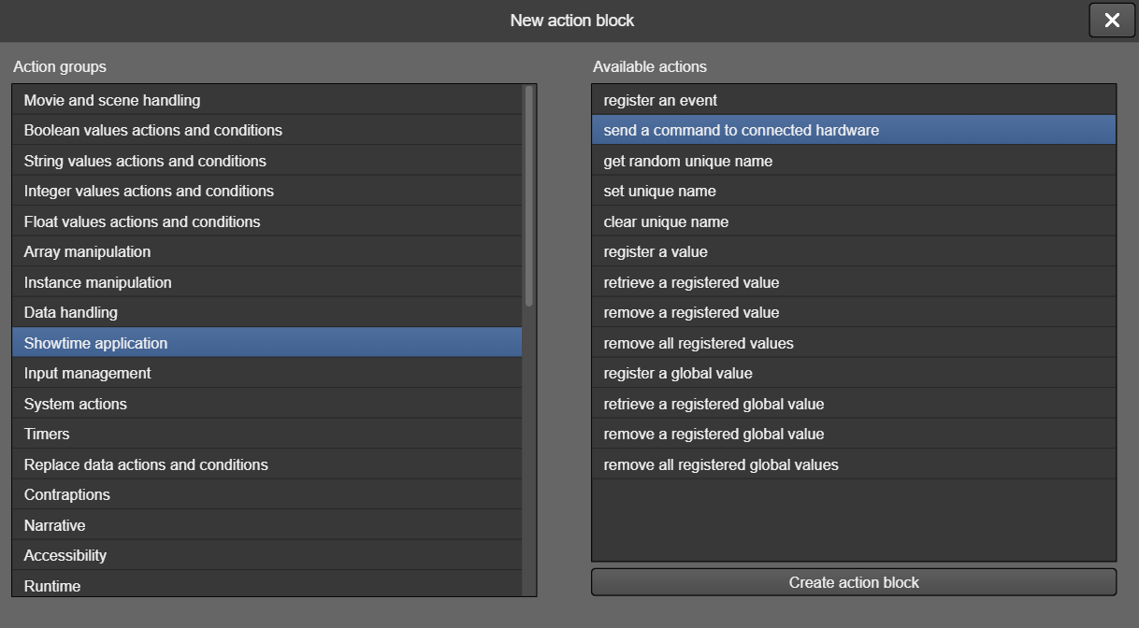
This block receives one to eight parameters. When this action is triggered, it will send a string containing as many parameters as are entered, separated by |, to the hardware's serial port. In the case of the picture below, the text sent is "light|on" which, in the sketch above, causes the LED to light up.
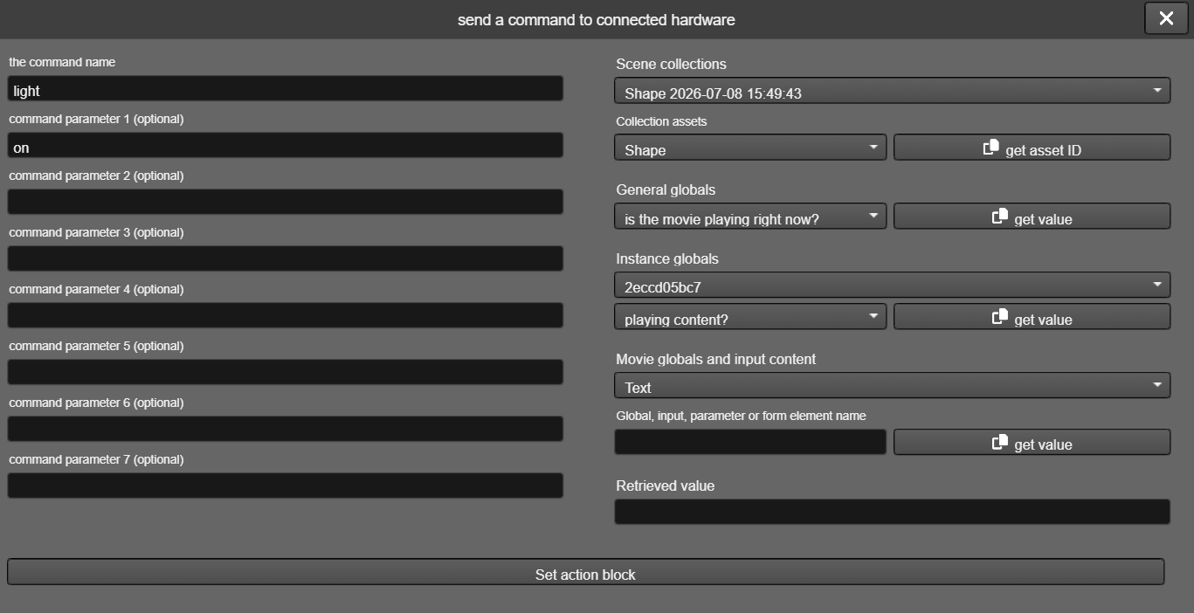
Sending commands from the hardware to TilBuci is also simple. All text written to the serial port is forwarded to its content and, if it is the code for a valid action, it will be executed. The example below shows a code snippet from a sketch that pauses the playback of a scene.
Serial.println("{\"ac\":\"scene.pause\",\"param\":[]}");

13.1.5. Online functionality
The Showtime application operates completely offline by default, but you can enable its online features by configuring a server. To do this, specify the URL of an online TilBuci installation, its access key (which we will see later), and specify an identifier for the current application to differentiate it from others connected to the same server. With these adjustments made, Showtime will communicate with the server at regular 15-minute intervals, sending and receiving information.
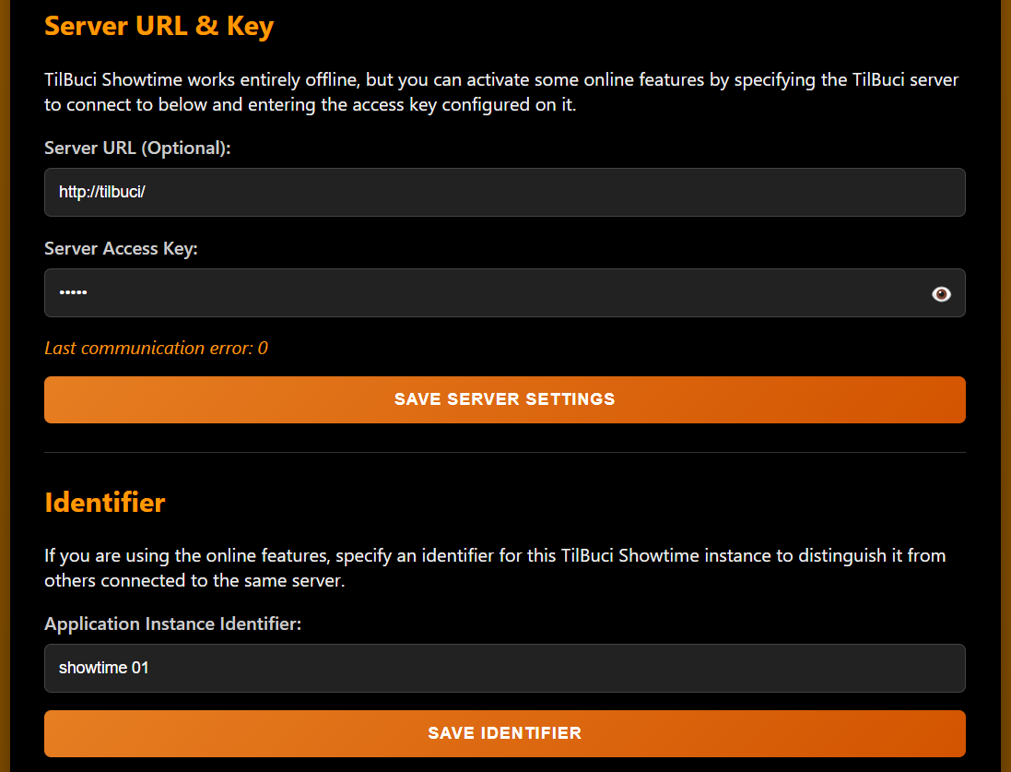
In the TilBuci online installation, access the setup menu and look for the Showtime tab.
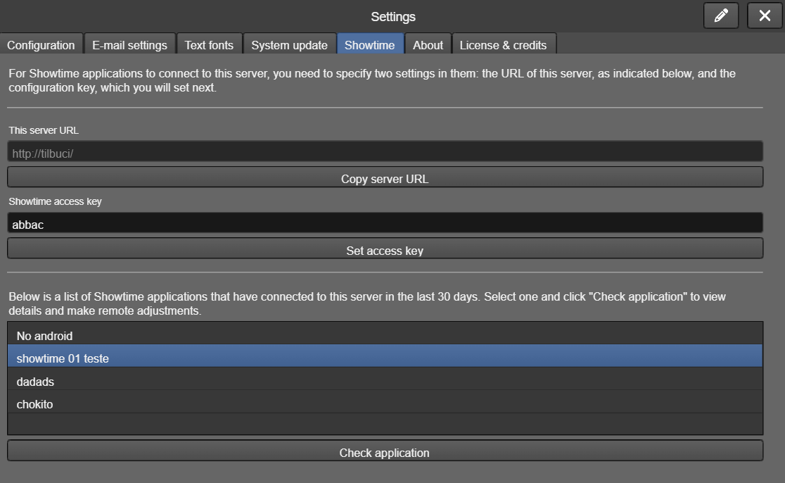
This screen first displays the server URL to be entered into the application and the key configured to authorize the connection. For greater security, consider using VPN access or similar.
Next, we see all the Showtime applications that connect to this TilBuci server. To check any of them, select the name and click "check application".
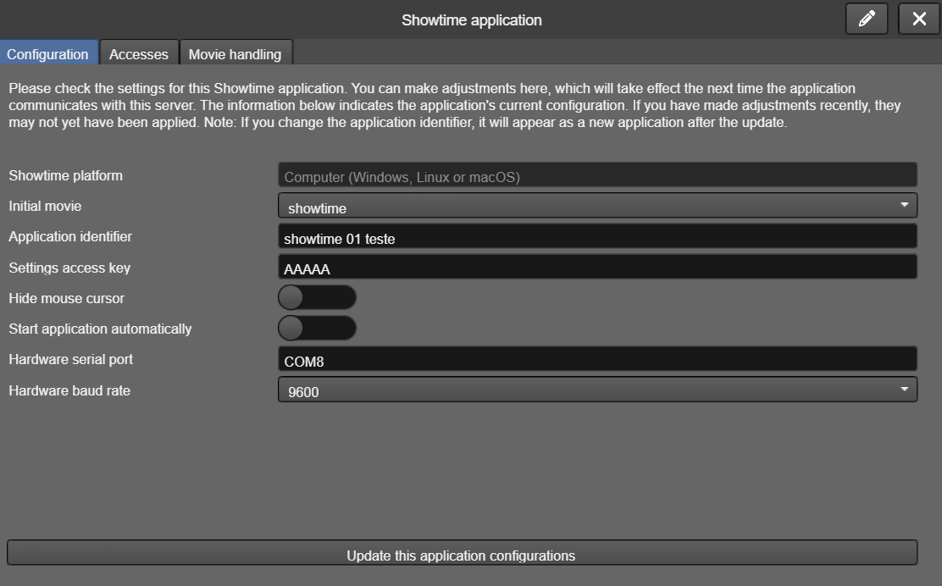
The "configuration" tab in the window that opens allows you not only to check how the application is configured, but also to change these values ​​by, for example, changing the movie to be displayed initially or the access key. Any changes made here will be sent to the application in its next communication.
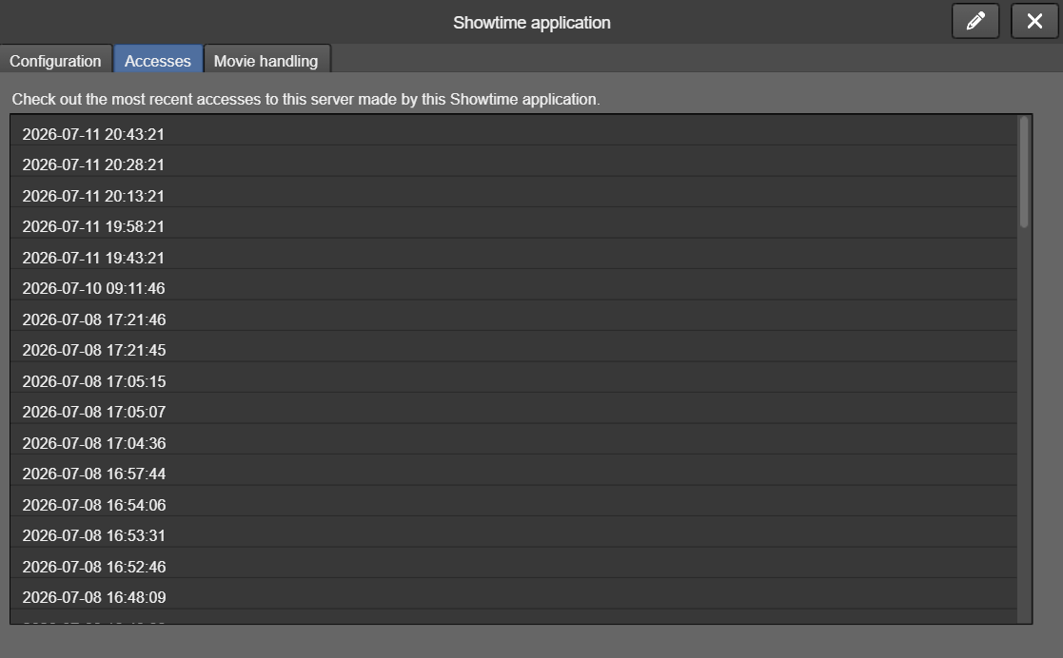
The "accesses" tab shows the latest communications made by the application with this server, which is useful for checking if it is actually running correctly if you do not have physical access to the location where it is installed.
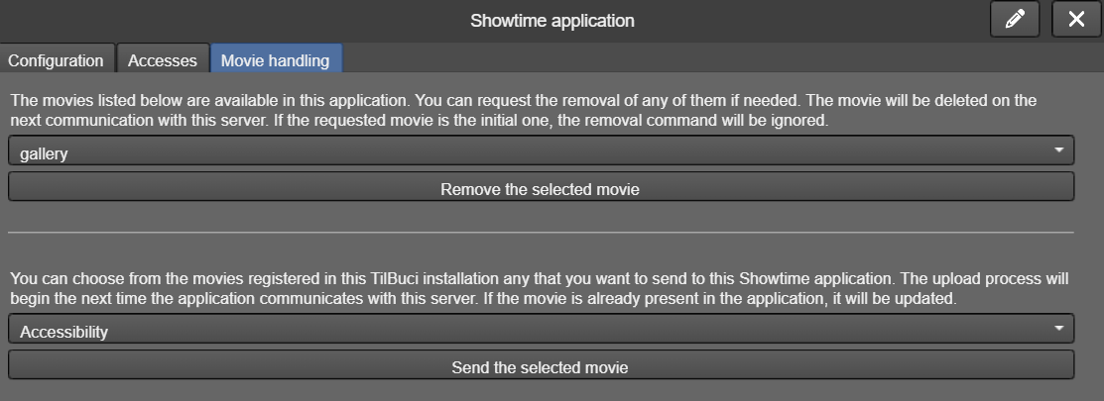
Finally, the "movie handling" tab allows you to manage the content included in the application. You can not only remotely delete movies that are no longer needed, but also send any movie present on the current server to the application. If the movie indicated for sending is already in the app, it will be updated, and if it is the initial one, the app will automatically restart after receiving it to show the updated version.
In addition to these Showtime-specific features, when you set up a server in your application, all the online features already present in TilBuci become available. In particular, online event registration can be very useful for monitoring the broadcast of your content remotely, without needing to access the device to retrieve local event files.
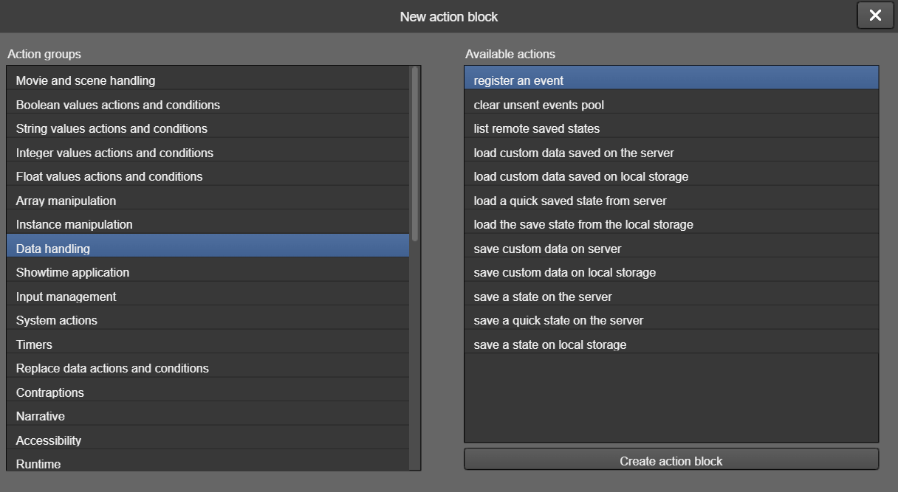
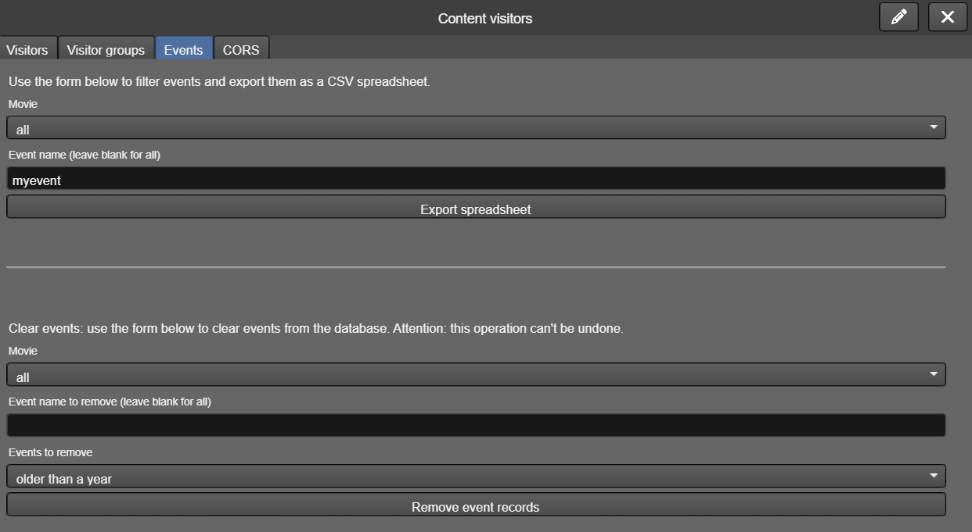

13.1.6. Installing Showtime
The desktop version of the Showtime application (Windows, Linux and macOS) is presented as a compressed, portable software. Therefore, you simply need to unpack it on your computer and configure it. Because it's a portable application, you can even configure it on your work computer and copy the folder to the computer you'll be using for the exhibition.
The Android version is presented as an APK file that needs to be installed directly on the device. You can copy the installation file and run it on your device normally, but due to system restrictions, if you do this, the kiosk mode will not be as "complete" - the user may still try to force the display of the navigation bar at the bottom of the screen and, with some knowledge, exit the display. To avoid this problem, the best way to install the application is using the ADB tool, available as part of Android Studio, which can be done in two steps, with two commands. First, install the APK file using the command:
adb install Showtime.apk
Then, it is necessary to activate the "device owner" mode by running this command:
adb shell dpm set-device-owner com.tilbuci.showtime/.MyDeviceAdminReceiver
For it to work, the device cannot have any Google account linked. If the message Success: Device owner set appears, the absolute kiosk mode will be activated on the device.
Furthermore, also due to system restrictions, it may be necessary to adjust the application permissions. Whenever you configure communication with new hardware, an authorization request will be displayed the first time the communication is made. Also, check if the "Display over other apps / SYSTEM_ALERT_WINDOW" permission is active in the application settings (it is usually automatically accepted by the system).

13.2. Showtime for Makers
Showtime for Makers is a tool capable of exporting your content for deployment on platforms that broadcast a dedicated Wi-Fi network to serve your content to connected devices. After creating your movie, go to the "Exchange" menu on the left and select the export option for this tool; the following window will appear:
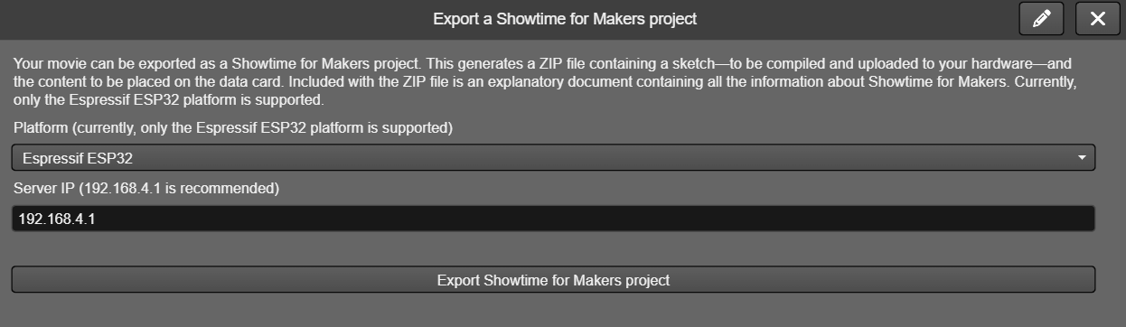
In this window, select the platform to be used and the connection IP address (the default value 192.168.4.1 is recommended). After that, simply click the export button, and a ZIP file containing the project will be downloaded.
This compressed file contains a short guide and two folders. The contents of the first folder, "card", should be copied to the SD card used with your hardware. The other folder, "sketch", contains a project to be opened in the Arduino IDE.
You may need to install additional libraries in your Arduino IDE, depending on the controller and hardware variations you are using. The project code files are organized by functionality and include comments to simplify customization for your specific setup. In particular, you may need to install the ESPAsyncWebServer (https://github.com/ESP32Async/ESPAsyncWebServer) and AsyncTCP (https://github.com/ESP32Async/AsyncTCP) libraries. Also, check how your chosen hardware accesses SD card data to make any necessary adjustments.
If your content interacts with the hardware beyond simple Wi-Fi transmission, you may need to modify the "HardwareHandler.cpp" file to include the commands you sent via TilBuci (we will cover this later). The hardware can also send messages to the content on connected devices using the "sendAction" function, which is available by including the "SseManager.h" header. For a practical example, please refer to the video tutorial at https://youtu.be/Nyia_E_WHUY .

13.2.1. Talking to the hardware
In the TilBuci editor, sending commands to hardware for Showtime for Makers is identical to the process used in Showtime for computers and Android. Simply create the "send a command to connected hardware" action from the "Showtime application" group, then specify the command name and include any necessary additional parameters.
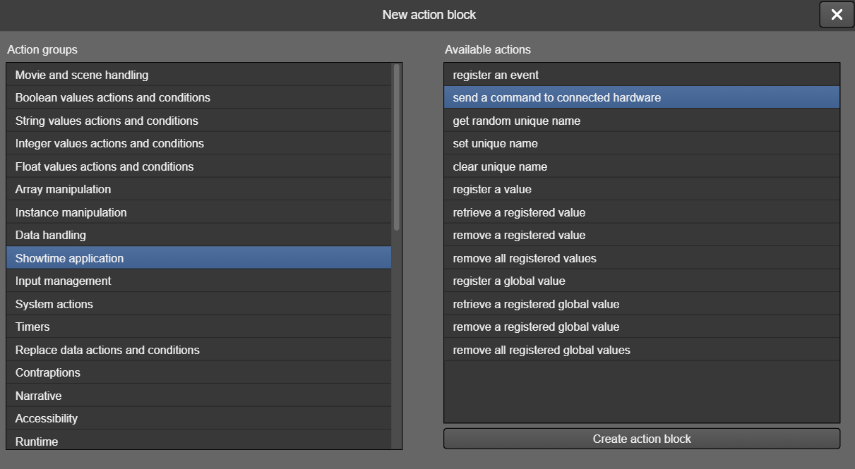
In your Arduino IDE project, you will need to implement the commands called from TilBuci at the end of the "HardwareHandler.cpp" file. The original exported file shows some examples of how to do this:
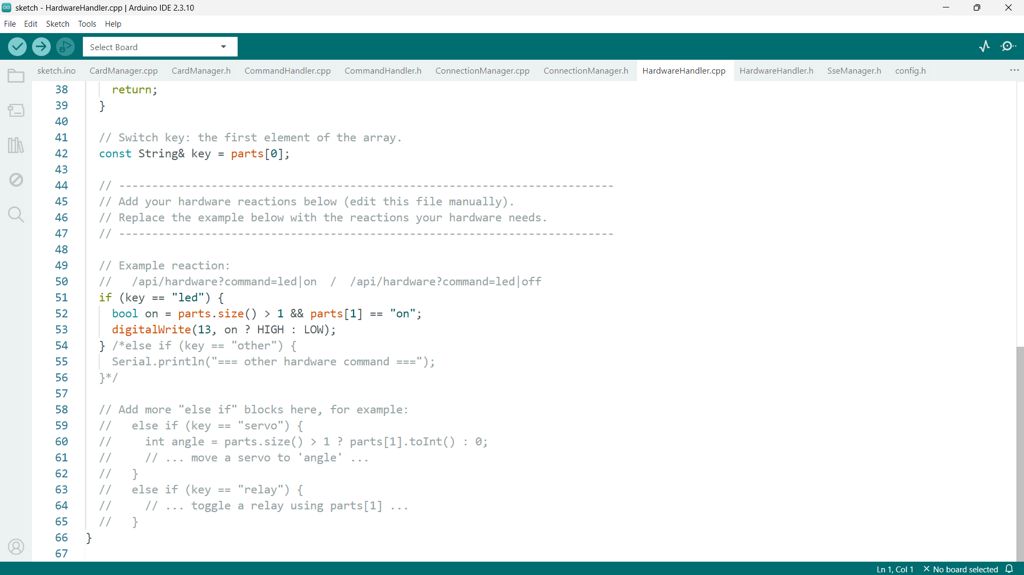
The name assigned to the command must be compared against the "key" variable. For example, if you created a command named "led" with an additional parameter that can be either "on" or "off," you should include a comparison in your code that checks whether "key" equals "led" and whether the first element of "parts" is "on" (to turn the LED on) or "off" (to turn the LED off).
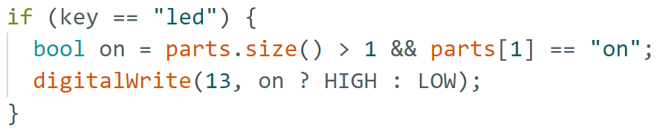
To enable the hardware to send commands back to the content on connected devices, first include the "SseManager.h" header in your implementation file. Then, simply execute the "sendAction" command with valid TilBuci actions, as shown in the following example:

13.3. Showtime actions
TilBuci offers various actions for interacting with content displayed in the Showtime tool, applicable to both the desktop/Android version and the Makers version.

13.3.1. Recording events
Event logging can be quite useful for tracking access to your creation. This action saves small JSON files containing information such as the event name, current movie and scene, as well as any custom information.
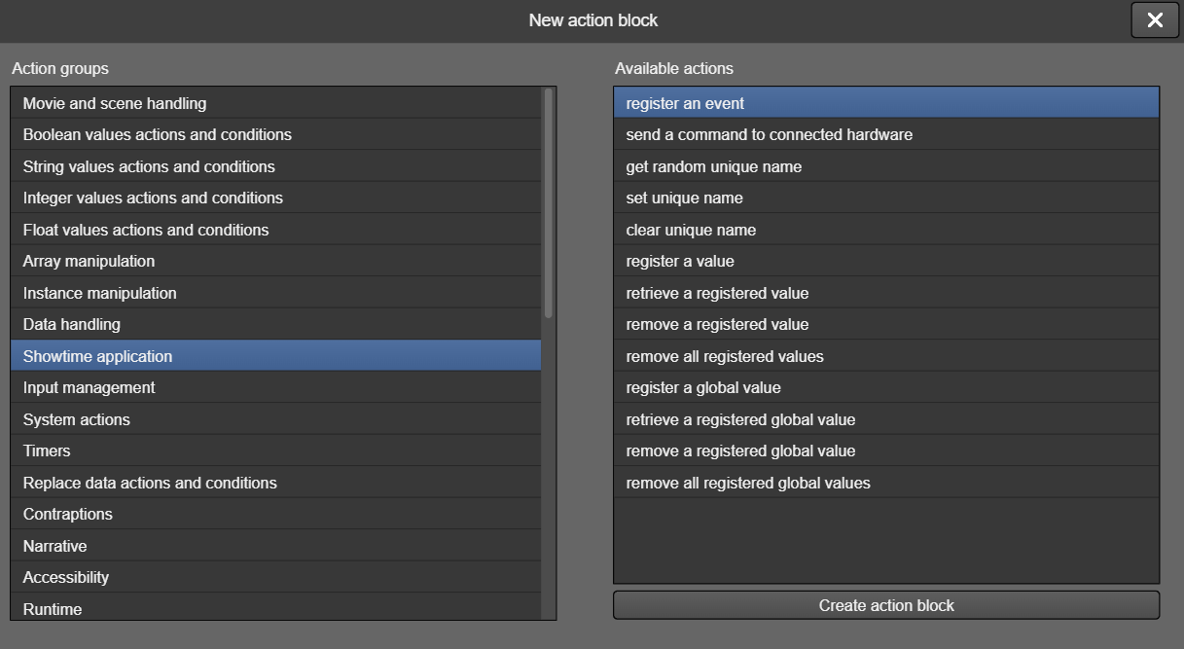
This command requires one parameter, which is the name of the event to be logged, but you can include others with customized information.
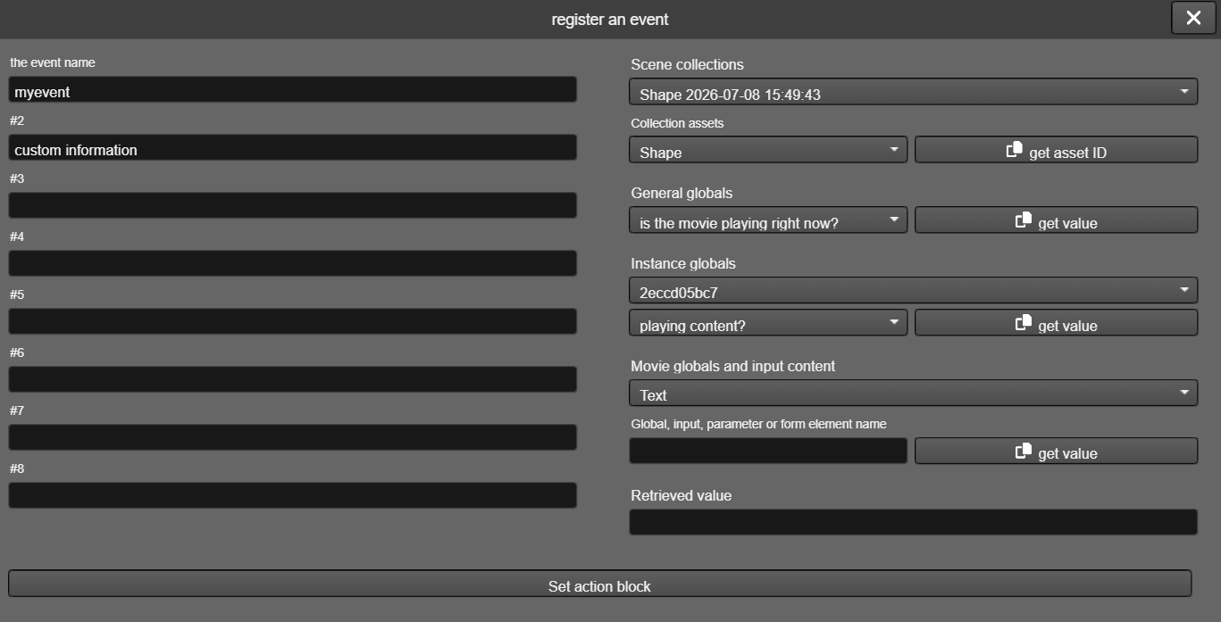
On the Makers platform, they are logged in the "events" folder created in the root of your SD card. In the app version, Showtime will save a file in the current user's documents folder on the device, whether it's a computer or an Android tablet. This file will be saved within the subfolder "TBShowtime/[movie]", where [movie] is the identifier of the current movie.

showtime.event
params
- the event name

13.3.2. Sending commands to hardware
As previously seen, this action sends commands to hardware connected to Showtime.

showtime.hardware
params
- the event name

13.3.3. Handling user names
Showtime allows for the recording and retrieval of information—such as variable values—on both the computers or tablets where it is installed and the SD card used on the Makers platform. These values ​​can be logged on a per-user basis, distinguishing between different access sessions and usage patterns. To enable this separation, a unique name can be assigned to the Showtime instance; this name can be either randomly generated or user-specified.

showtime.getname
Generates a random name for the current Showtime execution.

showtime.setname
Defines a name for the current Showtime execution.
params
- the name to use

showtime.clearname
Removes the name of the current Showtime execution.

13.3.4. Saving and retrieving values
You can log values ​​on the Showtime platform. These values ​​are always recorded as strings and are saved both in the documents folder of your computer or Android device and on the SD card within the Makers platform. If a name has been assigned to the Showtime execution, the value is logged specifically for that name; if no name has been defined, it is treated as "all".

showtime.setval
Records a value.
params
- the value name
- the value to store

showtime.getval
Retrieves a value.
params
- the value name
- the name of a string variable to receive the recovered data

showtime.delval
Deletes a stored value. Value storage is persistent, even when the app or hardware is turned off. This command permanently deletes a specific value.
params
- the value name

showtime.delallval
Removes all values ​​registered for the current name (or "all" if a name has not been defined).
In addition to recording information by name, it is also possible to record global information that is written and retrieved independently of the name assigned to the Showtime execution.

showtime.setglobal
Records a global value.
params
- the value name
- the value to store

showtime.getglobal
Retrieves a global value.
params
- the value name
- the name of a string variable to receive the recovered data

showtime.delglobal
Deletes a stored global value. Value storage is persistent, even when the app or hardware is turned off. This command permanently deletes a specific global value.
params
- the value name

showtime.delallglobal
Removes all global values ​​registered.

14. PDF Support
In TilBuci you can convert PDF files formatted in various programs into interactive movies. To do this, simply access the "Movie" menu and choose "New from PDF". After uploading the file, some properties will be defined and the import will be performed. Each page of the document is converted into a scene.
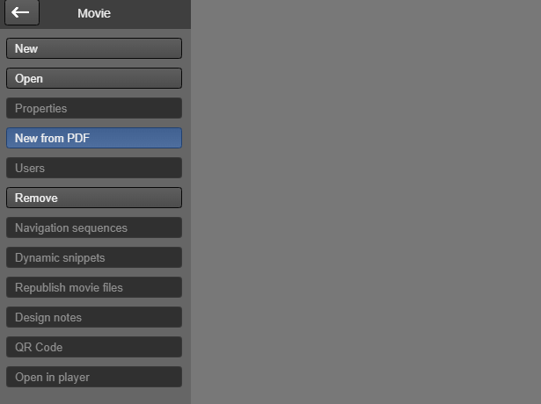
Attention: because there are various versions and ways to save PDF files, results may vary. TilBuci attempts to import the document as completely as possible, separating images, text, and converting the fonts found within it, but results may vary. For example, some PDFs record each page as a single image, and in that case, these single images will be imported one for each scene.
In addition to converting an entire PDF file into a movie, it's also possible to import just a single page as an isolated scene into the current movie.


